**PREDICTION OF CYBER-ATTACKS USING DATA SCIENCE TECHNIQUE**

**TABLE OF CONTENT**

|  |  |  |
| --- | --- | --- |
| **SL.NO** | **TITLE** | **PAGE.NO** |
| **01** | **ABSTRACT** |  |
| **02** | **EXISTING SYSTEM**  2.1 DRAWBACKS |  |
| **03** | **INTRODUCTION**  3.1 DATA SCIENCE  3.2 ARTIFICIAL INTELLIGENCE |  |
| **04** | **MACHINE LEARNING** |  |
| **05** | **PREPARING DATASET** |  |
| **06** | **PROPOSED SYSTEM**  6.1 ADVANTAGES |  |
| **07** | **LITERATURE SURVEY** |  |
| **08** | **SYSTEM STUDY**  8.1 OBJECTIVES  8.2 PROJECT GOAL  8.3 SCOPE OF THE PROJECT |  |
| **09** | **FEASIBILITY STUDY** |  |
| **10** | **LIST OF MODULES** |  |
| **11** | **PROJECT REQUIREMENTS**  11.1 FUNCTIONAL REQUIREMENTS  11.2 NON-FUNCTIONAL REQUIREMENTS |  |
| **12** | **ENVIRONMENT REQUIREMENT** |  |
| **13** | **SOFTWARE DESCRIPTION**  13.1 ANACONDA NAVIGATOR  13.2 JUPYTER NOTEBOOK |  |
| **14** | **PYTHON** |  |
| **15** | **SYSTEM ARCHITECTURE** |  |
| **16** | **WORKFLOW DIAGRAM** |  |
| **17** | **USECASE DIAGRAM** |  |
| **18** | **CLASS DIAGRAM** |  |
| **19** | **ACTIVITY DIAGRAM** |  |
| **20** | **SEQUENCE DIAGRAM** |  |
| **21** | **ER – DIAGRAM** |  |
| **22** | **MODULE DESCRIPTION**  22.1 MODULE DIAGRAM  22.2 MODULE GIVEN INPUT EXPECTED OUTPUT |  |
| **23** | **DEPLOYMENT (GUI)** |  |
| **24** | **CODING** |  |
| **25** | **CONCLUSION** |  |
| **26** | **FUTURE WORK** |  |

**LIST OF FIGURES**

|  |  |  |
| --- | --- | --- |
| **SL.NO** | **TITLE** | **PAGE.NO** |
| **01** | **SYSTEM ARCHITECTURE** |  |
| **02** | **WORKFLOW DIAGRAM** |  |
| **03** | **USECASE DIAGRAM** |  |
| **04** | **CLASS DIAGRAM** |  |
| **05** | **ACTIVITY DIAGRAM** |  |
| **06** | **SEQUENCE DIAGRAM** |  |
| **07** | **ER – DIAGRAM** |  |

**LIST OF SYSMBOLS**

|  |  |  |  |
| --- | --- | --- | --- |
| **S.NO** | **NOTATION**  **NAME** | **NOTATION** | **DESCRIPTION** |
| 1. | Class | *Class Name*  *-attribute*  *-attribute*  *+operation*  *+operation*  *+operation*    *+ public*  *-private*  *# protected* | Represents a collection of similar entities grouped together. |
| 2. | Association | name  Class B  Class A  Class A  Class B | Associations represents static relationships between classes. Roles represents the way the two classes see each other. |
| 3. | Actor |  | It aggregates several classes into a single classes. |
| 4. | Aggregation | Class A  Class A  Class B  Class B | Interaction between the system and external environment |
| 5. | Relation(uses) | uses | Used for additional process communication. |
| 6. | Relation  (extends) | extends | Extends relationship is used when one use case is similar to another use case but does a bit more. |
| 7. | Communication |  | Communication between various use cases. |
| 8. | State | State | State of the process. |
| 9. | Initial State |  | Initial state of the object |
| 10. | Final state |  | Final state of the object |
| 11. | Control flow |  | Represents various control flow between the states. |
| 12. | Decision box |  | Represents decision making process from a constraint |
| 13. | Use case |  | Interaction between the system and external environment. |
| 14. | Component |  | Represents physical modules which is a collection of components. |
| 15. | Node |  | Represents physical modules which are a collection of components |
| 16. | Data Process/State |  | A circle in DFD represents a state or process which has been triggered due to some event or action. |
| 17. | External entity |  | Represents external entities such as keyboard, sensors etc. |
| 18. | Transition |  | Represents communication that occurs between processes. |
| 19. | Object Lifeline |  | Represents the vertical dimensions that the object communications. |
| 20. | Message | Message | Represents the message exchanged. |

**Prediction of cyber-attacks using Data science Technique**

1. **Abstract:**

Cyber-attack, via cyberspace, targeting an enterprise's use of cyberspace for the purpose of disrupting, disabling, destroying, or maliciously controlling a computing environment/infrastructure; or destroying the integrity of the data or stealing controlled information. The state of the cyberspace portends uncertainty for the future Internet and its accelerated number of users. New paradigms add more concerns with big data collected through device sensors divulging large amounts of information, which can be used for targeted attacks. Though a plethora of extant approaches, models and algorithms have provided the basis for cyber-attack predictions, there is the need to consider new models and algorithms, which are based on data representations other than task-specific techniques. However, its non-linear information processing architecture can be adapted towards learning the different data representations of network traffic to classify type of network attack. In this paper, we model cyber-attack prediction as a classification problem, Networking sectors have to predict the type of Network attack from given dataset using machine learning techniques. The analysis of dataset by supervised machine learning technique(SMLT) to capture several information’s like, variable identification, uni-variate analysis, bi-variate and multi-variate analysis, missing value treatments etc. A comparative study between machine learning algorithms had been carried out in order to determine which algorithm is the most accurate in predicting the type cyber Attacks. We classify four types of attacks are DOS Attack, R2L Attack, U2R Attack, Probe attack. The results show that the effectiveness of the proposed machine learning algorithm technique can be compared with best accuracy with entropy calculation, precision, Recall, F1 Score, Sensitivity, Specificity and Entropy.

1. **Existing System:**

They proposed first to create a contrastive self-supervised learning to the anomaly detection problem of attributed networks. CoLa, is mainly consists of three components: contrastive instance pair sampling, GNN-based contrastive learning model, and multiround sampling-based anomaly score computation. Their model captures the relationship between each node and its neighbouring structure and uses an anomaly-related objective to train the contrastive learning model. We believe that the proposed framework opens a new opportunity to expand self-supervised learning and contrastive learning to increasingly graph anomaly detection applications. The multiround predicted scores by the contrastive learning model are further used to evaluate the abnormality of each node with statistical estimation. The training phase and the inference phase. In the training phase, the contrastive learning model is trained with sampled instance pairs in an unsupervised fashion. After that the anomaly score for each node is obtained in the inference phase.

**2.1 Disadvantages:**

1. The performance is not good and its get complicated for other networks.

2. The performance metrics like recall F1 score and comparison of machine learning algorithm is not done.

1. **INTRODUCTION**

**Domain overview**

**3.1 Data Science**

Data science is an interdisciplinary field that uses scientific methods, processes, algorithms and systems to extract knowledge and insights from structured and unstructured data, and apply knowledge and actionable insights from data across a broad range of application domains.

The term "data science" has been traced back to 1974, when Peter Naur proposed it as an alternative name for computer science. In 1996, the International Federation of Classification Societies became the first conference to specifically feature data science as a topic. However, the definition was still in flux.

The term “data science” was first coined in 2008 by D.J. Patil, and Jeff Hammerbacher, the pioneer leads of data and analytics efforts at LinkedIn and Facebook. In less than a decade, it has become one of the hottest and most trending professions in the market.

Data science is the field of study that combines domain expertise, programming skills, and knowledge of mathematics and statistics to extract meaningful insights from data.

Data science can be defined as a blend of mathematics, business acumen, tools, algorithms and machine learning techniques, all of which help us in finding out the hidden insights or patterns from raw data which can be of major use in the formation of big business decisions.

**Data Scientist:**

Data scientists examine which questions need answering and where to find the related data. They have business acumen and analytical skills as well as the ability to mine, clean, and present data.

Businesses use data scientists to source, manage, and analyze large amounts of unstructured data.

**Required Skills for a Data Scientist:**

* **Programming**: Python, SQL, Scala, Java, R, MATLAB.
* **Machine Learning**: Natural Language Processing, Classification, Clustering.
* **Data Visualization**: Tableau, SAS, D3.js, Python, Java, R libraries.
* **Big data platforms**: MongoDB, Oracle, Microsoft Azure, Cloudera.

**3.2 ARTIFICIAL INTELLIGENCE**

Artificial intelligence (AI) refers to the simulation of human intelligence in machines that are programmed to think like humans and mimic their actions. The term may also be applied to any machine that exhibits traits associated with a human mind such as learning and problem-solving.

Artificial intelligence (AI) is [intelligence](https://en.wikipedia.org/wiki/Intelligence) demonstrated by [machines](https://en.wikipedia.org/wiki/Machine), as opposed to the natural intelligence [displayed by humans](https://en.wikipedia.org/wiki/Human_intelligence) or [animals](https://en.wikipedia.org/wiki/Animal_cognition). Leading AI textbooks define the field as the study of "[intelligent agents](https://en.wikipedia.org/wiki/Intelligent_agent)" any system that perceives its environment and takes actions that maximize its chance of achieving its goals. Some popular accounts use the term "artificial intelligence" to describe machines that mimic "cognitive" functions that humans associate with the [human mind](https://en.wikipedia.org/wiki/Human_mind), such as "learning" and "problem solving", however this definition is rejected by major AI researchers.

Artificial intelligence is the simulation of human intelligence processes by machines, especially computer systems. Specific applications of AI include expert systems, natural language processing, speech recognition and machine vision.

AI applications include advanced web search engines, recommendation systems (used by Youtube, Amazon and Netflix), Understanding human speech (such as Siri or Alexa), self-driving cars (e.g. Tesla), and competing at the highest level in strategic game systems (such as chess and Go), As machines become increasingly capable, tasks considered to require "intelligence" are often removed from the definition of AI, a phenomenon known as the AI effect.

For instance, optical character recognition is frequently excluded from things considered to be AI, having become a routine technology.

Artificial intelligence was founded as an academic discipline in 1956, and in the years since has experienced several waves of optimism, followed by disappointment and the loss of funding (known as an "AI winter"), followed by new approaches, success and renewed funding.

AI research has tried and discarded many different approaches during its lifetime, including simulating the brain, modeling human problem solving, formal logic, large databases of knowledge and imitating animal behavior. In the first decades of the 21st century, highly mathematical statistical machine learning has dominated the field, and this technique has proved highly successful, helping to solve many challenging problems throughout industry and academia.

The various sub-fields of AI research are centered around particular goals and the use of particular tools. The traditional goals of AI research include reasoning, knowledge representation, planning, learning, natural language processing, perception and the ability to move and manipulate objects. General intelligence (the ability to solve an arbitrary problem) is among the field's long-term goals.

To solve these problems, AI researchers use versions of search and mathematical optimization, formal logic, artificial neural networks, and methods based on statistics, probability and economics. AI also draws upon computer science, psychology, linguistics, philosophy, and many other fields.

The field was founded on the assumption that human intelligence "can be so precisely described that a machine can be made to simulate it". This raises philosophical arguments about the mind and the ethics of creating artificial beings endowed with human-like intelligence.

These issues have been explored by myth, fiction and philosophy since antiquity. Science fiction and futurology have also suggested that, with its enormous potential and power, AI may become an existential risk to humanity.

As the hype around AI has accelerated, vendors have been scrambling to promote how their products and services use AI. Often what they refer to as AI is simply one component of AI, such as machine learning.

AI requires a foundation of specialized hardware and software for writing and training machine learning algorithms. No one programming language is synonymous with AI, but a few, including Python, R and Java, are popular.

In general, AI systems work by ingesting large amounts of labeled training data, analyzing the data for correlations and patterns, and using these patterns to make predictions about future states. In this way, a chatbot that is fed examples of text chats can learn to produce life like exchanges with people, or an image recognition tool can learn to identify and describe objects in images by reviewing millions of examples.

AI programming focuses on three cognitive skills: learning, reasoning and self-correction.

**Learning processes.** This aspect of AI programming focuses on acquiring data and creating rules for how to turn the data into actionable information. The rules, which are called algorithms, provide computing devices with step-by-step instructions for how to complete a specific task.

**Reasoning processes.** This aspect of AI programming focuses on choosing the right algorithm to reach a desired outcome.

**Self-correction processes.** This aspect of AI programming is designed to continually fine-tune algorithms and ensure they provide the most accurate results possible.

AI is important because it can give enterprises insights into their operations that they may not have been aware of previously and because, in some cases, AI can perform tasks better than humans. Particularly when it comes to repetitive, detail-oriented tasks like analyzing large numbers of legal documents to ensure relevant fields are filled in properly, AI tools often complete jobs quickly and with relatively few errors.

Artificial neural networks and deep learning artificial intelligence technologies are quickly evolving, primarily because AI processes large amounts of data much faster and makes predictions more accurately than humanly possible.

**Natural Language Processing (NLP):**

[Natural language processing](https://en.wikipedia.org/wiki/Natural_language_processing) (NLP) allows machines to read and [understand](https://en.wikipedia.org/wiki/Natural-language_understanding) human language. A sufficiently powerful natural language processing system would enable [natural-language user interfaces](https://en.wikipedia.org/wiki/Natural-language_user_interface) and the acquisition of knowledge directly from human-written sources, such as newswire texts. Some straightforward applications of natural language processing include [information retrieval](https://en.wikipedia.org/wiki/Information_retrieval), [text mining](https://en.wikipedia.org/wiki/Text_mining), [question answering](https://en.wikipedia.org/wiki/Question_answering) and [machine translation](https://en.wikipedia.org/wiki/Machine_translation). Many current approaches use word co-occurrence frequencies to construct syntactic representations of text. "Keyword spotting" strategies for search are popular and scalable but dumb; a search query for "dog" might only match documents with the literal word "dog" and miss a document with the word "poodle". "Lexical affinity" strategies use the occurrence of words such as "accident" to [assess the sentiment](https://en.wikipedia.org/wiki/Sentiment_analysis) of a document. Modern statistical NLP approaches can combine all these strategies as well as others, and often achieve acceptable accuracy at the page or paragraph level. Beyond semantic NLP, the ultimate goal of "narrative" NLP is to embody a full understanding of commonsense reasoning. By 2019, [transformer](https://en.wikipedia.org/wiki/Transformer_(machine_learning_model))-based deep learning architectures could generate coherent text.

1. **MACHINE LEARNING**

Machine learning is to predict the future from past data. Machine learning (ML) is a type of artificial intelligence (AI) that provides computers with the ability to learn without being explicitly programmed. Machine learning focuses on the development of Computer Programs that can change when exposed to new data and the basics of Machine Learning, implementation of a simple machine learning algorithm using python. Process of training and prediction involves use of specialized algorithms. It feed the training data to an algorithm, and the algorithm uses this training data to give predictions on a new test data. Machine learning can be roughly separated in to three categories. There are supervised learning, unsupervised learning and reinforcement learning. Supervised learning program is both given the input data and the corresponding labeling to learn data has to be labeled by a human being beforehand. Unsupervised learning is no labels. It provided to the learning algorithm. This algorithm has to figure out the clustering of the input data. Finally, Reinforcement learning dynamically interacts with its environment and it receives positive or negative feedback to improve its performance.

Data scientists use many different kinds of machine learning algorithms to discover patterns in python that lead to actionable insights. At a high level, these different algorithms can be classified into two groups based on the way they “learn” about data to make predictions: supervised and unsupervised learning. Classification is the process of predicting the class of given data points. Classes are sometimes called as targets/ labels or categories. Classification predictive modeling is the task of approximating a mapping function from input variables(X) to discrete output variables(y). In machine learning and statistics, classification is a supervised learning approach in which the computer program learns from the data input given to it and then uses this learning to classify new observation. This data set may simply be bi-class (like identifying whether the person is male or female or that the mail is spam or non-spam) or it may be multi-class too. Some examples of classification problems are: speech recognition, handwriting recognition, bio metric identification, document classification etc.

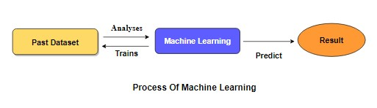

[Supervised Machine Learning](https://www.geeksforgeeks.org/supervised-unsupervised-learning/) **is the** majority of practical machine learning uses supervised learning. Supervised learning is where have input variables (X) and an output variable (y) and use an algorithm to learn the mapping function from the input to the output**is y = f(X).** The goal is to approximate the mapping function so well that when you have new input data (X) that you can predict the output variables (y) for that data. Techniques of Supervised Machine Learning algorithms include **logistic regression**, **multi-class classification**, **Decision Trees** and **support vector machines etc**. Supervised learning requires that the data used to train the algorithm is already labeled with correct answers. Supervised learning problems can be further grouped into **Classification** problems. This problem has as goal the construction of a succinct model that can predict the value of the dependent attribute from the attribute variables. The difference between the two tasks is the fact that the dependent attribute is numerical for categorical for classification. A classification model attempts to draw some conclusion from observed values. Given one or more inputs a classification model will try to predict the value of one or more outcomes. A classification problem is when the output variable is a category, such as “red” or “blue”.

1. **Preparing Dataset:**

This Dataset contains 3000 records of features. It is classified into 4 classes.

* DOS Attack
* R2L Attack
* U2R Attack
* Probe Attack

1. **Proposed System:**

The proposed model is to build a machine learning model for anomaly detection. Anomaly detection is an important technique for recognizing fraud activities, suspicious activities, network intrusion, and other abnormal events that may have great significance but are difficult to detect. The machine learning model is built by applying proper data science techniques like variable identification that is the dependent and independent variables. Then the visualisation of the data is done to insights of the data .The model is build based on the previous dataset where the algorithm learn data and get trained different algorithms are used for better comparisons. The performance metrics are calculated and compared.

**6.1 Advantages:**

1. The anomaly detection can be automated process using the machine learning.

2. Performance metric are compared in order to get better model.

1. **Literature Survey:**

**General**

A literature review is a body of text that aims to review the critical points of current knowledge on and/or methodological approaches to a particular topic. It is secondary sources and discuss published information in a particular subject area and sometimes information in a particular subject area within a certain time period. Its ultimate goal is to bring the reader up to date with current literature on a topic and forms the basis for another goal, such as future research that may be needed in the area and precedes a research proposal and may be just a simple summary of sources. Usually, it has an organizational pattern and combines both summary and synthesis.

A summary is a recap of important information about the source, but a synthesis is a re-organization, reshuffling of information. It might give a new interpretation of old material or combine new with old interpretations or it might trace the intellectual progression of the field, including major debates. Depending on the situation, the literature review may evaluate the sources and advise the reader on the most pertinent or relevant of them.

Loan default trends have been long studied from a socio-economic stand point. Most economics surveys believe in empirical modeling of these complex systems in order to be able to predict the loan default rate for a particular individual. The use of machine learning for such tasks is a trend which it is observing now. Some of the survey’s to understand the past and present perspective of loan approval or not.

**Review of Literature Survey**

**Title** : A Prediction Model of DoS Attack’s Distribution Discrete Probability

**Author:** Wentao Zhao, Jianping Yin and Jun Long

**Year :** 2008

The process of prediction analysis is a process of using some method or technology to explore or stimulate some unknown, undiscovered or complicated intermediate processes based on previous and present states and then speculated the results. In an early warning system, accurate prediction of DoS attacks is the prime aim in the network offence and defense task. Detection based on abnormity is effective to detect DoS attacks. A various studies focused on DoS attacks from different respects. However, these methods required a priori knowledge being a necessity and were difficult to discriminate between normal burst traffics and flux of DoS attacks. Moreover, they also required a large number of history records and cannot make the prediction for such attacks efficiently. Based on data from flux inspecting and intrusion detection, it proposed a prediction model of DOS attack’s distribution discrete probability based on clustering method of genetic algorithm and Bayesian method and the clustering problem first, and then utilizes the genetic algorithm to implement the optimization of clustering methods. Based on the optimized clustering on the sample data, we get various categories of the relation between traffics and attack amounts, and then builds up several prediction sub-models about DoS attack. Furthermore, according to the Bayesian method and deduce discrete probability calculation about each sub-model and then get the distribution discrete probability prediction model for DoS attack. This paper begins with the relation exists between network traffic data and the amount of DoS attack, and then proposes a clustering method based on the genetic optimization algorithm to implement the classification of DoS attack data. This method first gets the proper partition of the relation between the network traffic and the amount of DoS attack based on the optimized clustering and builds the prediction sub-models of DoS attack. Meanwhile, with the Bayesian method, the calculation of the output probability corresponding to each sub-model is deduced and then the distribution of the amount of DoS attack in some range in future is obtained.

**Title** : Apriori Viterbi Model for Prior Detection of Socio-Technical Attacks in a Social Network

**Author:** Preetish Ranjan, Abhishek Vaish

**Year :** 2014

Socio-technical attack is an organized approach which is defined by the interaction among people through maltreatment of technology with some of the malicious intent to attack the social structure based on trust and faith. Awful advertisement over internet and mobile phones may defame a person, organization, group and brand value in society which may be proved to be fatal. People are always very sensitive towards their religion therefore mass spread of manipulated information against their religious belief may create pandemonium in the society and can be one of the reasons for social riots, political misbalance etc. Cyber-attack on water, electricity, finance, healthcare, food and transportation system are may create chaos in society within few minutes and may prove even more destructive than that of a bomb as it does not attack physically but it attacks on the faith and trust which is the basic pillar of our social structure. Trust is a belief that the person who is being trusted will do what is being expected for and it starts from the family which grows to build a society. Trust for information may be established if it either comes from genuine source or information is validated by authentic body so that there is always a feeling of security and optimism. In the huge and complex social network formed using cyberspace or telecommunication technology, the identification or prediction of any kind of socio-technical attack is always difficult. This challenge creates an opportunity to explore different methodologies, concepts and algorithms used to identify these kinds of community on the basis of certain pattern, properties, structure and trend in their linkage. It tries to find the hidden information in huge social network by compressing it in small networks through apriori algorithm and then diagnosed using viterbi algorithm to predict the most probable pattern of conversation to be followed in the network and if this pattern matches with the existing pattern of criminals, terrorists and hijackers then it may be helpful to generate some kind of alert before crime.

Due to emergence of internet on mobile phone, the different social networks such as on social networking sites, blogs, opinion, ratings, review, serial bookmarking, social news, media sharing, Wikipedia led the people to disperse any kind of information very easily. Rigorous analysis of these patterns can reveal some very undisclosed and important information explicitly whether that person is conducting malignant or harmless communications with a particular user and may be a reason for any kind of socio technical attacks. From the above simulation done on CDR, it may be concluded that if this kind of simulation applied on networks based on the internet and if we are in the position to get the data which could be transformed in transition and emission matrix then several kind of prediction may be drawn which will be helpful to take our decisions.

**Title** : New Attack Scenario Prediction Methodology

**Author:** Seraj Fayyad, Cristoph Meinel

**Year :** 2013

Intrusion detection systems (IDS) are used to detect the occurrence of malicious activities against IT system. Through monitoring and analyzing of IT system activities the malicious activities will be detected. In ideal case IDS generate alert(s) for each detected malicious activity and store it in IDS database. Some of stored alerts in IDS database are related. Alerts relations are differentiated from duplication relation to same attack scenario relation. Duplication relation means that the two alerts generated as a result of same malicious activity. Where same attack scenario relation means that the two related alert are generated as a result of related malicious activities. Attack scenario or multi-step attack is a set of related malicious activities run by same attacker to reach specific goal. Normal relation between malicious activities belong to same attack scenario is causal relation. Causal relation means that current malicious activity output is pre-condition to run the next malicious activity. Possible multi-step attack against a network start with information gathering about network and the information gathering is done through network Reconnaissance and fingerprinting process. Through reconnaissance network configuration and running services are identified. Through fingerprint process Operating system type and version are identified. propose a real time prediction methodology for predicting most possible attack steps and attack scenarios. Proposed methodology benefits from attacks history against network and from attack graph source data. it comes without considerable computation overload such as checking of attack plans library. It provides parallel prediction for parallel attack scenarios. Possible third attack step is to identify attack plan based on the modeled attack graph in the past step. The attack plan usually will include the exploiting of a sequence of founded vulnerabilities. Mostly this sequence is distributed over a set of network nodes. This sequence of nodes vulnerabilities is related through causal relation and connectivity. Lastly Attacker start orderly exploits the attack scenario sequences till reaching his/her goal. Attack plan consist of many correlated malicious activities end up with attacking goal.

**Title** : Cyber Attacks Prediction Model Based on Bayesian Network

**Author:** Jinyu W1, Lihua Yin and Yunchuan Guo

**Year :** 2012

The prediction results reflect the security situation of the target network in the future, and security administrators can take corresponding measures to enhance network security according to the results. To quantitatively predict the possible attack of the network in the future, attack probability plays a significant role. It can be used to indicate the possibility of invasion by intruders. As an important kind of network security quantitative evaluation measure, attack probability and its computing methods has been studied for a long time. Many models have been proposed for performing evaluation of network security. Graphical models such as attack graphs become the main-stream approach. Attack graphs which capture the relationships among vulnerabilities and exploits show us all the possible attack paths that an attacker can take to intrude all the targets in the network. The traffics to different hosts or servers may differ from each other. The hosts or servers with big traffic may be more risky since they are often important hosts or servers, and intruders may have more contacts and understanding with them. In our cyber-attacks prediction model, they used attack graph to capture the vulnerabilities in the network. In addition we consider 3 environment factors that are the major impact factors of the cyber-attacks in the future. They are the value of assets in the network, the usage condition of the network and the attack history of the network. Cyber-attacks prediction is an important part of risk management. Existing cyber-attacks prediction methods did not fully consider the specific environment factors of the target network, which may make the results deviate from the true situation. In this paper, we propose a cyber-attacks prediction model based on Bayesian network. We use attack graphs to represent all the vulnerabilities and possible attack paths. Then we capture the using environment factors using Bayesian network model. Cyber-attacks predictions are performed on the constructed Bayesian network.

**Title** : A Prediction Model of DoS Attack’s Distribution Discrete Probability

**Author:** Wentao Zhao, Jianping Yin

**Year :** 2008

This paper begins with the relation exists between network traffic data and the amount of DoS attack, and then proposes a clustering method based on the genetic optimization algorithm to implement the classification of DoS attack data. This method first gets the proper partition of the relation between the network traffic and the amount of DoS attack based on the optimized clustering and builds the prediction sub-models of DoS attack. Meanwhile, with the Bayesian method, the calculation of the output probability corresponding to each sub-model is deduced and then the distribution of the amount of DoS attack in some range in future is obtained. This paper describes the clustering problem first, and then utilizes the genetic algorithm to implement the optimization of clustering methods. Based on the optimized clustering on the sample data, we get various categories of the relation between traffics and attack amounts, and then builds up several prediction sub-models about DoS attack. Furthermore, according to the Bayesian method, we deduce discrete probability calculation about each sub-model and then get the distribution discrete probability prediction model for DoS attack.

**Title** : Adversarial Examples: Attacks and Defenses for Deep Learning

**Author:** Xiaoyong Yuan , Pan He, Qile Zhu, and Xiaolin Li

**Year :** 2019

It reviewed the recent findings of adversarial examples in DNNs. We investigated the existing methods for generating adversarial examples. A taxonomy of adversarial examples was proposed. We also explored the applications and countermeasures for adversarial examples. This paper attempted to cover the state-of-the-art studies for adversarial examples in the DL domain. Compared with recent work on adversarial examples, we analyzed and discussed the current challenges and potential solutions in adversarial examples. However, deep neural networks (DNNs) have been recently found vulnerable to well-designed input samples called adversarial examples. Adversarial perturbations are imperceptible to human but can easily fool DNNs in the testing/deploying stage. The vulnerability to adversarial examples becomes one of the major risks for applying DNNs in safety-critical environments. Therefore, attacks and defenses on adversarial examples draw great attention. In this paper, we review recent findings on adversarial examples for DNNs, summarize the methods for generating adversarial examples, and propose taxonomy of these methods. Under the taxonomy, applications for adversarial examples are investigated. We further elaborate on countermeasures for adversarial examples. In addition, three major challenges in adversarial examples and the potential solutions are discussed.

**Title** : Distributed Secure Cooperative Control Under Denial-of-Service Attacks From Multiple Adversaries

**Author:** Wenying Xu, Guoqiang Hu

**Year :** 2019

This paper has investigated the distributed secure control of multiagent systems under DoS attacks. We focus on the investigation of a jointly adverse impact of distributed DoS attacks from multiple adversaries. In this scenario, two kinds of communication schemes, that is, sample-data and event-triggered communication schemes, have been discussed and, then, a fully distributed control protocol has been developed to guarantee satisfactory asymptotic consensus. Note that this protocol has strong robustness and high scalability. Its design does not involve any global information, and its efficiency has been proved. For the event-triggered case, two effective dynamical event conditions have been designed and implemented in a fully distributed way, and both of them have excluded Zeno behavior. Finally, a simulation example has been provided to verify the effectiveness of theoretical analysis. Our future research topics focus on fully distributed event/self-triggered control for linear/nonlinear multiagent systems to gain a better understanding of fully distributed control.

1. **SYSTEM STUDY**

#### Classification of Attacks:

The data set in KDD Cup99 have normal and 22 attack type data with 41 features and all generated traffic patterns end with a label either as ‘normal’ or any type of ‘attack’ for upcoming analysis. There are varieties of attacks which are entering into the network over a period of time and the attacks are classified into the following four main classes.

* Denial of Service (DoS)
* User to Root (U2R)
* Remote to User (R2L)
* Probing

**Denial of Service:**

Denial of Service is a class of attacks where an attacker makes some computing or memory resource too busy or too full to handle legitimate requests, denying legitimate users access to a machine. The different ways to launch a DoS attack are by abusing the computer’s legitimate features,

* by targeting the implementation bugs
* by exploiting the misconfiguration of the systems

DoS attacks are classified based on the services that an attacker renders unavailable to legitimate users.

**User to Root:**

In User to Root attack, an attacker starts with access to a normal user account on the system and gains root access. Regular programming mistakes and environment assumption give an attacker the opportunity to exploit the vulnerability of root access.

**Remote to User:**

In Remote to User attack, an attacker sends packets to a machine over a network that exploits the machine’s vulnerability to gain local access as a user illegally. There are different types of R2L attacks and the most common attack in this class is done by using social engineering.

**Probing**:

Probing is a class of attacks where an attacker scans a network to gather information in order to find known vulnerabilities. An attacker with a map of machines and services that are available on a network can manipulate the information to look for exploits. There are different types of probes: some of them abuse the computer’s legitimate features and some of them use social engineering techniques. This class of attacks is the most common because it requires very little technical expertise.

**Summary:**

This chapter outlines the structure of the dataset used in the proposed work. The various kinds of features such as discrete and continuous features are studied with a focus on their role in the attack. The attacks are classified with a brief introduction to each. The next chapter discusses the clustering and classification of the data with a direction to learning by machine.

Table: Attack Types Grouped to respective Class

|  |  |  |  |
| --- | --- | --- | --- |
| **Dos** | **R2L** | **U2R** | **Probe** |
| Back  Neptune  Land  Pod  Smurf  Teardrop  Apache2  Mail bomb  Process table  UDP Storm | FTP Write  Multihop  Phf  Spy  Warezclient  Warezmaster  Imap  Guess password  http tunnel  named  send mail  snmpget attack  snmp guess  worm  xlock  xsnoop | Load mosule  Rerl  Rootkit  Buffer overflow  Ps  Sql attack  xterm | Ip sweep  Nmap  Satan  Port sweep  Msscan  saint |

Table: Description of Attacks

|  |  |
| --- | --- |
| **Types of Attacks** | **Description** |
| back | Denial of service attack against apache web server where a client requests a URL containing many backslashes |
| neptune | Syn flood denial of service on one or more ports |
| land | Denial of service where a remote host is sent a UDP packet with the  same source and destination |
| pod | Denial of service ping of death |
| smurf | Denial of service icmp echo reply flood |
| teardrop | Denial of service where mis-fragmented UDP packets cause some  systems to reboot |
| multihop | Multi-day scenario in which a user first breaks into one machine |
| phf | Exploitable CGI script which allows a client to execute arbitrary commands on a machine with a mis-configured web server. |
| spy | Multi-day scenario in which a user breaks into a machine with the purpose of finding important information where the user tries to avoid detection. Uses several different exploit methods to gain access |
| warezclient | Users downloading illegal software which was previously posted via  anonymous FTP by the warezmaster |
| warezmaster | Anonymous FTP upload of Warez (usually illegal copies of copy writed  software) onto FTP server |
| Imap | Remote buffer overflow using imap port leads to root shell |
| loadmodule | Non-stealthy loadmodule attack which resets IFS for a normal user and  creates a root shell |
| Perl | Perl attack which sets the user id to root in a perl script and creates a root shell |
| rootkit | Multi-day scenario where a user installs one or more components of a  rootkit |
| ipsweep | Surveillance sweep performing either a port sweep or ping on multiple  host addresses |
| nmap | Network mapping using the nmap tool. Mode of exploring network will  vary-options include SYN |
| satan | Network probing tool which looks for well-known weaknesses. Operates at three different levels. Level 0 is light |
| portsweep | Surveillance sweep through many ports to determine which services are  supported on a single host |
| dict | Guess passwords for a valid user using simple variants of the account  name over a telnet connection |
| eject | Buffer overflow using eject program on Solaris. Leads to a user->root  transition if successful |
| ffb | Buffer overflow using the ffbconfig UNIX system command leads to  root shell |
| format | Buffer overflow using the fdformat UNIX system command leads to  root shell |
| ftp-write | Remote FTP user creates .rhost file in world writable anonymous FTP  directory and obtains local login |
| guest | Try to guess password via telnet for guest account |
| syslog | Denial of service for the syslog service connects to port 514 with  unresolvable source ip |
| warez | User logs into anonymous FTP site and creates a hidden directory |

#### 8.1 Objectives:

This analysis aims to observe which features are most helpful in predicting the network attacks of DOS, R2L, U2R, Probe and combination of attacks or not and to see the general trends that may help us in model selection and hyper parameter selection. To achieve used machine learning classification methods to fit a function that can predict the discrete class of new input.

The repository is a learning exercise to:

* Apply the fundamental concepts of machine learning from an available dataset and Evaluate and interpret my results and justify my interpretation based on observed dataset.
* Create notebooks that serve as computational records and document my thought process and investigate the network connection whether attacked or not to analyses the data set.

## Evaluate and analyses statistical and visualized results, which find the standard patterns for all regiments.

**8.2 Project Goals**

# Exploration data analysis of variable identification

* Loading the given dataset
* Import required libraries packages
* Analyze the general properties
* Find duplicate and missing values
* Checking unique and count values

# Uni-variate data analysis

* Rename, add data and drop the data
* To specify data type

# Exploration data analysis of bi-variate and multi-variate

* Plot diagram of pairplot, heatmap, bar chart and Histogram

# Method of Outlier detection with feature engineering

* Pre-processing the given dataset
* Splitting the test and training dataset
* Comparing the Decision tree and Logistic regression model and random forest

# Comparing algorithm to predict the result

* Based on the best accuracy

**8.3 Scope:**

The scope of this project is to investigate a dataset of network connection attacks for KDD records for medical sector using machine learning technique. To identifying network connection is attacked or not.

1. **Feasibility study:**

## Data Wrangling

## In this section of the report will load in the data, check for cleanliness, and then trim and clean given dataset for analysis. Make sure that the document steps carefully and justify for cleaning decisions.

**Data collection**

The data set collected for predicting given data is split into Training set and Test set. Generally, 7:3 ratios are applied to split the Training set and Test set. The Data Model which was created using Random Forest, logistic, Decision tree algorithms and Support vector classifier (SVC) are applied on the Training set and based on the test result accuracy, Test set prediction is done.

**Preprocessing**

The data which was collected might contain missing values that may lead to inconsistency. To gain better results data need to be preprocessed so as to improve the efficiency of the algorithm. The outliers have to be removed and also variable conversion need to be done.

**Building the classification model**

The prediction of Phishing Website, A Random Forest Algorithm prediction model is effective because of the following reasons: It provides better results in classification problem.

* It is strong in preprocessing outliers, irrelevant variables, and a mix of continuous, categorical and discrete variables.
* It produces out of bag estimate error which has proven to be unbiased in many tests and it is relatively easy to tune with.

**Construction of a Predictive Model**

Machine learning needs data gathering have lot of past data’s. Data gathering have sufficient historical data and raw data. Before data pre-processing, raw data can’t be used directly. It’s used to preprocess then, what kind of algorithm with model. Training and testing this model working and predicting correctly with minimum errors. Tuned model involved by tuned time to time with improving the accuracy.

Data Gathering

Data Pre-Processing

Choose model

Train model

Test model

Tune model

Prediction

Process of dataflow diagram

1. **List Of Modules:**

* Data validation process and Visualization (Module-01)
* DOS Attack Algorithm Comparision (Module-02)
* R2L Attack Algorithm Comparision (Module-03)
* U2R Attack Algorithm Comparision (Module-04)
* Probe Attack Algorithm Comparision (Module-05)
* Overall Attack Algorithm Comparision (Module-06)
* Deployment in GUI

1. **Project Requirements**

**General:**

Requirements are the basic constrains that are required to develop a system. Requirements are collected while designing the system. The following are the requirements that are to be discussed.

1. Functional requirements

2. Non-Functional requirements

3. Environment requirements

A. Hardware requirements

B. software requirements

**11.1 Functional requirements:**

The software requirements specification is a technical specification of requirements for the software product. It is the first step in the requirements analysis process. It lists requirements of a particular software system. The following details to follow the special libraries like sk-learn, pandas, numpy, matplotlib and seaborn.

**11.2 Non-Functional Requirements:**

Process of functional steps,

1. Problem define
2. Preparing data
3. Evaluating algorithms
4. Improving results
5. Prediction the result
6. **Environment Requirements:**

1. Software Requirements:

Operating System : Windows

Tool : Anaconda with Jupyter Notebook

2. Hardware requirements:

Processor : Pentium IV/III

Hard disk : minimum 80 GB

RAM : minimum 2 GB

1. **SOFTWARE DESCRIPTION**

Anaconda is a [free and open-source](https://en.wikipedia.org/wiki/Free_and_open-source) distribution of the [Python](https://en.wikipedia.org/wiki/Python_(programming_language)) and [R](https://en.wikipedia.org/wiki/R_(programming_language)) programming languages for [scientific computing](https://en.wikipedia.org/wiki/Scientific_computing) ([data science](https://en.wikipedia.org/wiki/Data_science), [machine learning](https://en.wikipedia.org/wiki/Machine_learning) applications, large-scale data processing, [predictive analytics](https://en.wikipedia.org/wiki/Predictive_analytics), etc.), that aims to simplify [package management](https://en.wikipedia.org/wiki/Package_management) and deployment. Package versions are managed by the [package management system](https://en.wikipedia.org/wiki/Package_manager) “Conda”. The Anaconda distribution is used by over 12 million users and includes more than 1400 popular data-science packages suitable for Windows, Linux, and MacOS. So, Anaconda distribution comes with more than 1,400 packages as well as the [Conda](https://en.wikipedia.org/wiki/Conda_(package_manager)) package and virtual environment manager called Anaconda Navigator and it eliminates the need to learn to install each library independently. The open source packages can be individually installed from the Anaconda repository with the conda install command or using the pip install command that is installed with Anaconda. [Pip packages](https://en.wikipedia.org/wiki/Pip_(package_manager)) provide many of the features of conda packages and in most cases they can work together. Custom packages can be made using the conda build command, and can be shared with others by uploading them to Anaconda Cloud, [PyPI](https://en.wikipedia.org/wiki/Python_Package_Index) or other repositories. The default installation of Anaconda2 includes Python 2.7 and Anaconda3 includes Python 3.7. However, you can create new environments that include any version of Python packaged with conda.

**13.1 ANACONDA NAVIGATOR**

Anaconda Navigator is a desktop graphical user interface (GUI) included in Anaconda® distribution that allows you to launch applications and easily manage conda packages, environments, and channels without using command-line commands. Navigator can search for packages on Anaconda.org or in a local Anaconda Repository.

Anaconda. Now, if you are primarily doing data science work, Anaconda is also a great option. Anaconda is created by Continuum Analytics, and it is a Python distribution that comes preinstalled with lots of useful python libraries for data science.

Anaconda is a distribution of the Python and R programming languages for scientific computing (data science, machine learning applications, large-scale data processing, predictive analytics, etc.), that aims to simplify package management and deployment.

In order to run, many scientific packages depend on specific versions of other packages. Data scientists often use multiple versions of many packages and use multiple environments to separate these different versions.

The command-line program conda is both a package manager and an environment manager. This helps data scientists ensure that each version of each package has all the dependencies it requires and works correctly.

Navigator is an easy, point-and-click way to work with packages and environments without needing to type conda commands in a terminal window. You can use it to find the packages you want, install them in an environment, run the packages, and update them – all inside Navigator.

The following applications are available by default in Navigator:

* [JupyterLab](https://jupyterlab.readthedocs.io/en/stable/)
* [Jupyter Notebook](https://jupyter.readthedocs.io/en/latest/)
* [Spyder](https://www.spyder-ide.org/)
* [PyCharm](https://www.jetbrains.com/pycharm/documentation/)
* [VSCode](https://code.visualstudio.com/docs)
* [Glueviz](http://glueviz.org/en/stable/)
* [Orange 3 App](http://orange.biolab.si/docs/)
* [RStudio](http://docs.rstudio.com/)
* Anaconda Prompt (Windows only)
* Anaconda PowerShell (Windows only)

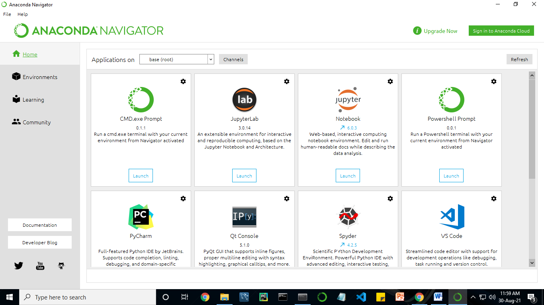

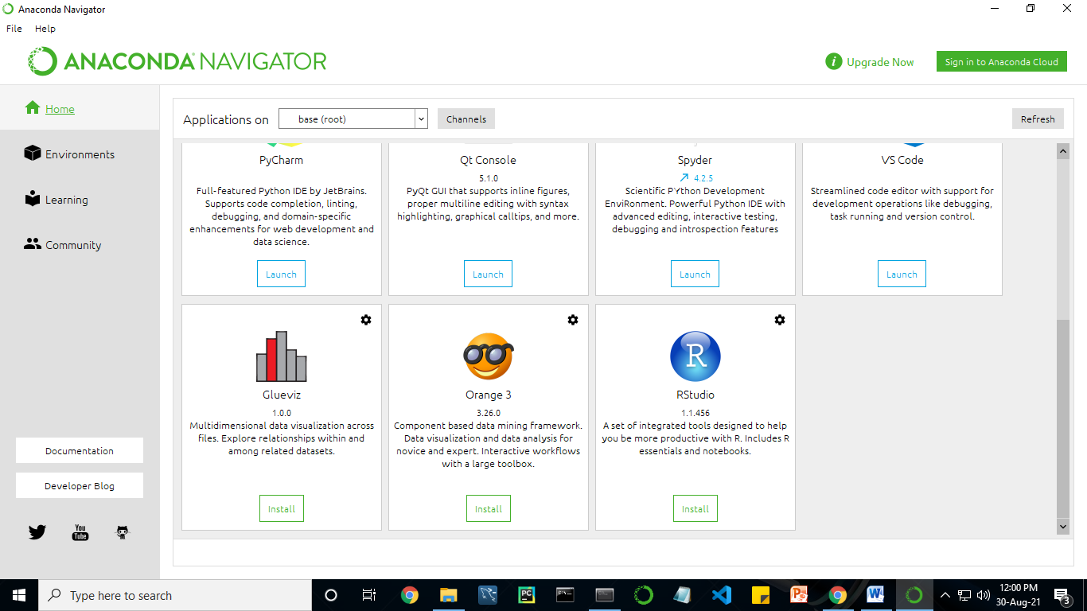

Anaconda Navigator is a desktop graphical user interface (GUI) included in Anaconda distribution.

Navigator allows you to launch common Python programs and easily manage conda packages, environments, and channels without using command-line commands. Navigator can search for packages on Anaconda Cloud or in a local Anaconda Repository.

Anaconda comes with many built-in packages that you can easily find with conda list on your anaconda prompt. As it has lots of packages (many of which are rarely used), it requires lots of space and time as well. If you have enough space, time and do not want to burden yourself to install small utilities like JSON, YAML, you better go for Anaconda.

**Conda :**

Conda is an open source, cross-platform, language-agnostic package manager and environment management systemthat installs, runs, and updates packages and their dependencies. It was created for Python programs, but it can package and distribute software for any language (e.g., R), including multi-language projects. The conda package and environment manager is included in all versions of Anaconda, Miniconda, and Anaconda Repository.

Anaconda is freely available, open source distribution of python and R programming languages which is used for scientific computations. If you are doing any machine learning or deep learning project then this is the best place for you. It consists of many softwares which will help you to build your machine learning project and deep learning project. these softwares have great graphical user interface and these will make your work easy to do. you can also use it to run your python script. These are the software carried by anaconda navigator.

**13.2 JUPYTER NOTEBOOK**

This website acts as “meta” documentation for the Jupyter ecosystem. It has a collection of resources to navigate the tools and communities in this ecosystem, and to help you get started.

Project Jupyter is a project and community whose goal is to "develop open-source software, open-standards, and services for interactive computing across dozens of programming languages". It was spun off from IPython in 2014 by Fernando Perez.

Notebook documents are documents produced by the [Jupyter Notebook App](https://jupyter-notebook-beginner-guide.readthedocs.io/en/latest/what_is_jupyter.html#notebook-app), which contain both computer code (e.g. python) and rich text elements (paragraph, equations, figures, links, etc…). Notebook documents are both human-readable documents containing the analysis description and the results (figures, tables, etc.) as well as executable documents which can be run to perform data analysis.

## Installation: The easiest way to install the Jupyter Notebook App is installing a scientific python distribution which also includes scientific python packages. The most common distribution is called **Anaconda**

# Running the Jupyter Notebook

## Launching Jupyter Notebook App: The [Jupyter Notebook App](https://jupyter-notebook-beginner-guide.readthedocs.io/en/latest/what_is_jupyter.html#notebook-app) can be launched by clicking on the Jupyter Notebook icon installed by Anaconda in the start menu (Windows) or by typing in a terminal (cmd on Windows): “jupyter notebook”

## This will launch a new browser window (or a new tab) showing the [Notebook Dashboard](https://jupyter-notebook-beginner-guide.readthedocs.io/en/latest/what_is_jupyter.html#dashboard), a sort of control panel that allows (among other things) to select which notebook to open.

## When started, the [Jupyter Notebook App](https://jupyter-notebook-beginner-guide.readthedocs.io/en/latest/what_is_jupyter.html#notebook-app) can access only files within its start-up folder (including any sub-folder). No configuration is necessary if you place your notebooks in your home folder or subfolders. Otherwise, you need to choose a [Jupyter Notebook App](https://jupyter-notebook-beginner-guide.readthedocs.io/en/latest/what_is_jupyter.html#notebook-app) start-up folder which will contain all the notebooks.

## Save notebooks: Modifications to the notebooks are automatically saved every few minutes. To avoid modifying the original notebook, make a copy of the notebook document (menu file -> make a copy…) and save the modifications on the copy.

## Executing a notebook: Download the notebook you want to execute and put it in your notebook folder (or a sub-folder of it).

* Launch the jupyter notebook app
* In the [Notebook Dashboard](https://jupyter-notebook-beginner-guide.readthedocs.io/en/latest/what_is_jupyter.html#dashboard) navigate to find the notebook: clicking on its name will open it in a new browser tab.
* Click on the menu Help -> User Interface Tour for an overview of the [Jupyter Notebook App](https://jupyter-notebook-beginner-guide.readthedocs.io/en/latest/what_is_jupyter.html#notebook-app) user interface.
* You can run the notebook document step-by-step (one cell a time) by pressing shift + enter.
* You can run the whole notebook in a single step by clicking on the menu Cell -> Run All.
* To restart the [kernel](https://jupyter-notebook-beginner-guide.readthedocs.io/en/latest/what_is_jupyter.html#kernel) (i.e. the computational engine), click on the menu Kernel -> Restart. This can be useful to start over a computation from scratch (e.g. variables are deleted, open files are closed, etc…).

[**Purpose**](https://www.google.com/search?q=project+jupyter+purpose&sa=X&ved=2ahUKEwin49vtmdjyAhXx4zgGHXSOCuwQ6BMoADAkegQINxAC&cshid=1630307847256010)**:** To support [interactive](https://www.google.com/search?q=interactive&stick=H4sIAAAAAAAAAONgVuLUz9U3MM0uyYpfxMqdmVeSWpSYXJJZlgoApkTFPhsAAAA&sa=X&ved=2ahUKEwin49vtmdjyAhXx4zgGHXSOCuwQmxMoATAkegQINxAD&cshid=1630307847256010) data science and scientific computing across all programming languages.

**File Extension:** An IPYNB file is a notebook document created by Jupyter Notebook, an interactive computational environment that helps scientists manipulate and analyze data using Python.

**JUPYTER Notebook App:**

The Jupyter Notebook App is a server-client application that allows editing and running [notebook documents](https://jupyter-notebook-beginner-guide.readthedocs.io/en/latest/what_is_jupyter.html#notebook-document) via a web browser.

The Jupyter Notebook App can be executed on a local desktop requiring no internet access (as described in this document) or can be installed on a remote server and accessed through the internet.

In addition to displaying/editing/running notebook documents, the Jupyter Notebook App has a “Dashboard” ([Notebook Dashboard](https://jupyter-notebook-beginner-guide.readthedocs.io/en/latest/what_is_jupyter.html#dashboard)), a “control panel” showing local files and allowing to open notebook documents or shutting down their [kernels](https://jupyter-notebook-beginner-guide.readthedocs.io/en/latest/what_is_jupyter.html#kernel).

## [kernel](https://jupyter-notebook-beginner-guide.readthedocs.io/en/latest/what_is_jupyter.html#id7): A notebook kernel is a “computational engine” that executes the code contained in a [Notebook document](https://jupyter-notebook-beginner-guide.readthedocs.io/en/latest/what_is_jupyter.html#notebook-document). The ipython kernel, referenced in this guide, executes python code. Kernels for many other languages exist ([official kernels](http://jupyter.readthedocs.org/en/latest/#kernels)).

When you open a [Notebook document](https://jupyter-notebook-beginner-guide.readthedocs.io/en/latest/what_is_jupyter.html#notebook-document), the associated kernel is automatically launched. When the notebook is executed (either cell-by-cell or with menu Cell -> Run All), the kernel performs the computation and produces the results.

Depending on the type of computations, the kernel may consume significant CPU and RAM. Note that the RAM is not released until the kernel is shut-down

## [Notebook Dashboard](https://jupyter-notebook-beginner-guide.readthedocs.io/en/latest/what_is_jupyter.html#id8): The Notebook Dashboard is the component which is shown first when you launch [Jupyter Notebook App](https://jupyter-notebook-beginner-guide.readthedocs.io/en/latest/what_is_jupyter.html#notebook-app). The Notebook Dashboard is mainly used to open [notebook documents](https://jupyter-notebook-beginner-guide.readthedocs.io/en/latest/what_is_jupyter.html#notebook-document), and to manage the running [kernels](https://jupyter-notebook-beginner-guide.readthedocs.io/en/latest/what_is_jupyter.html#kernel) (visualize and shutdown).

The Notebook Dashboard has other features similar to a file manager, namely navigating folders and renaming/deleting files

**Working Process:**

* Download and install anaconda and get the most useful package for machine learning in Python.
* Load a dataset and understand its structure using statistical summaries and data visualization.
* Machine learning models, pick the best and build confidence that the accuracy is reliable.

Python is a popular and powerful interpreted language. Unlike R, Python is a complete language and platform that you can use for both research and development and developing production systems. There are also a lot of modules and libraries to choose from, providing multiple ways to do each task. It can feel overwhelming.

The best way to get started using Python for machine learning is to complete a project.

* It will force you to install and start the Python interpreter (at the very least).
* It will give you a bird’s eye view of how to step through a small project.
* It will give you confidence, maybe to go on to your own small projects.

When you are applying machine learning to your own datasets, you are working on a project. A machine learning project may not be linear, but it has a number of well-known steps:

* Define Problem.
* Prepare Data.
* Evaluate Algorithms.
* Improve Results.
* Present Results.

The best way to really come to terms with a new platform or tool is to work through a machine learning project end-to-end and cover the key steps. Namely, from loading data, summarizing data, evaluating algorithms and making some predictions.

Here is an overview of what we are going to cover:

1. Installing the Python anaconda platform.
2. Loading the dataset.
3. Summarizing the dataset.
4. Visualizing the dataset.
5. Evaluating some algorithms.
6. Making some predictions.
7. **PYTHON**

**Introduction:**

Python is an [interpreted](https://en.wikipedia.org/wiki/Interpreted_language) [high-level](https://en.wikipedia.org/wiki/High-level_programming_language) [general-purpose programming language](https://en.wikipedia.org/wiki/General-purpose_programming_language). Its design philosophy emphasizes [code readability](https://en.wikipedia.org/wiki/Code_readability) with its use of [significant indentation](https://en.wikipedia.org/wiki/Off-side_rule). Its [language constructs](https://en.wikipedia.org/wiki/Language_construct) as well as its [object-oriented](https://en.wikipedia.org/wiki/Object-oriented_programming) approach aim to help [programmers](https://en.wikipedia.org/wiki/Programmers) write clear, logical code for small and large-scale projects.

Python is [dynamically-typed](https://en.wikipedia.org/wiki/Type_system#DYNAMIC) and [garbage-collected](https://en.wikipedia.org/wiki/Garbage_collection_(computer_science)). It supports multiple [programming paradigms](https://en.wikipedia.org/wiki/Programming_paradigms), including [structured](https://en.wikipedia.org/wiki/Structured_programming) (particularly, [procedural](https://en.wikipedia.org/wiki/Procedural_programming)), object-oriented and [functional programming](https://en.wikipedia.org/wiki/Functional_programming). It is often described as a "batteries included" language due to its comprehensive [standard library](https://en.wikipedia.org/wiki/Standard_library).

[Guido van Rossum](https://en.wikipedia.org/wiki/Guido_van_Rossum) began working on Python in the late 1980s, as a successor to the [ABC programming language](https://en.wikipedia.org/wiki/ABC_(programming_language)), and first released it in 1991 as Python 0.9.0. Python 2.0 was released in 2000 and introduced new features, such as [list comprehensions](https://en.wikipedia.org/wiki/List_comprehension) and a garbage collection system using [reference counting](https://en.wikipedia.org/wiki/Reference_counting). Python 3.0 was released in 2008 and was a major revision of the language that is not completely [backward-compatible](https://en.wikipedia.org/wiki/Backward_compatibility). Python 2 was discontinued with version 2.7.18 in 2020.

Python consistently ranks as one of the most popular programming languages

**History:**

Python was conceived in the late 1980s by [Guido van Rossum](https://en.wikipedia.org/wiki/Guido_van_Rossum) at [Centrum Wiskunde & Informatica](https://en.wikipedia.org/wiki/Centrum_Wiskunde_%26_Informatica) (CWI) in the [Netherlands](https://en.wikipedia.org/wiki/Netherlands) as a successor to [ABC programming language](https://en.wikipedia.org/wiki/ABC_(programming_language)), which was inspired by [SETL](https://en.wikipedia.org/wiki/SETL),  capable of [exception handling](https://en.wikipedia.org/wiki/Exception_handling) and interfacing with the [Amoeba](https://en.wikipedia.org/wiki/Amoeba_(operating_system)) operating system. Its implementation began in December 1989.  Van Rossum shouldered sole responsibility for the project, as the lead developer, until 12 July 2018, when he announced his "permanent vacation" from his responsibilities as Python's [Benevolent Dictator For Life](https://en.wikipedia.org/wiki/Benevolent_Dictator_For_Life), a title the Python community bestowed upon him to reflect his long-term commitment as the project's chief decision-maker. In January 2019, active Python core developers elected a 5-member "Steering Council" to lead the project.  As of 2021, the current members of this council are Barry Warsaw, Brett Cannon, Carol Willing, Thomas Wouters, and Pablo Galindo Salgado.

Python 2.0 was released on 16 October 2000, with many major new features, including a [cycle-detecting](https://en.wikipedia.org/wiki/Cycle_detection) [garbage collector](https://en.wikipedia.org/wiki/Garbage_collection_(computer_science)) and support for [Unicode](https://en.wikipedia.org/wiki/Unicode).

Python 3.0 was released on 3 December 2008. It was a major revision of the language that is not completely [backward-compatible](https://en.wikipedia.org/wiki/Backward_compatibility). Many of its major features were [backported](https://en.wikipedia.org/wiki/Backporting) to Python 2.6.x and 2.7.x version series. Releases of Python 3 include the 2 to 3 utility, which automates (at least partially) the translation of Python 2 code to Python 3.

Python 2.7's [end-of-life](https://en.wikipedia.org/wiki/End-of-life_(product)) date was initially set at 2015 then postponed to 2020 out of concern that a large body of existing code could not easily be forward-ported to Python 3. No more security patches or other improvements will be released for it. With Python 2's [end-of-life](https://en.wikipedia.org/wiki/End-of-life_(product)), only Python 3.6.x  and later are supported.

Python 3.9.2 and 3.8.8 were expeditedas all versions of Python (including 2.7) had security issues, leading to possible [remote code execution](https://en.wikipedia.org/wiki/Remote_code_execution) and [web cache poisoning](https://en.wikipedia.org/wiki/Cache_poisoning).

**Design Philosophy & Feature**

Python is a [multi-paradigm programming language](https://en.wikipedia.org/wiki/Multi-paradigm_programming_language). [Object-oriented programming](https://en.wikipedia.org/wiki/Object-oriented_programming) and [structured programming](https://en.wikipedia.org/wiki/Structured_programming) are fully supported, and many of its features support functional programming and [aspect-oriented programming](https://en.wikipedia.org/wiki/Aspect-oriented_programming) (including by [meta-programming](https://en.wikipedia.org/wiki/Metaprogramming) and [meta-objects](https://en.wikipedia.org/wiki/Metaobject) (magic methods)). Many other paradigms are supported via extensions, including [design by contract](https://en.wikipedia.org/wiki/Design_by_contract) and [logic programming](https://en.wikipedia.org/wiki/Logic_programming).

Python uses [dynamic typing](https://en.wikipedia.org/wiki/Dynamic_typing) and a combination of [reference counting](https://en.wikipedia.org/wiki/Reference_counting) and a cycle-detecting garbage collector for [memory management](https://en.wikipedia.org/wiki/Memory_management). It also features dynamic [name resolution](https://en.wikipedia.org/wiki/Name_resolution_(programming_languages)) ([late binding](https://en.wikipedia.org/wiki/Late_binding)), which binds method and variable names during program execution.

Python's design offers some support for functional programming in the [Lisp](https://en.wikipedia.org/wiki/Lisp_(programming_language)) tradition. It has filter, map and reduce functions;  [list comprehensions](https://en.wikipedia.org/wiki/List_comprehension), [dictionaries](https://en.wikipedia.org/wiki/Associative_array), sets, and [generator](https://en.wikipedia.org/wiki/Generator_(computer_programming)) expressions. The standard library has two modules (itertools and functools) that implement functional tools borrowed from [Haskell](https://en.wikipedia.org/wiki/Haskell_(programming_language)) and [Standard ML](https://en.wikipedia.org/wiki/Standard_ML).

The language's core philosophy is summarized in the document The [Zen of Python](https://en.wikipedia.org/wiki/Zen_of_Python) (PEP 20), which includes [aphorisms](https://en.wikipedia.org/wiki/Aphorism) such as:

* Beautiful is better than ugly.
* Explicit is better than implicit.
* Simple is better than complex.
* Complex is better than complicated.
* Readability counts.

Rather than having all of its functionality built into its core, Python was designed to be highly [extensible](https://en.wikipedia.org/wiki/Extensibility) (with modules). This compact modularity has made it particularly popular as a means of adding programmable interfaces to existing applications. Van Rossum's vision of a small core language with a large standard library and easily extensible interpreter stemmed from his frustrations with [ABC](https://en.wikipedia.org/wiki/ABC_(programming_language)), which espoused the opposite approach.

Python strives for a simpler, less-cluttered syntax and grammar while giving developers a choice in their coding methodology. In contrast to [Perl](https://en.wikipedia.org/wiki/Perl)'s "[there is more than one way to do it](https://en.wikipedia.org/wiki/There_is_more_than_one_way_to_do_it)" motto, Python embraces a "there should be one— and preferably only one —obvious way to do it" design philosophy. [Alex Martelli](https://en.wikipedia.org/wiki/Alex_Martelli), a [Fellow](https://en.wikipedia.org/wiki/Fellow) at the [Python Software Foundation](https://en.wikipedia.org/wiki/Python_Software_Foundation) and Python book author, writes that "To describe something as 'clever' is not considered a compliment in the Python culture."

Python's developers strive to avoid [premature optimization](https://en.wikipedia.org/wiki/Premature_optimization), and reject patches to non-critical parts of the [C-Python](https://en.wikipedia.org/wiki/CPython) reference implementation that would offer marginal increases in speed at the cost of clarity. When speed is important, a Python programmer can move time-critical functions to extension modules written in languages such as C, or use [PyPy](https://en.wikipedia.org/wiki/PyPy), a [just-in-time compiler](https://en.wikipedia.org/wiki/Just-in-time_compilation). [Cython](https://en.wikipedia.org/wiki/Cython) is also available, which translates a Python script into C and makes direct C-level API calls into the Python interpreter.

Python's developers aim to keep the language fun to use. This is reflected in its name a tribute to the British comedy group [Monty Python](https://en.wikipedia.org/wiki/Monty_Python) and in occasionally playful approaches to tutorials and reference materials, such as examples that refer to spam and eggs (a reference to a [Monty Python sketch](https://en.wikipedia.org/wiki/Spam_(Monty_Python))) instead of the standard [foo and bar](https://en.wikipedia.org/wiki/Foobar).

A common [neologism](https://en.wikipedia.org/wiki/Neologism) in the Python community is pythonic, which can have a wide range of meanings related to program style. To say that code is pythonic is to say that it uses Python idioms well, that it is natural or shows fluency in the language, that it conforms with Python's minimalist philosophy and emphasis on readability. In contrast, code that is difficult to understand or reads like a rough transcription from another programming language is called unpythonic.

Users and admirers of Python, especially those considered knowledgeable or experienced, are often referred to as Pythonistas

**Syntax and Semantics :**

Python is meant to be an easily readable language. Its formatting is visually uncluttered, and it often uses English keywords where other languages use punctuation. Unlike many other languages, it does not use [curly brackets](https://en.wikipedia.org/wiki/Curly_bracket_programming_language) to delimit blocks, and semicolons after statements are allowed but are rarely, if ever, used. It has fewer syntactic exceptions and special cases than [C](https://en.wikipedia.org/wiki/C_(programming_language)) or [Pascal](https://en.wikipedia.org/wiki/Pascal_(programming_language)).

**Indentation :**

Main article: [Python syntax and semantics & Indentation](https://en.wikipedia.org/wiki/Python_syntax_and_semantics#Indentation)

Python uses [whitespace](https://en.wikipedia.org/wiki/Whitespace_character) indentation, rather than [curly brackets](https://en.wikipedia.org/wiki/Curly_bracket_programming_language) or keywords, to delimit [blocks](https://en.wikipedia.org/wiki/Block_(programming)). An increase in indentation comes after certain statements; a decrease in indentation signifies the end of the current block. Thus, the program's visual structure accurately represents the program's semantic structure. This feature is sometimes termed the [off-side rule](https://en.wikipedia.org/wiki/Off-side_rule), which some other languages share, but in most languages indentation does not have any semantic meaning. The recommended indent size is four spaces.

**Statements and control flow :**

Python's [statements](https://en.wikipedia.org/wiki/Statement_(computer_science)) include:

* The [assignment](https://en.wikipedia.org/wiki/Assignment_(computer_science)) statement, using a single equals sign =.
* The if statement, which conditionally executes a block of code, along with else and elif (a contraction of else-if).
* The for statement, which iterates over an iterable object, capturing each element to a local variable for use by the attached block.
* The while statement, which executes a block of code as long as its condition is true.
* The Try statement, which allows exceptions raised in its attached code block to be caught and handled by except clauses; it also ensures that clean-up code in a finally block will always be run regardless of how the block exits.
* The raise statement, used to raise a specified exception or re-raise a caught exception.
* The class statement, which executes a block of code and attaches its local namespace to a [class](https://en.wikipedia.org/wiki/Class_(computer_science)), for use in object-oriented programming.
* The def statement, which defines a [function](https://en.wikipedia.org/wiki/Function_(computing)) or [method](https://en.wikipedia.org/wiki/Method_(computing)).
* The with statement, which encloses a code block within a context manager (for example, acquiring a [lock](https://en.wikipedia.org/wiki/Lock_(computer_science)) before the block of code is run and releasing the lock afterwards, or opening a [file](https://en.wikipedia.org/wiki/Computer_file) and then closing it), allowing [resource-acquisition-is-initialization](https://en.wikipedia.org/wiki/Resource_acquisition_is_initialization) (RAII) - like behavior and replaces a common try/finally idiom.
* The break statement, exits from a loop.
* The continue statement, skips this iteration and continues with the next item.
* The del statement, removes a variable, which means the reference from the name to the value is deleted and trying to use that variable will cause an error. A deleted variable can be reassigned.
* The pass statement, which serves as a [NOP](https://en.wikipedia.org/wiki/NOP_(code)). It is syntactically needed to create an empty code block.
* The assert statement, used during debugging to check for conditions that should apply.
* The yield statement, which returns a value from a [generator](https://en.wikipedia.org/wiki/Generator_(computer_programming)#Python) function and yield is also an operator. This form is used to implement [co-routines](https://en.wikipedia.org/wiki/Coroutine).
* The return statement, used to return a value from a function.
* The import statement, which is used to import modules whose functions or variables can be used in the current program.

The assignment statement (=) operates by binding a name as a [reference](https://en.wikipedia.org/wiki/Pointer_(computer_programming)) to a separate, dynamically-allocated [object](https://en.wikipedia.org/wiki/Object_(computer_science)). Variables may be subsequently rebound at any time to any object. In Python, a variable name is a generic reference holder and does not have a fixed [data type](https://en.wikipedia.org/wiki/Type_system) associated with it. However, at a given time, a variable will refer to some object, which will have a type. This is referred to as [dynamic typing](https://en.wikipedia.org/wiki/Dynamic_type) and is contrasted with [statically-typed](https://en.wikipedia.org/wiki/Statically-typed) programming languages, where each variable may only contain values of a certain type.

Python does not support [tail call](https://en.wikipedia.org/wiki/Tail_call) optimization or [first-class continuations](https://en.wikipedia.org/wiki/First-class_continuations), and, according to Guido van Rossum, it never will.[[80]](https://en.wikipedia.org/wiki/Python_(programming_language)#cite_note-AutoNT-55-80)[[81]](https://en.wikipedia.org/wiki/Python_(programming_language)#cite_note-AutoNT-56-81) However, better support for [co-routine](https://en.wikipedia.org/wiki/Coroutine)-like functionality is provided, by extending Python's [generators](https://en.wikipedia.org/wiki/Generator_(computer_programming)). Before 2.5, generators were [lazy](https://en.wikipedia.org/wiki/Lazy_evaluation) [iterators](https://en.wikipedia.org/wiki/Iterator); information was passed uni-directionally out of the generator. From Python 2.5, it is possible to pass information back into a generator function, and from Python 3.3, the information can be passed through multiple stack levels.

**Expressions** :

Some Python [expressions](https://en.wikipedia.org/wiki/Expression_(computer_science)) are similar to those found in languages such as C and [Java](https://en.wikipedia.org/wiki/Java_(programming_language)), while some are not:

* Addition, subtraction, and multiplication are the same, but the behavior of division differs. There are two types of divisions in Python. They are floor division (or integer division) // and floating-point/division. Python also uses the ** operator for exponentiation.
* From Python 3.5, the new @ infix operator was introduced. It is intended to be used by libraries such as [NumPy](https://en.wikipedia.org/wiki/NumPy) for [matrix multiplication](https://en.wikipedia.org/wiki/Matrix_multiplication).
* From Python 3.8, the syntax :=, called the 'walrus operator' was introduced. It assigns values to variables as part of a larger expression.
* In Python, == compares by value, versus Java, which compares numerics by value and objects by reference. (Value comparisons in Java on objects can be performed with the equals() method.) Python's is operator may be used to compare object identities (comparison by reference). In Python, comparisons may be chained, for example A<=B<=C.
* Python uses the words and, or, not for or its boolean operators rather than the symbolic &&, ||, ! used in Java and C.
* Python has a type of expression termed a [list comprehension](https://en.wikipedia.org/wiki/List_comprehension#Python) as well as a more general expression termed a [generator](https://en.wikipedia.org/wiki/Generator_(computer_programming)) expression.
* [Anonymous functions](https://en.wikipedia.org/wiki/Anonymous_function) are implemented using [lambda expressions](https://en.wikipedia.org/wiki/Lambda_(programming)); however, these are limited in that the body can only be one expression.
* Conditional expressions in Python are written as x if c else y (different in order of operands from the c ? x : y operator common to many other languages).
* Python makes a distinction between [lists](https://en.wikipedia.org/wiki/List_(computer_science)) and [tuples](https://en.wikipedia.org/wiki/Tuple). Lists are written as [1, 2, 3], are mutable, and cannot be used as the keys of dictionaries (dictionary keys must be [immutable](https://en.wikipedia.org/wiki/Immutable) in Python). Tuples are written as (1, 2, 3), are immutable and thus can be used as the keys of dictionaries, provided all elements of the tuple are immutable. The + operator can be used to concatenate two tuples, which does not directly modify their contents, but rather produces a new tuple containing the elements of both provided tuples. Thus, given the variable t initially equal to (1, 2, 3), executing t = t + (4, 5) first evaluates t + (4, 5), which yields (1, 2, 3, 4, 5), which is then assigned back to t, thereby effectively "modifying the contents" of t, while conforming to the immutable nature of tuple objects. Parentheses are optional for tuples in unambiguous contexts.
* Python features sequence unpacking wherein multiple expressions, each evaluating to anything that can be assigned to (a variable, a writable property, etc.), are associated in an identical manner to that forming tuple literals and, as a whole, are put on the left-hand side of the equal sign in an assignment statement. The statement expects an iterable object on the right-hand side of the equal sign that produces the same number of values as the provided writable expressions when iterated through and will iterate through it, assigning each of the produced values to the corresponding expression on the left.
* Python has a "string format" operator %. This functions analogously ton printf format strings in C, e.g. “spam=%s eggs=%d” % (“blah”,2) evaluates to “spam=blah eggs=2”. In Python 3 and 2.6+, this was supplemented by the format() method of the str class, e.g. “spam={0} eggs={1}”.format(“blah”,2). Python 3.6 added "f-strings": blah = “blah”; eggs = 2; f‘spam={blah} eggs={eggs}’
* Strings in Python can be [concatenated](https://en.wikipedia.org/wiki/Concatenation), by "adding" them (same operator as for adding integers and floats). E.g. “spam” + “eggs” returns “spameggs”. Even if your strings contain numbers, they are still added as strings rather than integers. E.g. “2” + “2” returns “2”.
* Python has various kinds of [string literals](https://en.wikipedia.org/wiki/String_literal):
  + Strings delimited by single or double quote marks. Unlike in [Unix shells](https://en.wikipedia.org/wiki/Unix_shell), [Perl](https://en.wikipedia.org/wiki/Perl) and Perl-influenced languages, single quote marks and double quote marks function identically. Both kinds of string use the backslash (\) as an [escape character](https://en.wikipedia.org/wiki/Escape_character). [String interpolation](https://en.wikipedia.org/wiki/String_interpolation) became available in Python 3.6 as "formatted string literals".
  + Triple-quoted strings, which begin and end with a series of three single or double quote marks. They may span multiple lines and function like [here documents](https://en.wikipedia.org/wiki/Here_document) in shells, Perl and [Ruby](https://en.wikipedia.org/wiki/Ruby_(programming_language)).
  + [Raw string](https://en.wikipedia.org/wiki/Raw_string) varieties, denoted by prefixing the string literal with an r. Escape sequences are not interpreted; hence raw strings are useful where literal backslashes are common, such as [regular expressions](https://en.wikipedia.org/wiki/Regular_expression) and [Windows](https://en.wikipedia.org/wiki/Microsoft_Windows)-style paths. Compare "@-quoting" in [C#](https://en.wikipedia.org/wiki/C_Sharp_(programming_language)).
* Python has [array index](https://en.wikipedia.org/wiki/Array_index) and [array slicing](https://en.wikipedia.org/wiki/Array_slicing) expressions on lists, denoted as a[Key], a[start:stop] or a[start:stop:step]. Indexes are [zero-based](https://en.wikipedia.org/wiki/Zero-based_numbering), and negative indexes are relative to the end. Slices take elements from the start index up to, but not including, the stop index. The third slice parameter, called step or stride, allows elements to be skipped and reversed. Slice indexes may be omitted, for example a[:] returns a copy of the entire list. Each element of a slice is a [shallow copy](https://en.wikipedia.org/wiki/Shallow_copy).

In Python, a distinction between expressions and statements is rigidly enforced, in contrast to languages such as [Common Lisp](https://en.wikipedia.org/wiki/Common_Lisp), [Scheme](https://en.wikipedia.org/wiki/Scheme_(programming_language)), or [Ruby](https://en.wikipedia.org/wiki/Ruby_(programming_language)). This leads to duplicating some functionality. For example:

* [List comprehensions](https://en.wikipedia.org/wiki/List_comprehensions) vs. for-loops
* [Conditional](https://en.wikipedia.org/wiki/Conditional_(programming)) expressions vs. if blocks
* The eval() vs. exec() built-in functions (in Python 2, exec is a statement); the former is for expressions, the latter is for statements.

Statements cannot be a part of an expression, so list and other comprehensions or [lambda expressions](https://en.wikipedia.org/wiki/Lambda_(programming)), all being expressions, cannot contain statements. A particular case of this is that an assignment statement such as a=1 cannot form part of the conditional expression of a conditional statement. This has the advantage of avoiding a classic C error of mistaking an assignment operator = for an equality operator == in conditions: if (c==1) {…} is syntactically valid (but probably unintended) C code but if c=1: … causes a syntax error in Python.

**Methods** :

[Methods](https://en.wikipedia.org/wiki/Method_(programming)) on objects are [functions](https://en.wikipedia.org/wiki/Function_(programming)) attached to the object's class; the syntax instance.method(argument) is, for normal methods and functions, [syntactic sugar](https://en.wikipedia.org/wiki/Syntactic_sugar) for Class.method(instance, argument). Python methods have an explicit self parameter access [instance data](https://en.wikipedia.org/wiki/Instance_data), in contrast to the implicit self (or this) in some other object-oriented programming languages (e.g., [C++](https://en.wikipedia.org/wiki/C%2B%2B), Java, [Objective-C](https://en.wikipedia.org/wiki/Objective-C), or [Ruby](https://en.wikipedia.org/wiki/Ruby_(programming_language))). Apart from this Python also provides methods, sometimes called d-under methods due to their names beginning and ending with double-underscores, to extend the functionality of custom class to support native functions such as print, length, comparison, support for arithmetic operations, type conversion, and many more.

### Typing :

Python uses duck typing and has typed objects but untyped variable names. Type constraints are not checked at compile time; rather, operations on an object may fail, signifying that the given object is not of a suitable type. Despite being dynamically-typed, Python is strongly-typed, forbidding operations that are not well-defined (for example, adding a number to a string) rather than silently attempting to make sense of them.

Python allows programmers to define their own types using [classes](https://en.wikipedia.org/wiki/Class_(computer_science)), which are most often used for object-oriented programming. New instances of classes are constructed by calling the class (for example, SpamClass() or EggsClass()), and the classes are instances of the metaclass type (itself an instance of itself), allowing meta-programming and reflection.

Before version 3.0, Python had two kinds of classes: old-style and new-style.The syntax of both styles is the same, the difference being whether the class object is inherited from, directly or indirectly (all new-style classes inherit from object and are instances of type). In versions of Python 2 from Python 2.2 onwards, both kinds of classes can be used. Old-style classes were eliminated in Python 3.0.

The long-term plan is to support gradual typing and from Python 3.5, the syntax of the language allows specifying static types but they are not checked in the default implementation, CPython. An experimental optional static type checker named mypy supports compile-time type checking.

1. **System Architecture**

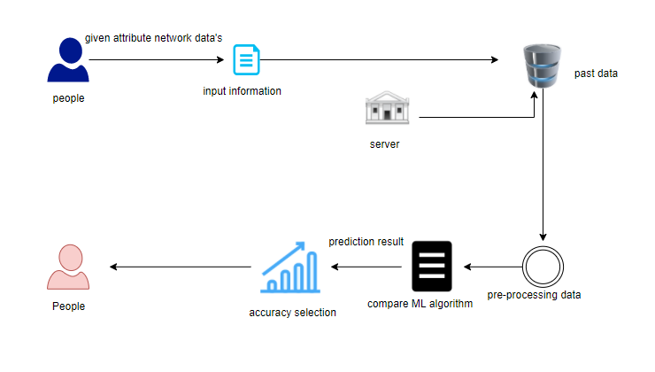

1. **Work flow diagram:**

Source Data

Data Processing and Cleaning

Training Dataset

Testing Dataset

Best Model by Accuracy

Classification ML Algorithms

Finding network attack Website

Workflow Diagram

1. **Use Case Diagram**

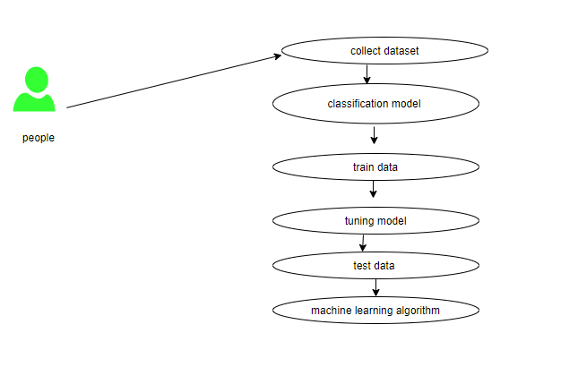

Use case diagrams are considered for high level requirement analysis of a system. So when the requirements of a system are analyzed the functionalities are captured in use cases. So, it can say that uses cases are nothing but the system functionalities written in an organized manner.

1. **Class Diagram**:

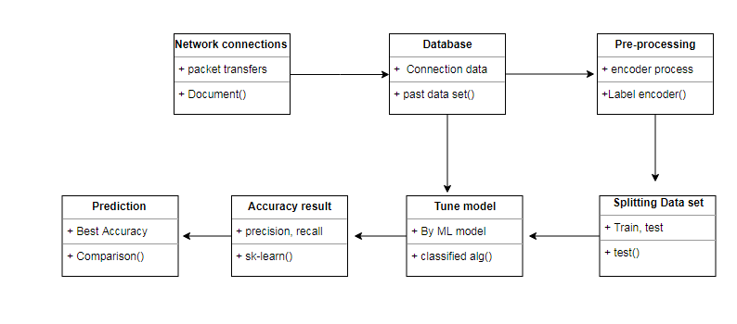

Class diagram is basically a graphical representation of the static view of the system and represents different aspects of the application. So a collection of class diagrams represent the whole system. The name of the class diagram should be meaningful to describe the aspect of the system. Each element and their relationships should be identified in advance Responsibility (attributes and methods) of each class should be clearly identified for each class minimum number of properties should be specified and because, unnecessary properties will make the diagram complicated. Use notes whenever required to describe some aspect of the diagram and at the end of the drawing it should be understandable to the developer/coder. Finally, before making the final version, the diagram should be drawn on plain paper and rework as many times as possible to make it correct.

1. **Activity Diagram**:

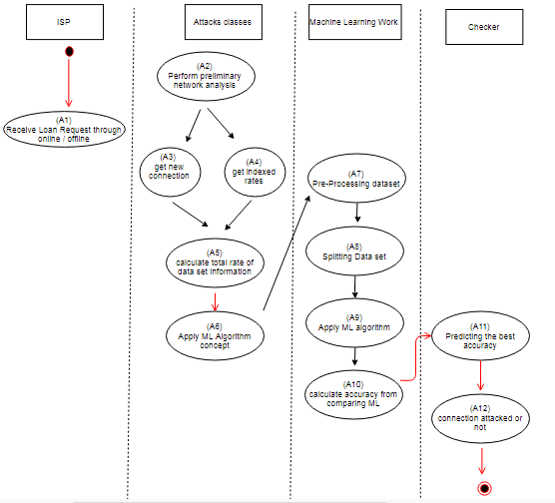

Activity is a particular operation of the system. Activity diagrams are not only used for visualizing dynamic nature of a system but they are also used to construct the executable system by using forward and reverse engineering techniques. The only missing thing in activity diagram is the message part. It does not show any message flow from one activity to another. Activity diagram is some time considered as the flow chart. Although the diagrams looks like a flow chart but it is not. It shows different flow like parallel, branched, concurrent and single.

1. **Sequence Diagram**:

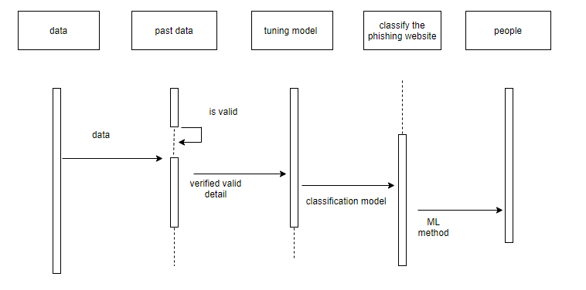

Sequence diagrams model the flow of logic within your system in a visual manner, enabling you both to document and validate your logic, and are commonly used for both analysis and design purposes. Sequence diagrams are the most popular UML artifact for dynamic modeling, which focuses on identifying the behavior within your system. Other dynamic modeling techniques include [activity diagramming](http://agilemodeling.com/artifacts/activityDiagram.htm), [communication diagramming](http://agilemodeling.com/artifacts/communicationDiagram.htm), [timing diagramming](http://agilemodeling.com/artifacts/timingDiagram.htm), and [interaction overview diagramming](http://agilemodeling.com/artifacts/interactionOverviewDiagram.htm). Sequence diagrams, along with [class diagrams](http://agilemodeling.com/artifacts/classDiagram.htm) and [physical data models](http://agiledata.org/essays/dataModeling101.html) are in my opinion the most important design-level models for modern business application development.

1. **Entity Relationship Diagram (ERD)**

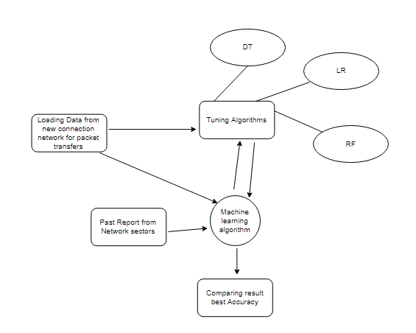

An entity relationship diagram (ERD), also known as an entity relationship model, is a graphical representation of an information system that depicts the relationships among people, objects, places, concepts or events within that system. An ERD is a [data modeling](https://searchdatamanagement.techtarget.com/definition/data-modeling) technique that can help define business processes and be used as the foundation for a [relational database](https://searchdatamanagement.techtarget.com/definition/relational-database). Entity relationship diagrams provide a visual starting point for database design that can also be used to help determine information system requirements throughout an organization. After a relational database is rolled out, an ERD can still serve as a referral point, should any debugging or business process re-engineering be needed later.

1. **Module Description:**

* Data validation process by each attack (Module-01)
* Performance measurements of DoS attacks (Module-02)
* Performance measurements of R2L attacks (Module-03)
* Performance measurements of U2R attacks (Module-04)
* Performance measurements of Probe attacks (Module-05)
* Performance measurements of overall network attacks (Module-06)
* GUI based prediction results of Network attacks (Module-07)

**Module-01:**

**Variable Identification Process / data validation process:**

Validation techniques in machine learning are used to get the error rate of the Machine Learning (ML) model, which can be considered as close to the true error rate of the dataset. If the data volume is large enough to be representative of the population, you may not need the validation techniques. However, in real-world scenarios, to work with samples of data that may not be a true representative of the population of given dataset. To finding the missing value, duplicate value and description of data type whether it is float variable or integer. The sample of data used to provide an unbiased evaluation of a model fit on the training dataset while tuning model hyper parameters. The evaluation becomes more biased as skill on the validation dataset is incorporated into the model configuration. The validation set is used to evaluate a given model, but this is for frequent evaluation. It as machine learning engineers uses this data to fine-tune the model hyper parameters. Data collection, data analysis, and the process of addressing data content, quality, and structure can add up to a time-consuming to-do list. During the process of data identification, it helps to understand your data and its properties; this knowledge will help you choose which algorithm to use to build your model. For example, time series data can be analyzed by regression algorithms; classification algorithms can be used to analyze discrete data. (For example to show the data type format of given dataset)

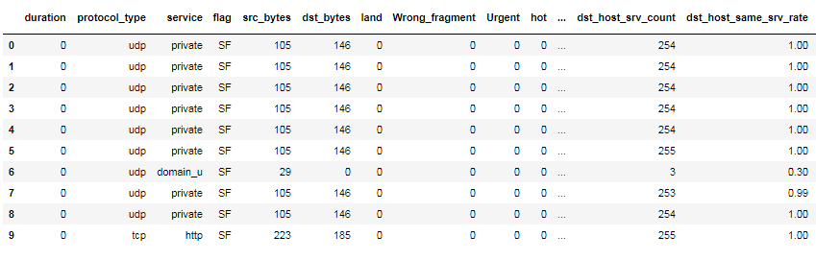

Given data frame

**Data Validation/ Cleaning/Preparing Process:**

Importing the library packages with loading given dataset. To analyzing the variable identification by data shape, data type and evaluating the missing values, duplicate values. A validation dataset is a sample of data held back from training your model that is used to give an estimate of model skill while tuning model's and procedures that you can use to make the best use of validation and test datasets when evaluating your models. Data cleaning / preparing by rename the given dataset and drop the column etc. to analyze the uni-variate, bi-variate and multi-variate process. The steps and techniques for data cleaning will vary from dataset to dataset. The primary goal of data cleaning is to detect and remove errors and anomalies to increase the value of data in analytics and decision making.

**Exploration data analysis of visualization:**

Data visualization is an important skill in applied statistics and machine learning. Statistics does indeed focus on quantitative descriptions and estimations of data. Data visualization provides an important suite of tools for gaining a qualitative understanding. This can be helpful when exploring and getting to know a dataset and can help with identifying patterns, corrupt data, outliers, and much more. With a little domain knowledge, data visualizations can be used to express and demonstrate key relationships in plots and charts that are more visceral and stakeholders than measures of association or significance. Data visualization and exploratory data analysis are whole fields themselves and it will recommend a deeper dive into some the books mentioned at the end.

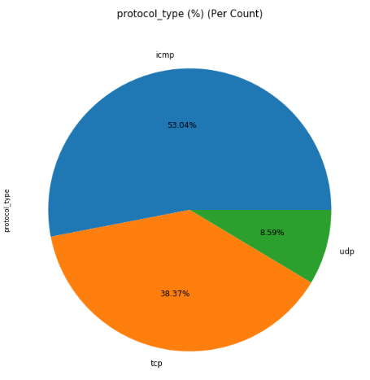

Percentage level of protocol type

Sometimes data does not make sense until it can look at in a visual form, such as with charts and plots. Being able to quickly visualize of data samples and others is an important skill both in applied statistics and in applied machine learning. It will discover the many types of plots that you will need to know when visualizing data in Python and how to use them to better understand your own data.

* How to chart time series data with line plots and categorical quantities with bar charts.
* How to summarize data distributions with histograms and box plots.
* How to summarize the relationship between variables with scatter plots.

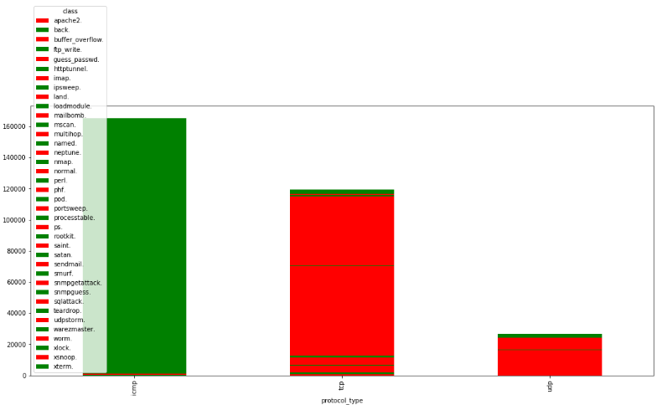

Comparison of service type and protocol type

Many machine learning algorithms are sensitive to the range and distribution of attribute values in the input data. Outliers in input data can skew and mislead the training process of machine learning algorithms resulting in longer training times, less accurate models and ultimately poorer results.

Even before predictive models are prepared on training data, outliers can result in misleading representations and in turn misleading interpretations of collected data. Outliers can skew the summary distribution of attribute values in descriptive statistics like mean and standard deviation and in plots such as histograms and scatterplots, compressing the body of the data. Finally, outliers can represent examples of data instances that are relevant to the problem such as anomalies in the case of fraud detection and computer security.

It couldn’t fit the model on the training data and can’t say that the model will work accurately for the real data. For this, we must assure that our model got the correct patterns from the data, and it is not getting up too much noise. Cross-validation is a technique in which we train our model using the subset of the data-set and then evaluate using the complementary subset of the data-set.

The three steps involved in cross-validation are as follows:

1. Reserve some portion of sample data-set.
2. Using the rest data-set train the model.
3. Test the model using the reserve portion of the data-set.

**Advantages of train/test split:**

1. This runs K times faster than Leave One Out cross-validation because K-fold cross-validation repeats the train/test split K-times.
2. Simpler to examine the detailed results of the testing process.

Advantages of cross-validation:

1. More accurate estimate of out-of-sample accuracy.
2. More “efficient” use of data as every observation is used for both training and testing.

**Data Pre-processing:**

Pre-processing refers to the transformations applied to our data before feeding it to the algorithm. Data Preprocessing is a technique that is used to convert the raw data into a clean data set. In other words, whenever the data is gathered from different sources it is collected in raw format which is not feasible for the analysis. To achieving better results from the applied model in Machine Learning method of the data has to be in a proper manner. Some specified Machine Learning model needs information in a specified format; for example, Random Forest algorithm does not support null values. Therefore, to execute random forest algorithm null values have to be managed from the original raw data set. And another aspect is that data set should be formatted in such a way that more than one Machine Learning and Deep Learning algorithms are executed in given dataset.

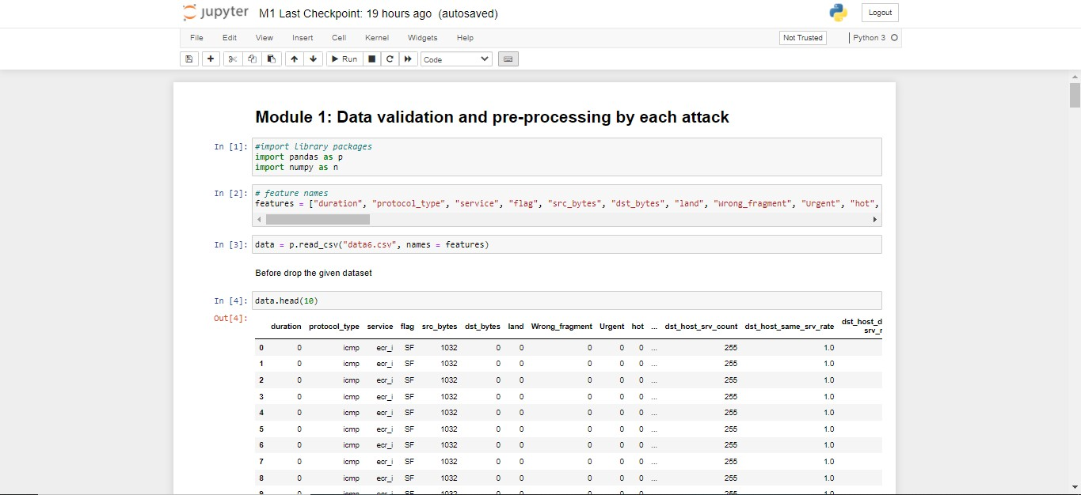

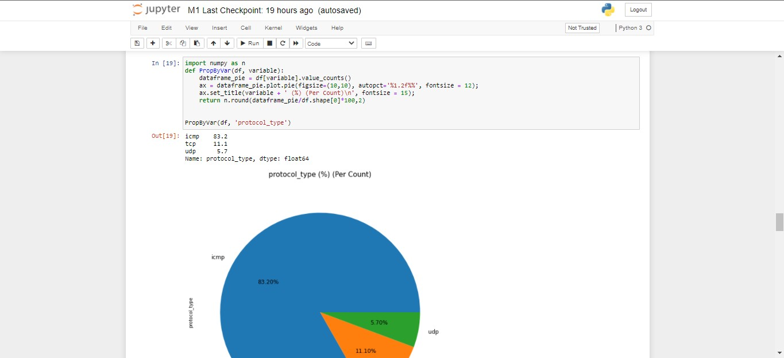

**MODULE DIAGRAM**

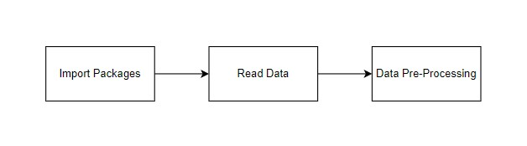

**GIVEN INPUT EXPECTED OUTPUT**

**input :** data

**output :** removing noisy data

**MODULE DIAGRAM**

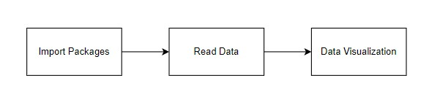

**GIVEN INPUT EXPECTED OUTPUT**

**input :** data

**output :** visualized data

**Module-02:**

In [computing](https://en.wikipedia.org/wiki/Computing), a denial-of-service attack (DoS attack) is a [cyber-attack](https://en.wikipedia.org/wiki/Cyber-attack) in which the perpetrator seeks to make a machine or network resource unavailable to its intended [users](https://en.wikipedia.org/wiki/User_(computing)) by temporarily or indefinitely disrupting [services](https://en.wikipedia.org/wiki/Network_service) of a [host](https://en.wikipedia.org/wiki/Host_(network)) connected to the [Internet](https://en.wikipedia.org/wiki/Internet). Denial of service is typically accomplished by flooding the targeted machine or resource with superfluous requests in an attempt to overload systems and prevent some or all legitimate requests from being fulfilled. In a distributed denial-of-service attack (DDoS attack), the incoming traffic flooding the victim originates from many different sources. This effectively makes it impossible to stop the attack simply by blocking a single source. A DoS or DDoS attack is analogous to a group of people crowding the entry door of a shop, making it hard for legitimate customers to enter, disrupting trade.

A distributed denial-of-service (DDoS) is a large-scale DoS attack where the perpetrator uses more than one unique [IP address](https://en.wikipedia.org/wiki/IP_address), often thousands of them.[[10]](https://en.wikipedia.org/wiki/Denial-of-service_attack#cite_note-10) A distributed denial of service attack typically involves more than around 3–5 nodes on different networks; fewer nodes may qualify as a DoS attack but is not a DDoS attack.[[11]](https://en.wikipedia.org/wiki/Denial-of-service_attack#cite_note-Infosec7Layer-11)[[12]](https://en.wikipedia.org/wiki/Denial-of-service_attack#cite_note-12) Since the incoming traffic flooding the victim originates from different sources, it may be impossible to stop the attack simply by using [ingress filtering](https://en.wikipedia.org/wiki/Ingress_filtering). It also makes it difficult to distinguish legitimate user traffic from attack traffic when spread across multiple points of origin. As an alternative or augmentation of a DDoS, attacks may involve forging of IP sender addresses ([IP address spoofing](https://en.wikipedia.org/wiki/IP_address_spoofing)) further complicating identifying and defeating the attack. An application layer DDoS attack (sometimes referred to as layer 7 DDoS attack) is a form of DDoS attack where attackers target [application-layer](https://en.wikipedia.org/wiki/Application_layer) processes. The attack over-exercises specific functions or features of a website with the intention to disable those functions or features. This application-layer attack is different from an entire network attack, and is often used against financial institutions to distract IT and security personnel from security breaches.

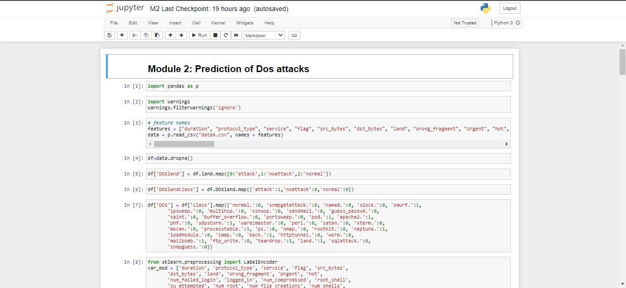

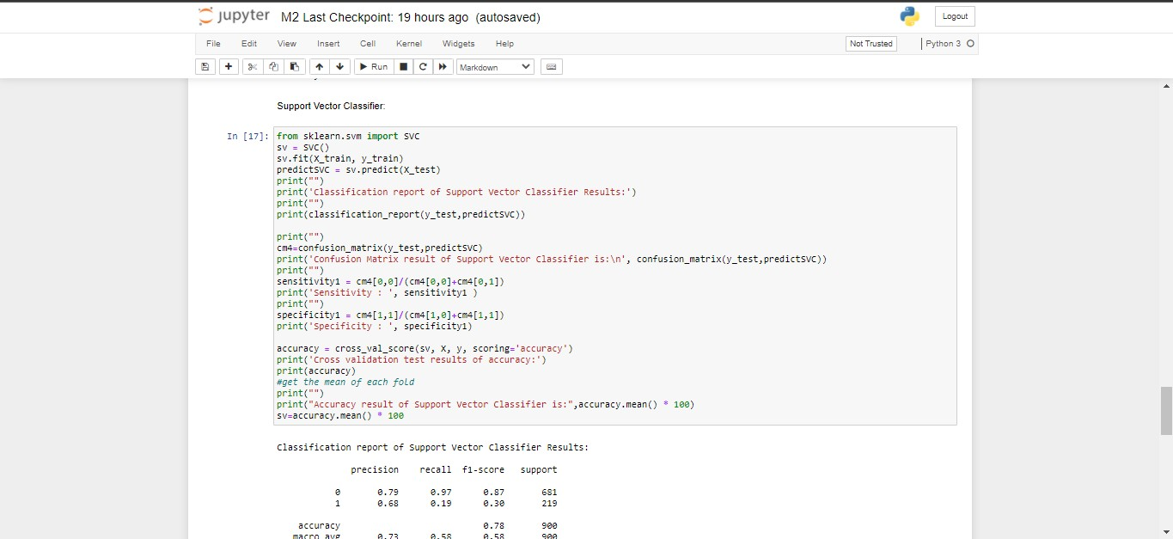

**MODULE DIAGRAM**

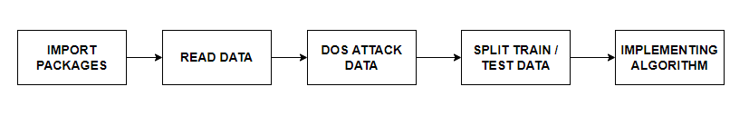

**GIVEN INPUT EXPECTED OUTPUT**

**input :** data

**output :** getting accuracy

**Module-03:**

Now-a-days, it is very important to maintain a high level security to ensure safe and trusted communication of information between various organizations. But secured data communication over internet and any other network is always under threat of intrusions and misuses. To control these threats, recognition of attacks is critical matter. Probing, Denial of Service (DoS), Remote To User (R2L) attacks is some of the attacks which affect large number of computers in the world daily. Detection of these attacks and prevention of computers from it is a major research topic for researchers throughout the world.

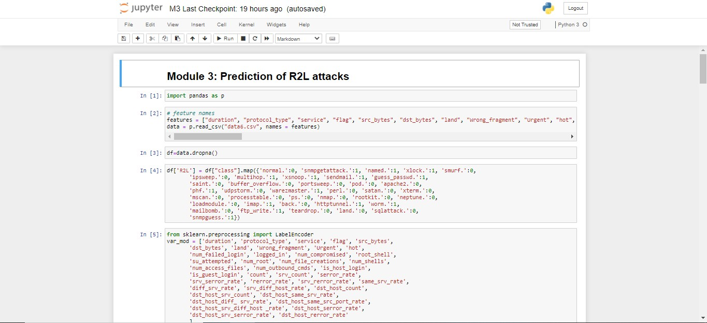

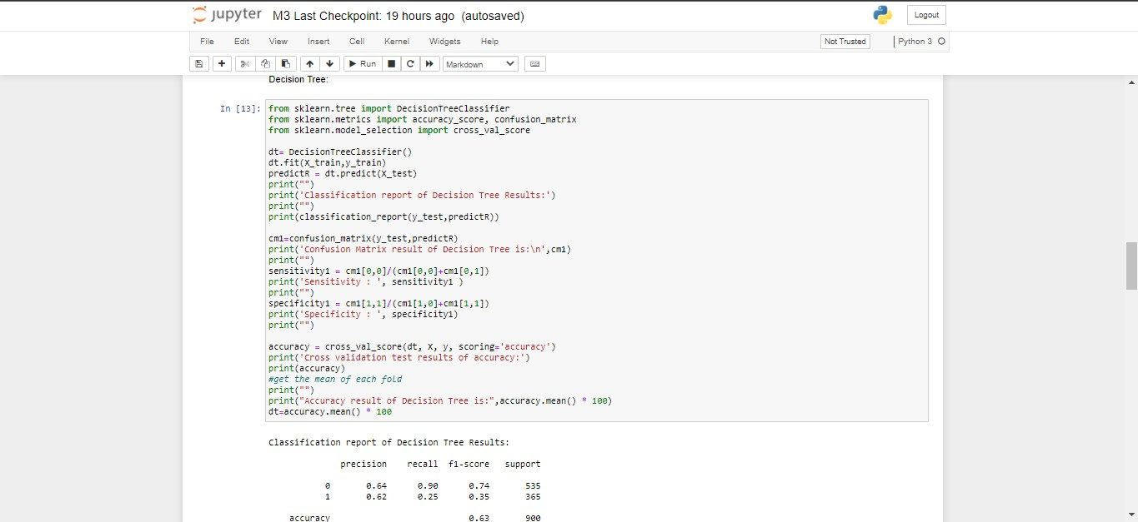

**MODULE DIAGRAM**

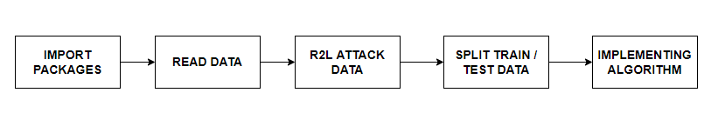

**GIVEN INPUT EXPECTED OUTPUT**

**input :** data

**output :** getting accuracy

**Module-04:**

Remote to local attack (r2l) has been widely known to be launched by an attacker to gain unauthorized access to a victim machine in the entire network. Similarly user to root attack (u2r) is usually launched for illegally obtaining the root's privileges when legally accessing a local machine. Buffer overflow is the most common of U2R attacks. This class begins by gaining access to a normal user while sniffing around for passwords to gain access as a root user to a computer resource. Detection of these attacks and prevention of computers from it is a major research topic for researchers throughout the world.

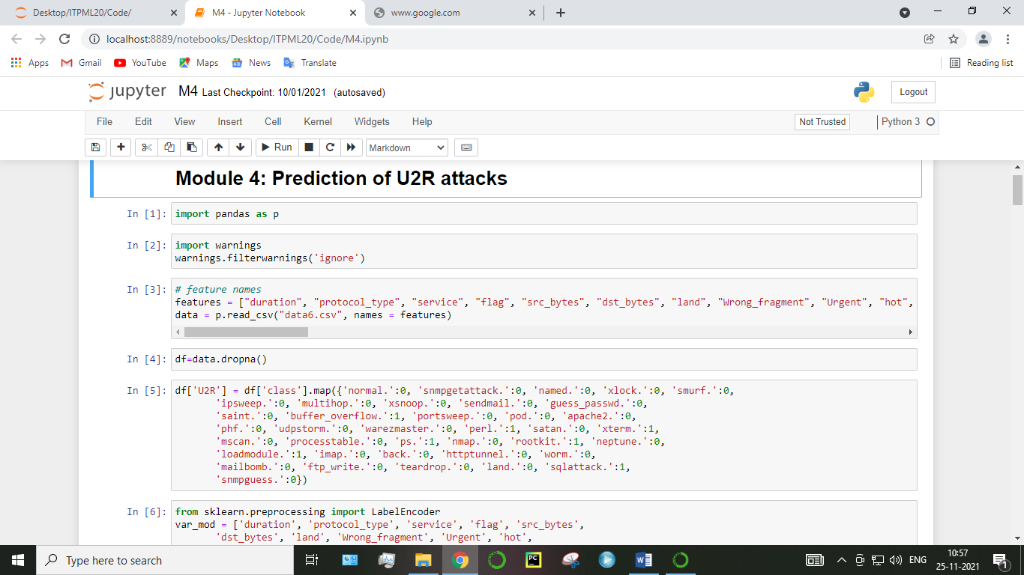

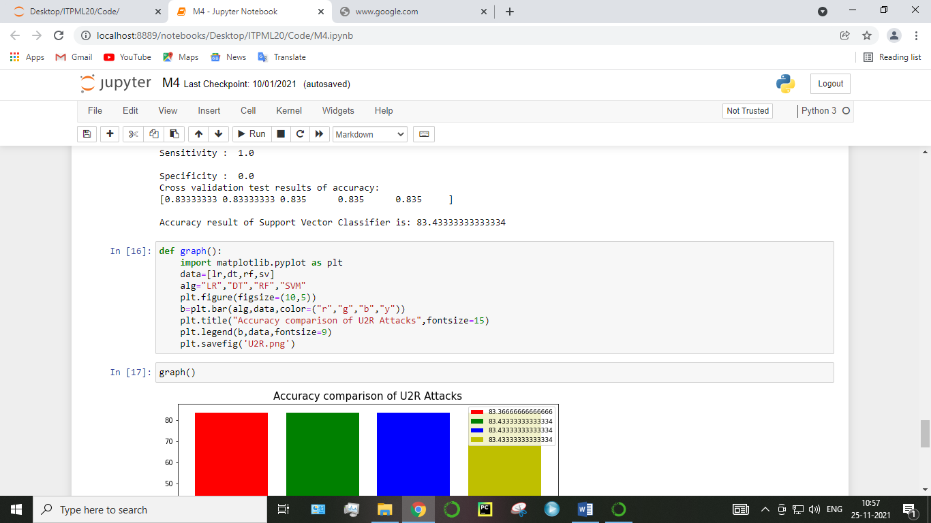

**MODULE DIAGRAM:**

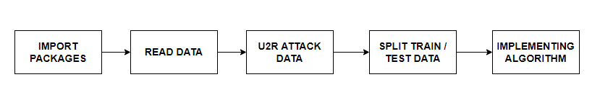

**GIVEN INPUT EXPECTED OUTPUT**

**input :** data

**output :** getting accuracy

**Module-05:**

Probing attacks are an invasive method for bypassing security measures by observing the physical silicon implementation of a chip. As an invasive attack, one directly accesses the internal wires and connections of a targeted device and extracts sensitive information. A probe is an attack which is deliberately crafted so that its target detects and reports it with a recognizable “fingerprint” in the report. The attacker then uses the collaborative infrastructure to learn the detector's location and defensive capabilities from this report. This is an attack where the attacker attempts to gather information about the target machine or the network, to map out the network. Information about target may reveal useful information such as open ports, its IP address, hostname, and operating system. Network Probe is the ultimate network monitor and protocol analyzer to monitor network traffic in real-time, and will help you find the sources of any network slow-downs in a matter of seconds.

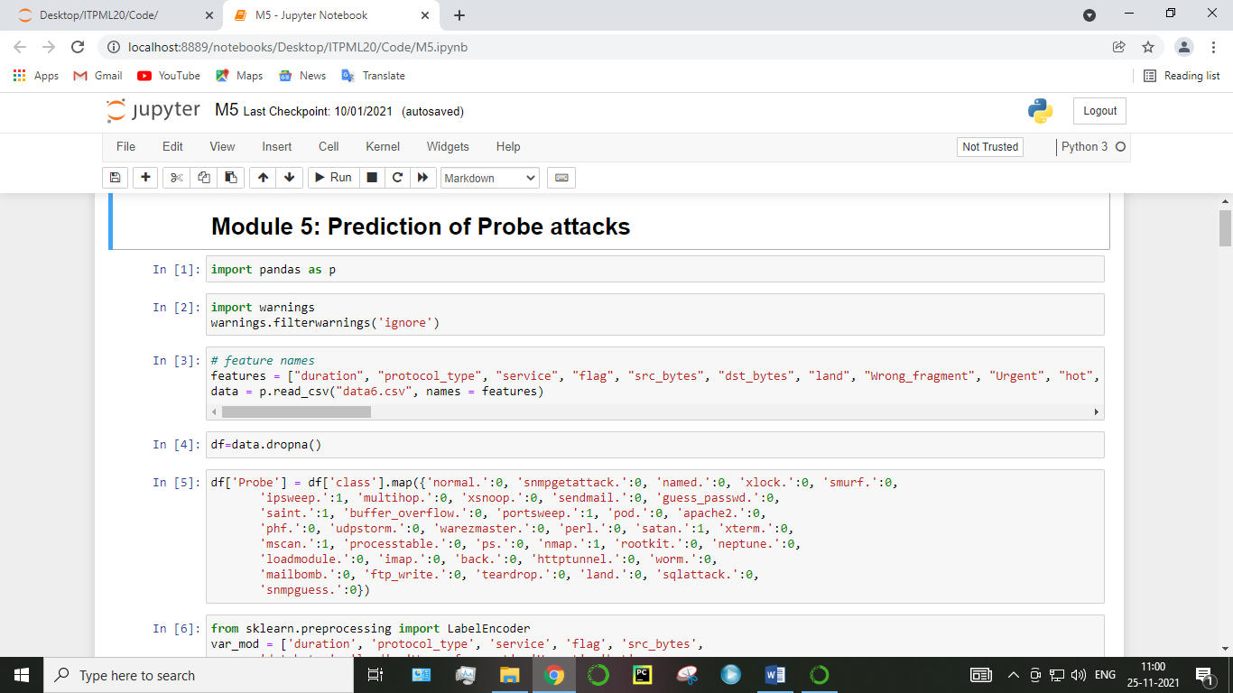

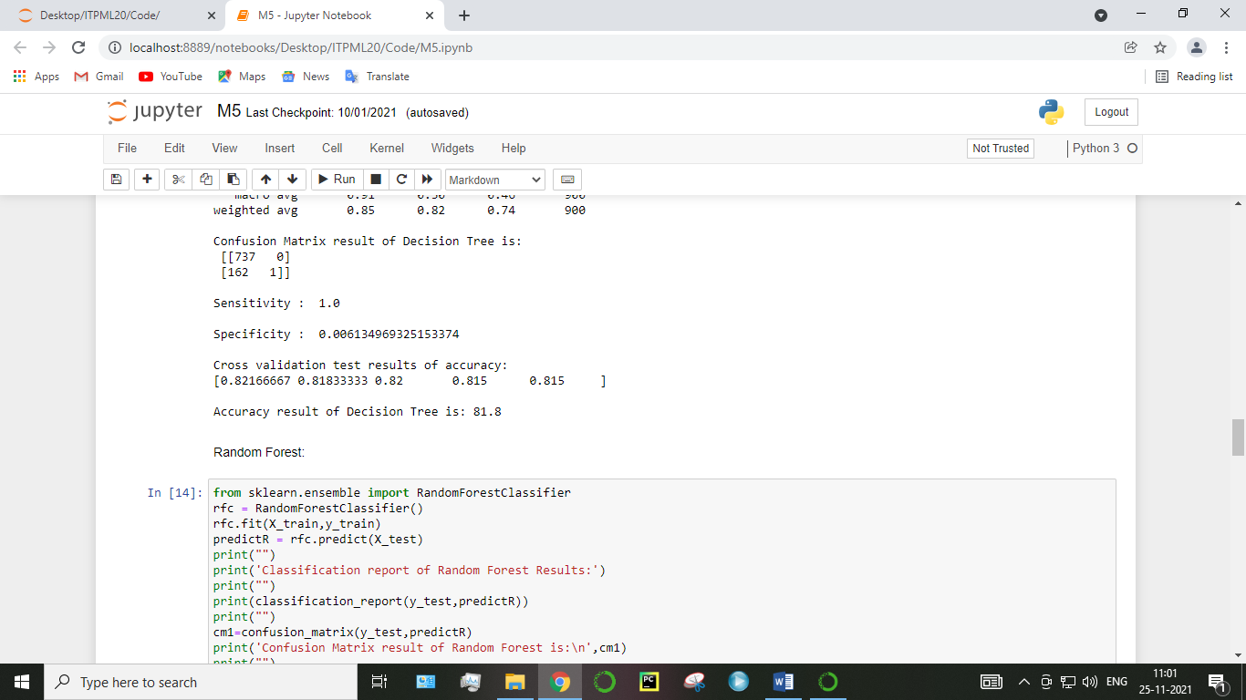

**MODULE DIAGRAM:**

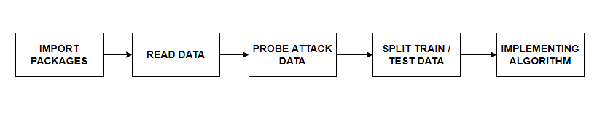

**GIVEN INPUT EXPECTED OUTPUT**

**input :** data

**output :** getting accuracy

**Module-06:**

Increasingly, attacks are executed in multiple steps, making them harder to detect. Such complex attacks require that defenders recognize the separate stages of an attack, possibly carried out over a longer period, as belonging to the same attack. Complex attacks can be divided into exploration and exploitation phases. Exploration involves identifying vulnerabilities and scanning and testing a system. It is how an attacker gathers information about the system. Exploitation involves gaining and maintaining access. At this stage, the attacker applies the know-how gathered during the exploration stage. An example of a complex attack that combines exploration and exploitation is a sequence of a phishing attack, followed by an exfiltration attack. First, attackers will attempt to collect information on the organization they intend to attack, e.g., names of key employees. Then, they will craft a targeted phishing attack. The phishing attack allows the attackers to gain access to the user’s system and install malware. The purpose of the malware could be to extract files from the user’s machine or to use the user’s machine as an attack vector to attack other machines in the organization’s network. A phishing attack is usually carried out by sending an email purporting to come from a trusted source and tricking its receiver to click on a URL that results in installing malware on the user’s system. This malware then creates a backdoor into the user’s system for staging a more complex attack. Phishing attacks can be recognized both by the types of keywords used in the email (as with a spam email), as well as by the characteristics of URLs included in the message. Features that have been used successfully to detect phishing attacks include URLs that include IP addresses, the age of a linked-to domain, and a mismatch between anchor and text of a link.

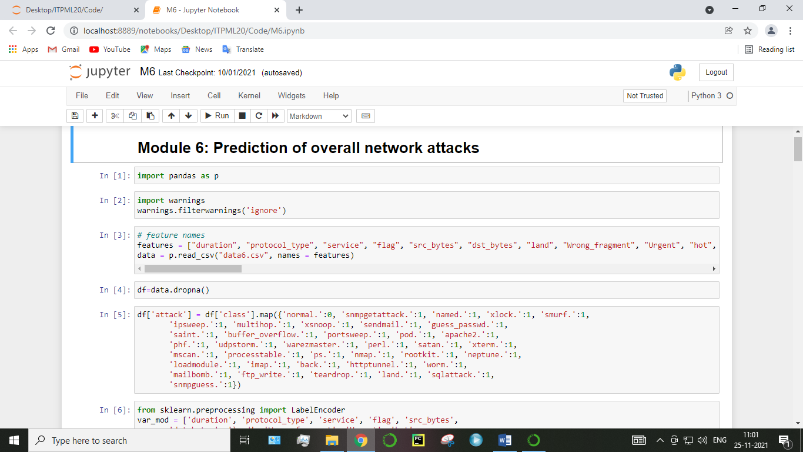

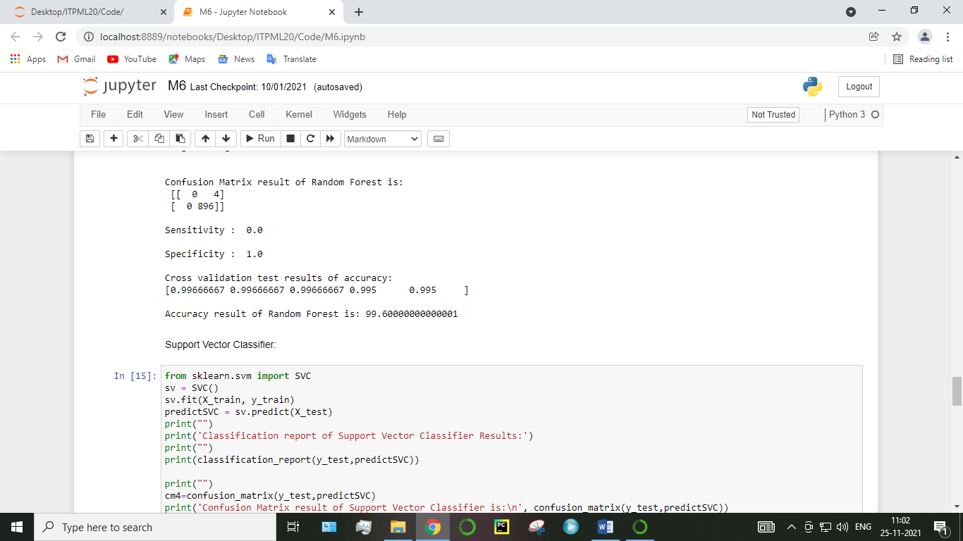

**MODULE DIAGRAM:**

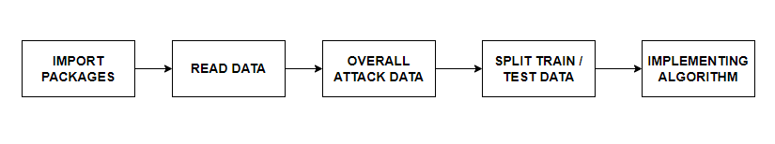

**GIVEN INPUT EXPECTED OUTPUT**

**input :** data

**output :** getting accuracy

**Module-07:**

GUI means Graphical User Interface. It is the common user Interface that includes Graphical representation like buttons and icons, and communication can be performed by interacting with these icons rather than the usual text-based or command-based communication. A common example of a GUI is Microsoft operating systems.

The graphical user interface (GUI) is a form of user interface that allows users to interact with electronic devices through graphical icons and audio indicator such as primary notation, instead of text-based user interfaces, typed command labels or text navigation. GUIs were introduced in reaction to the perceived steep learning curve of command-line interfaces (CLIs) which require commands to be typed on a computer keyboard.

The actions in a GUI are usually performed through direct manipulation of the graphical elements. Beyond computers, GUIs are used in many handheld mobile devices such as MP3 players, portable media players, gaming devices, smartphones and smaller household, office and industrial controls. The term GUI tends not to be applied to other lower-display resolution types of interfaces, such as video games (where head-up display (HUD) is preferred), or not including flat screens, like volumetric displays because the term is restricted to the scope of two-dimensional display screens able to describe generic information, in the tradition of the computer science research at the Xerox Palo Alto Research Center.

Graphical user interface (GUI) wrappers find a way around the command-line interface versions (CLI) of (typically) Linux and Unix-like software applications and their text-based user interfaces or typed command labels. While command-line or text-based applications allow users to run a program non-interactively, GUI wrappers atop them avoid the steep learning curve of the command-line, which requires commands to be typed on the keyboard. By starting a GUI wrapper, users can intuitively interact with, start, stop, and change its working parameters, through graphical icons and visual indicators of a desktop environment, for example. Applications may also provide both interfaces, and when they do the GUI is usually a WIMP wrapper around the command-line version. This is especially common with applications designed for Unix-like operating systems. The latter used to be implemented first because it allowed the developers to focus exclusively on their product's functionality without bothering about interface details such as designing icons and placing buttons. Designing programs this way also allows users to run the program in a shell script.

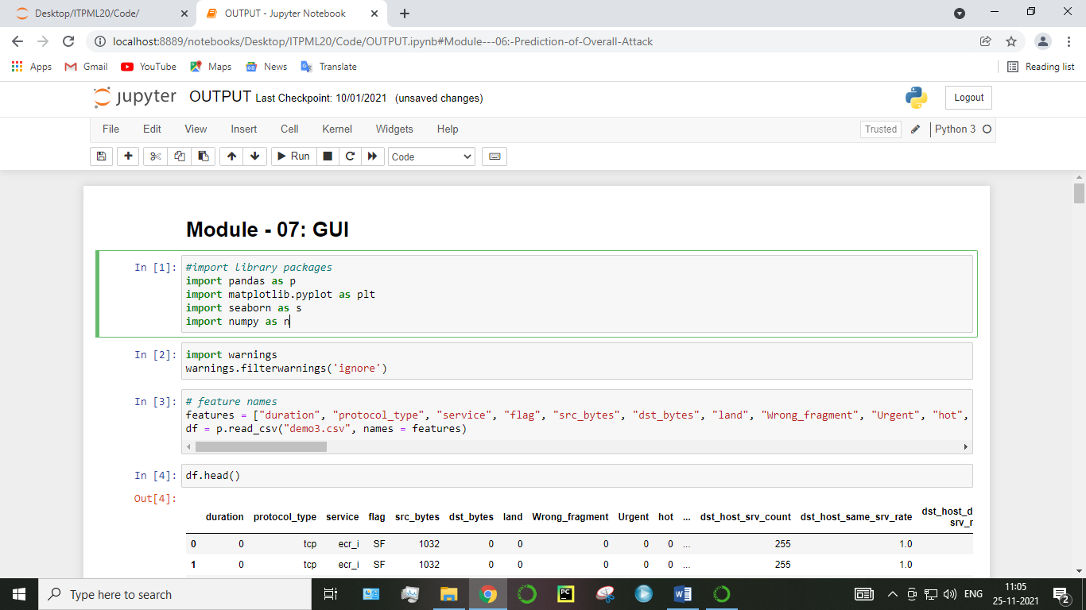

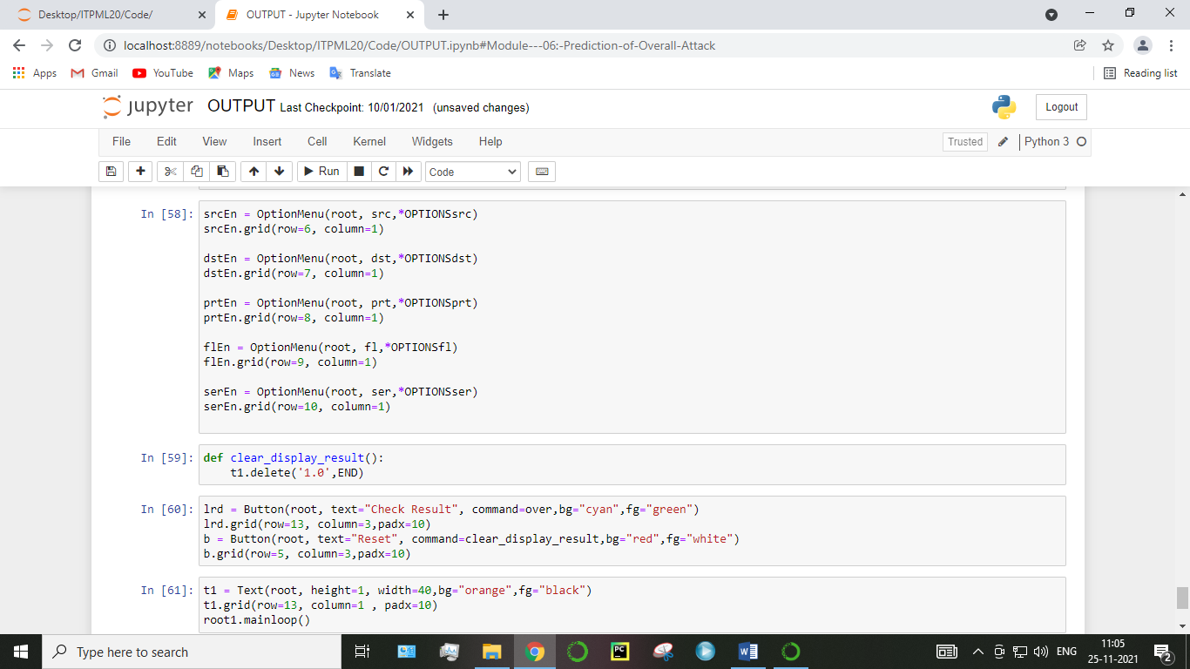

**MODULE DIAGRAM:**

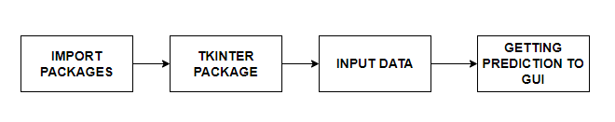

**GIVEN INPUT EXPECTED OUTPUT**

**input :** data values

**output :** predicting output

**Algorithm Explanation:**

In machine learning and statistics, classification is a supervised learning approach in which the computer program learns from the data input given to it and then uses this learning to classify new observation. This data set may simply be bi-class (like identifying whether the person is male or female or that the mail is spam or non-spam) or it may be multi-class too. Some examples of classification problems are: speech recognition, handwriting recognition, bio metric identification, document classification etc. In Supervised Learning, algorithms learn from labeled data. After understanding the data, the algorithm determines which label should be given to new data based on pattern and associating the patterns to the unlabeled new data.

[**Logistic Regression**](https://en.wikipedia.org/wiki/Logistic_regression):

It is a statistical method for analysing a data set in which there are one or more independent variables that determine an outcome. The outcome is measured with a dichotomous variable (in which there are only two possible outcomes). The goal of logistic regression is to find the best fitting model to describe the relationship between the dichotomous characteristic of interest (dependent variable = response or outcome variable) and a set of independent (predictor or explanatory) variables. Logistic regression is a Machine Learning classification algorithm that is used to predict the probability of a categorical dependent variable. In logistic regression, the dependent variable is a binary variable that contains data coded as 1 (yes, success, etc.) or 0 (no, failure, etc.).

In other words, the logistic regression model predicts P(Y=1) as a function of X. Logistic regression Assumptions:

* Binary logistic regression requires the dependent variable to be binary.
* For a binary regression, the factor level 1 of the dependent variable should represent the desired outcome.
* Only the meaningful variables should be included.
* The independent variables should be independent of each other. That is, the model should have little.
* The independent variables are linearly related to the log odds.
* Logistic regression requires quite large sample sizes.

[**Decision Tree**](https://www.geeksforgeeks.org/decision-tree/)**:**

It is one of the most powerful and popular algorithm. Decision-tree algorithm falls under the category of supervised learning algorithms. It works for both continuous as well as categorical output variables. Assumptions of Decision tree:

* At the beginning, we consider the whole training set as the root.
* Attributes are assumed to be categorical for information gain, attributes are assumed to be continuous.
* On the basis of attribute values records are distributed recursively.
* We use statistical methods for ordering attributes as root or internal node.

Decision tree builds classification or regression models in the form of a tree structure. It breaks down a data set into smaller and smaller subsets while at the same time an associated decision tree is incrementally developed. A decision node has two or more branches and a leaf node represents a classification or decision. The topmost decision node in a tree which corresponds to the best predictor called root node. Decision trees can handle both categorical and numerical data. Decision tree builds classification or regression models in the form of a tree structure. It utilizes an if-then rule set which is mutually exclusive and exhaustive for classification. The rules are learned sequentially using the training data one at a time. Each time a rule is learned, the tuples covered by the rules are removed.

This process is continued on the training set until meeting a termination condition. It is constructed in a top-down recursive divide-and-conquer manner. All the attributes should be categorical. Otherwise, they should be discretized in advance. Attributes in the top of the tree have more impact towards in the classification and they are identified using the information gain concept. A decision tree can be easily over-fitted generating too many branches and may reflect anomalies due to noise or outliers.

**Random Forest:**

Random forests or random decision forests are an ensemble learning method for classification, regression and other tasks, that operate by constructing a multitude of decision trees at training time and outputting the class that is the mode of the classes (classification) or mean prediction (regression) of the individual trees. Random decision forests correct for decision trees’ habit of over fitting to their training set. Random forest is a type of supervised machine learning algorithm based on [ensemble learning](https://en.wikipedia.org/wiki/Ensemble_learning). Ensemble learning is a type of learning where you join different types of algorithms or same algorithm multiple times to form a more powerful prediction model. The [random forest](https://en.wikipedia.org/wiki/Random_forest) algorithm combines multiple algorithm of the same type i.e. multiple decision trees, resulting in a forest of trees, hence the name "Random Forest". The random forest algorithm can be used for both regression and classification tasks.

The following are the basic steps involved in performing the random forest algorithm:

* Pick N random records from the dataset.
* Build a decision tree based on these N records.
* Choose the number of trees you want in your algorithm and repeat steps 1 and 2.
* In case of a regression problem, for a new record, each tree in the forest predicts a value for Y (output). The final value can be calculated by taking the average of all the values predicted by all the trees in forest. Or, in case of a classification problem, each tree in the forest predicts the category to which the new record belongs. Finally, the new record is assigned to the category that wins the majority vote.

**Support Vector Machines:**

A classifier that categorizes the data set by setting an optimal hyper plane between data. I chose this classifier as it is incredibly versatile in the number of different kernelling functions that can be applied and this model can yield a high predictability rate. Support Vector Machines are perhaps one of the most popular and talked about machine learning algorithms. They were extremely popular around the time they were developed in the 1990s and continue to be the go-to method for a high-performing algorithm with little tuning.

* How to disentangle the many names used to refer to support vector machines.
* The representation used by SVM when the model is actually stored on disk.
* How a learned SVM model representation can be used to make predictions for new data.
* How to learn an SVM model from training data.
* How to best prepare your data for the SVM algorithm.
* Where you might look to get more information on SVM.

**Used Python Packages:**

**sklearn:**

* + In python, sklearn is a machine learning package which include a lot of ML algorithms.
  + Here, we are using some of its modules like train_test_split, DecisionTreeClassifier or Logistic Regression and accuracy_score.

**NumPy:**

* + It is a numeric python module which provides fast maths functions for calculations.
  + It is used to read data in numpy arrays and for manipulation purpose.

**Pandas:**

* + Used to read and write different files.
  + Data manipulation can be done easily with data frames.

**Matplotlib:**

* + Data visualization is a useful way to help with identify the patterns from given dataset.
  + Data manipulation can be done easily with data frames.

**tkinter:**

* + Standard python interface to the GUI toolkit.
  + Accessible to everybody and reusable in various contexts.

1. **Deployment:**

**Tkinter:**

Tkinter is Python's de-facto standard GUI (Graphical User Interface) package. It is a thin object-oriented layer on top of Tcl/Tk. Tkinter is not the only GUI Programming toolkit for Python. It is however the most commonly used one. ... Graphical User Interfaces with Tk, a chapter from the Python Documentation.

The [tkinter](https://docs.python.org/3/library/tkinter.html#module-tkinter) package (“Tk interface”) is the standard Python interface to the Tcl/Tk GUI toolkit. Both Tk and [tkinter](https://docs.python.org/3/library/tkinter.html#module-tkinter) are available on most Unix platforms, including macOS, as well as on Windows systems.

Running python –m tkinter from the command line should open a window demonstrating a simple Tk interface, letting you know that [tkinter](https://docs.python.org/3/library/tkinter.html#module-tkinter) is properly installed on your system, and also showing what version of Tcl/Tk is installed, so you can read the Tcl/Tk documentation specific to that version.

Tkinter supports a range of Tcl/Tk versions, built either with or without thread support. The official Python binary release bundles Tcl/Tk 8.6 threaded. See the source code for the _tkinter module for more information about supported versions.

Tkinter is not a thin wrapper, but adds a fair amount of its own logic to make the experience more pythonic. This documentation will concentrate on these additions and changes, and refer to the official Tcl/Tk documentation for details that are unchanged.

Tkinter is a Python binding to the Tk GUI toolkit. It is the standard Python interface to the Tk GUI toolkit, and is Python's de facto standard GUI. Tkinter is included with standard GNU/Linux, Microsoft Windows and macOS installs of Python.

The name Tkinter comes from Tk interface. Tkinter was written by Fredrik Lundh.

Tkinter is free software released under a Python license.

As with most other modern Tk bindings, Tkinter is implemented as a Python wrapper around a complete Tcl interpreter embedded in the Python interpreter. Tkinter calls are translated into Tcl commands, which are fed to this embedded interpreter, thus making it possible to mix Python and Tcl in a single application.

There are several popular GUI library alternatives available, such as wxPython, PyQt, PySide, Pygame, Pyglet, and PyGTK.

1. **Coding:**

**MODULE – 1**

*#import library packages*

**import** pandas **as** p

**import** numpy **as** n

*# feature names*

features **=** ["duration", "protocol_type", "service", "flag", "src_bytes", "dst_bytes", "land", "Wrong_fragment", "Urgent", "hot", "num_failed_login", "logged_in", "num_compromised", "root_shell", "su_attempted", "num_root", "num_file_creations", "num_shells", "num_access_files", "num_outbound_cmds", "is_host_login", "is_guest_login", "count", "srv_count", "serror_rate", "srv_serror_rate", "rerror_rate", "srv_rerror_rate", "same_srv_rate", "diff_srv_rate", "srv_diff_host_rate", "dst_host_count", "dst_host_srv_count", "dst_host_same_srv_rate", "dst_host_diff_ srv_rate", "dst_host_same_src_port_rate", "dst_host_srv_diff_host _rate", "dst_host_serror_rate", "dst_host_srv_serror_rate", "dst_host_rerror_rate", "dst_host_srv_rerror_rate","class"]

data **=** p**.**read_csv("data6.csv", names **=** features)

Before drop the given dataset

data**.**head(10)

After drop the given dataset

df**=**data**.**dropna()

df**.**head(10)

*#show columns*

df**.**columns

Index(['duration', 'protocol_type', 'service', 'flag', 'src_bytes',

'dst_bytes', 'land', 'Wrong_fragment', 'Urgent', 'hot',

'num_failed_login', 'logged_in', 'num_compromised', 'root_shell',

'su_attempted', 'num_root', 'num_file_creations', 'num_shells',

'num_access_files', 'num_outbound_cmds', 'is_host_login',

'is_guest_login', 'count', 'srv_count', 'serror_rate',

'srv_serror_rate', 'rerror_rate', 'srv_rerror_rate', 'same_srv_rate',

'diff_srv_rate', 'srv_diff_host_rate', 'dst_host_count',

'dst_host_srv_count', 'dst_host_same_srv_rate',

'dst_host_diff_ srv_rate', 'dst_host_same_src_port_rate',

'dst_host_srv_diff_host _rate', 'dst_host_serror_rate',

'dst_host_srv_serror_rate', 'dst_host_rerror_rate',

'dst_host_srv_rerror_rate', 'class'],

dtype='object')

*#To describe the dataframe*

df**.**describe()

*#Checking datatype and information about dataset*

df**.**info()

Checking duplicate values of dataframe

*#Checking for duplicate data*

df**.**duplicated()

*#find sum of duplicate data*

sum(df**.**duplicated())

*#Checking sum of missing values*

df**.**isnull()**.**sum()

d **=** p**.**crosstab(df['protocol_type'], df['class'])

d**.**plot(kind**=**'bar', stacked**=True**, color**=**['red','green'], grid**=False**, figsize**=**(18,8))

**import** matplotlib.pyplot **as** plt

pr **=** df["protocol_type"]

fl **=** df["flag"]

plt**.**plot(fl, pr, color**=**'g')

plt**.**xlabel('Flag Types')

plt**.**ylabel('Protocol Types')

plt**.**title('Flag Details by protocol type')

plt**.**show()

df["class"]**.**unique()

df['land']**.**value_counts()

df['service']**.**value_counts()

df['protocol_type']**.**value_counts()

**import** numpy **as** n

**def** PropByVar(df, variable):

dataframe_pie **=** df[variable]**.**value_counts()

ax **=** dataframe_pie**.**plot**.**pie(figsize**=**(10,10), autopct**=**'%1.2f%%', fontsize **=** 12);

ax**.**set_title(variable **+** ' (%) (Per Count)\n', fontsize **=** 15);

**return** n**.**round(dataframe_pie**/**df**.**shape[0]**\***100,2)

PropByVar(df, 'protocol_type')

df['DOSland'] **=** df**.**land**.**map({0:'attack',1:'noattack',2:'normal'})

df['DOSlandclass'] **=** df**.**DOSland**.**map({'attack':1,'noattack':0,'normal':0})

df['DOSlandclass']**.**value_counts()

df['DOS'] **=** df['class']**.**map({'normal.':0, 'snmpgetattack.':0, 'named.':0, 'xlock.':0, 'smurf.':1,

'ipsweep.':0, 'multihop.':0, 'xsnoop.':0, 'sendmail.':0, 'guess_passwd.':0,

'saint.':0, 'buffer_overflow.':0, 'portsweep.':0, 'pod.':1, 'apache2.':1,

'phf.':0, 'udpstorm.':1, 'warezmaster.':0, 'perl.':0, 'satan.':0, 'xterm.':0,

'mscan.':0, 'processtable.':1, 'ps.':0, 'nmap.':0, 'rootkit.':0, 'neptune.':1,

'loadmodule.':0, 'imap.':0, 'back.':1, 'httptunnel.':0, 'worm.':0,

'mailbomb.':1, 'ftp_write.':0, 'teardrop.':1, 'land.':1, 'sqlattack.':0,

'snmpguess.':0})

df**.**head()

df['R2L'] **=** df['class']**.**map({'normal.':0, 'snmpgetattack.':1, 'named.':1, 'xlock.':1, 'smurf.':0,

'ipsweep.':0, 'multihop.':1, 'xsnoop.':1, 'sendmail.':1, 'guess_passwd.':1,

'saint.':0, 'buffer_overflow.':0, 'portsweep.':0, 'pod.':0, 'apache2.':0,

'phf.':1, 'udpstorm.':0, 'warezmaster.':1, 'perl.':0, 'satan.':0, 'xterm.':0,

'mscan.':0, 'processtable.':0, 'ps.':0, 'nmap.':0, 'rootkit.':0, 'neptune.':0,

'loadmodule.':0, 'imap.':1, 'back.':0, 'httptunnel.':1, 'worm.':1,

'mailbomb.':0, 'ftp_write.':1, 'teardrop.':0, 'land.':0, 'sqlattack.':0,

'snmpguess.':1})

df['U2R'] **=** df['class']**.**map({'normal.':0, 'snmpgetattack.':0, 'named.':0, 'xlock.':0, 'smurf.':0,

'ipsweep.':0, 'multihop.':0, 'xsnoop.':0, 'sendmail.':0, 'guess_passwd.':0,

'saint.':0, 'buffer_overflow.':1, 'portsweep.':0, 'pod.':0, 'apache2.':0,

'phf.':0, 'udpstorm.':0, 'warezmaster.':0, 'perl.':1, 'satan.':0, 'xterm.':1,

'mscan.':0, 'processtable.':0, 'ps.':1, 'nmap.':0, 'rootkit.':1, 'neptune.':0,

'loadmodule.':1, 'imap.':0, 'back.':0, 'httptunnel.':0, 'worm.':0,

'mailbomb.':0, 'ftp_write.':0, 'teardrop.':0, 'land.':0, 'sqlattack.':1,

'snmpguess.':0})

df['Probe'] **=** df['class']**.**map({'normal.':0, 'snmpgetattack.':0, 'named.':0, 'xlock.':0, 'smurf.':0,

'ipsweep.':1, 'multihop.':0, 'xsnoop.':0, 'sendmail.':0, 'guess_passwd.':0,

'saint.':1, 'buffer_overflow.':0, 'portsweep.':1, 'pod.':0, 'apache2.':0,

'phf.':0, 'udpstorm.':0, 'warezmaster.':0, 'perl.':0, 'satan.':1, 'xterm.':0,

'mscan.':1, 'processtable.':0, 'ps.':0, 'nmap.':1, 'rootkit.':0, 'neptune.':0,

'loadmodule.':0, 'imap.':0, 'back.':0, 'httptunnel.':0, 'worm.':0,

'mailbomb.':0, 'ftp_write.':0, 'teardrop.':0, 'land.':0, 'sqlattack.':0,

'snmpguess.':0})

df['attack'] **=** df['class']**.**map({'normal.':0, 'snmpgetattack.':1, 'named.':1, 'xlock.':1, 'smurf.':1,

'ipsweep.':1, 'multihop.':1, 'xsnoop.':1, 'sendmail.':1, 'guess_passwd.':1,

'saint.':1, 'buffer_overflow.':1, 'portsweep.':1, 'pod.':1, 'apache2.':1,

'phf.':1, 'udpstorm.':1, 'warezmaster.':1, 'perl.':1, 'satan.':1, 'xterm.':1,

'mscan.':1, 'processtable.':1, 'ps.':1, 'nmap.':1, 'rootkit.':1, 'neptune.':1,

'loadmodule.':1, 'imap.':1, 'back.':1, 'httptunnel.':1, 'worm.':1,

'mailbomb.':1, 'ftp_write.':1, 'teardrop.':1, 'land.':1, 'sqlattack.':1,

'snmpguess.':1})

df**.**head()

df**.**corr()

Before Pre-Processing:

df**.**head()

After Pre-Processing:

df**.**columns

**from** sklearn.preprocessing **import** LabelEncoder

var_mod **=** ['duration', 'protocol_type', 'service', 'flag', 'src_bytes',

'dst_bytes', 'land', 'Wrong_fragment', 'Urgent', 'hot',

'num_failed_login', 'logged_in', 'num_compromised', 'root_shell',

'su_attempted', 'num_root', 'num_file_creations', 'num_shells',

'num_access_files', 'num_outbound_cmds', 'is_host_login',

'is_guest_login', 'count', 'srv_count', 'serror_rate',

'srv_serror_rate', 'rerror_rate', 'srv_rerror_rate', 'same_srv_rate',

'diff_srv_rate', 'srv_diff_host_rate', 'dst_host_count',

'dst_host_srv_count', 'dst_host_same_srv_rate',

'dst_host_diff_ srv_rate', 'dst_host_same_src_port_rate',

'dst_host_srv_diff_host _rate', 'dst_host_serror_rate',

'dst_host_srv_serror_rate', 'dst_host_rerror_rate',

'dst_host_srv_rerror_rate', ]

le **=** LabelEncoder()

**for** i **in** var_mod:

df[i] **=** le**.**fit_transform(df[i])**.**astype(str)

df**.**head()

**MODULE-2**

**import** pandas **as** p

**import** warnings

warnings**.**filterwarnings('ignore')

*# feature names*

features **=** ["duration", "protocol_type", "service", "flag", "src_bytes", "dst_bytes", "land", "Wrong_fragment", "Urgent", "hot", "num_failed_login", "logged_in", "num_compromised", "root_shell", "su_attempted", "num_root", "num_file_creations", "num_shells", "num_access_files", "num_outbound_cmds", "is_host_login", "is_guest_login", "count", "srv_count", "serror_rate", "srv_serror_rate", "rerror_rate", "srv_rerror_rate", "same_srv_rate", "diff_srv_rate", "srv_diff_host_rate", "dst_host_count", "dst_host_srv_count", "dst_host_same_srv_rate", "dst_host_diff_ srv_rate", "dst_host_same_src_port_rate", "dst_host_srv_diff_host _rate", "dst_host_serror_rate", "dst_host_srv_serror_rate", "dst_host_rerror_rate", "dst_host_srv_rerror_rate","class"]

data **=** p**.**read_csv("data6.csv", names **=** features)

df**=**data**.**dropna()

df['DOSland'] **=** df**.**land**.**map({0:'attack',1:'noattack',2:'normal'})

df['DOSlandclass'] **=** df**.**DOSland**.**map({'attack':1,'noattack':0,'normal':0})

df['DOS'] **=** df['class']**.**map({'normal.':0, 'snmpgetattack.':0, 'named.':0, 'xlock.':0, 'smurf.':1,

'ipsweep.':0, 'multihop.':0, 'xsnoop.':0, 'sendmail.':0, 'guess_passwd.':0,

'saint.':0, 'buffer_overflow.':0, 'portsweep.':0, 'pod.':1, 'apache2.':1,

'phf.':0, 'udpstorm.':1, 'warezmaster.':0, 'perl.':0, 'satan.':0, 'xterm.':0,

'mscan.':0, 'processtable.':1, 'ps.':0, 'nmap.':0, 'rootkit.':0, 'neptune.':1,

'loadmodule.':0, 'imap.':0, 'back.':1, 'httptunnel.':0, 'worm.':0,

'mailbomb.':1, 'ftp_write.':0, 'teardrop.':1, 'land.':1, 'sqlattack.':0,

'snmpguess.':0})

**from** sklearn.preprocessing **import** LabelEncoder

var_mod **=** ['duration', 'protocol_type', 'service', 'flag', 'src_bytes',

'dst_bytes', 'land', 'Wrong_fragment', 'Urgent', 'hot',

'num_failed_login', 'logged_in', 'num_compromised', 'root_shell',

'su_attempted', 'num_root', 'num_file_creations', 'num_shells',

'num_access_files', 'num_outbound_cmds', 'is_host_login',

'is_guest_login', 'count', 'srv_count', 'serror_rate',

'srv_serror_rate', 'rerror_rate', 'srv_rerror_rate', 'same_srv_rate',

'diff_srv_rate', 'srv_diff_host_rate', 'dst_host_count',

'dst_host_srv_count', 'dst_host_same_srv_rate',

'dst_host_diff_ srv_rate', 'dst_host_same_src_port_rate',

'dst_host_srv_diff_host _rate', 'dst_host_serror_rate',

'dst_host_srv_serror_rate', 'dst_host_rerror_rate'

]

le **=** LabelEncoder()

**for** i **in** var_mod:

df[i] **=** le**.**fit_transform(df[i])**.**astype(int)

**del** df['DOSland']

**del** df['dst_host_srv_rerror_rate']

**del** df['DOSlandclass']

**del** df['class']

*#According to the cross-validated MCC scores, the random forest is the best-performing model, so now let's evaluate its performance on the test set.*

**from** sklearn.metrics **import** confusion_matrix, classification_report, matthews_corrcoef, cohen_kappa_score, accuracy_score, average_precision_score, roc_auc_score

X **=** df**.**drop(labels**=**'DOS', axis**=**1)

*#Response variable*

y **=** df**.**loc[:,'DOS']

*#We'll use a test size of 30%. We also stratify the split on the response variable, which is very important to do because there are so few fraudulent transactions.*

**from** sklearn.model_selection **import** train_test_split

X_train, X_test, y_train, y_test **=** train_test_split(X, y, test_size**=**0.3, random_state**=**1, stratify**=**y)

*#According to the cross-validated MCC scores, the random forest is the best-performing model, so now let's evaluate its performance on the test set.*

**from** sklearn.metrics **import** confusion_matrix, classification_report, matthews_corrcoef, cohen_kappa_score, accuracy_score, average_precision_score, roc_auc_score

**Logistic Regression :**

**from** sklearn.metrics **import** accuracy_score, confusion_matrix

**from** sklearn.linear_model **import** LogisticRegression

**from** sklearn.model_selection **import** cross_val_score

logR**=** LogisticRegression()

logR**.**fit(X_train,y_train)

predictR **=** logR**.**predict(X_test)

print("")

print('Classification report of Logistic Regression Results:')

print("")

print(classification_report(y_test,predictR))

cm1**=**confusion_matrix(y_test,predictR)

print('Confusion Matrix result of Logistic Regression is:\n',cm1)

print("")

sensitivity1 **=** cm1[0,0]**/**(cm1[0,0]**+**cm1[0,1])

print('Sensitivity : ', sensitivity1 )

print("")

specificity1 **=** cm1[1,1]**/**(cm1[1,0]**+**cm1[1,1])

print('Specificity : ', specificity1)

print("")

accuracy **=** cross_val_score(logR, X, y, scoring**=**'accuracy')

print('Cross validation test results of accuracy:')

print(accuracy)

*#get the mean of each fold*

print("")

print("Accuracy result of Logistic Regression is:",accuracy**.**mean() **\*** 100)

lr**=**accuracy**.**mean() **\*** 100

**Decision Tree:**

**from** sklearn.tree **import** DecisionTreeClassifier

**from** sklearn.metrics **import** accuracy_score, confusion_matrix

**from** sklearn.model_selection **import** cross_val_score

dt**=** DecisionTreeClassifier()

dt**.**fit(X_train,y_train)

predictR **=** dt**.**predict(X_test)

print("")

print('Classification report of Decision Tree Results:')

print("")

print(classification_report(y_test,predictR))

cm1**=**confusion_matrix(y_test,predictR)

print('Confusion Matrix result of Decision Tree is:\n',cm1)

print("")

sensitivity1 **=** cm1[0,0]**/**(cm1[0,0]**+**cm1[0,1])

print('Sensitivity : ', sensitivity1 )

print("")

specificity1 **=** cm1[1,1]**/**(cm1[1,0]**+**cm1[1,1])

print('Specificity : ', specificity1)

print("")

accuracy **=** cross_val_score(dt, X, y, scoring**=**'accuracy')

print('Cross validation test results of accuracy:')

print(accuracy)

*#get the mean of each fold*

print("")

print("Accuracy result of Decision Tree is:",accuracy**.**mean() **\*** 100)

dt**=**accuracy**.**mean() **\*** 100

**Random Forest:**

**from** sklearn.ensemble **import** RandomForestClassifier

rfc **=** RandomForestClassifier()

rfc**.**fit(X_train,y_train)

predictR **=** rfc**.**predict(X_test)

print("")

print('Classification report of Random Forest Results:')

print("")

print(classification_report(y_test,predictR))

print("")

cm1**=**confusion_matrix(y_test,predictR)

print('Confusion Matrix result of Random Forest is:\n',cm1)

print("")

sensitivity1 **=** cm1[0,0]**/**(cm1[0,0]**+**cm1[0,1])

print('Sensitivity : ', sensitivity1 )

print("")

specificity1 **=** cm1[1,1]**/**(cm1[1,0]**+**cm1[1,1])

print('Specificity : ', specificity1)

print("")

accuracy **=** cross_val_score(rfc, X, y, scoring**=**'accuracy')

print('Cross validation test results of accuracy:')

print(accuracy)

*#get the mean of each fold*

print("")

print("Accuracy result of Random Forest is:",accuracy**.**mean() **\*** 100)

rf**=**accuracy**.**mean() **\*** 100

Support Vector Classifier:

**from** sklearn.svm **import** SVC

sv **=** SVC()

sv**.**fit(X_train, y_train)

predictSVC **=** sv**.**predict(X_test)

print("")

print('Classification report of Support Vector Classifier Results:')

print("")

print(classification_report(y_test,predictSVC))

print("")

cm4**=**confusion_matrix(y_test,predictSVC)

print('Confusion Matrix result of Support Vector Classifier is:\n', confusion_matrix(y_test,predictSVC))

print("")

sensitivity1 **=** cm4[0,0]**/**(cm4[0,0]**+**cm4[0,1])

print('Sensitivity : ', sensitivity1 )

print("")

specificity1 **=** cm4[1,1]**/**(cm4[1,0]**+**cm4[1,1])

print('Specificity : ', specificity1)

accuracy **=** cross_val_score(sv, X, y, scoring**=**'accuracy')

print('Cross validation test results of accuracy:')

print(accuracy)

*#get the mean of each fold*

print("")

print("Accuracy result of Support Vector Classifier is:",accuracy**.**mean() **\*** 100)

sv**=**accuracy**.**mean() **\*** 100

**def** graph():

**import** matplotlib.pyplot **as** plt

data**=**[lr,dt,rf,sv]

alg**=**"LR","DT","RF","SVM"

plt**.**figure(figsize**=**(10,5))

b**=**plt**.**bar(alg,data,color**=**("r","g","b","y"))

plt**.**title("Accuracy comparison of DoS Attacks",fontsize**=**15)

plt**.**legend(b,data,fontsize**=**9)

plt**.**savefig('DOS.png')

graph()

**import** tkinter

**from** matplotlib.backends.backend_tkagg **import** (FigureCanvasTkAgg, NavigationToolbar2Tk)

**from** matplotlib.backend_bases **import** key_press_handler

**from** matplotlib.figure **import** Figure

**import** numpy **as** np

root **=** tkinter**.**Tk()

root**.**wm_title("Accuracy plot for DoS Attacks")

fig **=** Figure(figsize**=**(10,10),dpi**=**1)

canvas **=** FigureCanvasTkAgg(fig, master**=**root)

canvas**.**draw()

canvas**.**get_tk_widget()**.**pack(side**=**tkinter**.**TOP, fill**=**tkinter**.**BOTH, expand**=**1)

icon**=**tkinter**.**PhotoImage(file**=**'DOS.png')

label**=**tkinter**.**Label(root,image**=**icon)

label**.**pack()

root**.**mainloop()

**MODULE-3**

**import** pandas **as** p

*# feature names*

features **=** ["duration", "protocol_type", "service", "flag", "src_bytes", "dst_bytes", "land", "Wrong_fragment", "Urgent", "hot", "num_failed_login", "logged_in", "num_compromised", "root_shell", "su_attempted", "num_root", "num_file_creations", "num_shells", "num_access_files", "num_outbound_cmds", "is_host_login", "is_guest_login", "count", "srv_count", "serror_rate", "srv_serror_rate", "rerror_rate", "srv_rerror_rate", "same_srv_rate", "diff_srv_rate", "srv_diff_host_rate", "dst_host_count", "dst_host_srv_count", "dst_host_same_srv_rate", "dst_host_diff_ srv_rate", "dst_host_same_src_port_rate", "dst_host_srv_diff_host _rate", "dst_host_serror_rate", "dst_host_srv_serror_rate", "dst_host_rerror_rate", "dst_host_srv_rerror_rate","class"]

data **=** p**.**read_csv("data6.csv", names **=** features)

df**=**data**.**dropna()

df['R2L'] **=** df["class"]**.**map({'normal.':0, 'snmpgetattack.':1, 'named.':1, 'xlock.':1, 'smurf.':0,

'ipsweep.':0, 'multihop.':1, 'xsnoop.':1, 'sendmail.':1, 'guess_passwd.':1,

'saint.':0, 'buffer_overflow.':0, 'portsweep.':0, 'pod.':0, 'apache2.':0,

'phf.':1, 'udpstorm.':0, 'warezmaster.':1, 'perl.':0, 'satan.':0, 'xterm.':0,

'mscan.':0, 'processtable.':0, 'ps.':0, 'nmap.':0, 'rootkit.':0, 'neptune.':0,

'loadmodule.':0, 'imap.':1, 'back.':0, 'httptunnel.':1, 'worm.':1,

'mailbomb.':0, 'ftp_write.':1, 'teardrop.':0, 'land.':0, 'sqlattack.':0,

'snmpguess.':1})

**from** sklearn.preprocessing **import** LabelEncoder

var_mod **=** ['duration', 'protocol_type', 'service', 'flag', 'src_bytes',

'dst_bytes', 'land', 'Wrong_fragment', 'Urgent', 'hot',

'num_failed_login', 'logged_in', 'num_compromised', 'root_shell',

'su_attempted', 'num_root', 'num_file_creations', 'num_shells',

'num_access_files', 'num_outbound_cmds', 'is_host_login',

'is_guest_login', 'count', 'srv_count', 'serror_rate',

'srv_serror_rate', 'rerror_rate', 'srv_rerror_rate', 'same_srv_rate',

'diff_srv_rate', 'srv_diff_host_rate', 'dst_host_count',

'dst_host_srv_count', 'dst_host_same_srv_rate',

'dst_host_diff_ srv_rate', 'dst_host_same_src_port_rate',

'dst_host_srv_diff_host _rate', 'dst_host_serror_rate',

'dst_host_srv_serror_rate', 'dst_host_rerror_rate'

]

le **=** LabelEncoder()

**for** i **in** var_mod:

df[i] **=** le**.**fit_transform(df[i])**.**astype(int)

**del** df['dst_host_srv_rerror_rate']

**del** df["class"]

*#According to the cross-validated MCC scores, the random forest is the best-performing model, so now let's evaluate its performance on the test set.*

**from** sklearn.metrics **import** confusion_matrix, classification_report, matthews_corrcoef, cohen_kappa_score, accuracy_score, average_precision_score, roc_auc_score

X **=** df**.**drop(labels**=**'R2L', axis**=**1)

*#Response variable*

y **=** df**.**loc[:,'R2L']

*#We'll use a test size of 30%. We also stratify the split on the response variable, which is very important to do because there are so few fraudulent transactions.*

**from** sklearn.model_selection **import** train_test_split

X_train, X_test, y_train, y_test **=** train_test_split(X, y, test_size**=**0.3, random_state**=**1, stratify**=**y)

**import** warnings

warnings**.**filterwarnings('ignore')

*#According to the cross-validated MCC scores, the random forest is the best-performing model, so now let's evaluate its performance on the test set.*

**from** sklearn.metrics **import** confusion_matrix, classification_report, matthews_corrcoef, cohen_kappa_score, accuracy_score, average_precision_score, roc_auc_score

**Logistic Regression :**

**from** sklearn.metrics **import** accuracy_score, confusion_matrix

**from** sklearn.linear_model **import** LogisticRegression

**from** sklearn.model_selection **import** cross_val_score

logR**=** LogisticRegression()

logR**.**fit(X_train,y_train)

predictR **=** logR**.**predict(X_test)

print("")

print('Classification report of Logistic Regression Results:')

print("")

print(classification_report(y_test,predictR))

cm1**=**confusion_matrix(y_test,predictR)

print('Confusion Matrix result of Logistic Regression is:\n',cm1)

print("")

sensitivity1 **=** cm1[0,0]**/**(cm1[0,0]**+**cm1[0,1])

print('Sensitivity : ', sensitivity1 )

print("")

specificity1 **=** cm1[1,1]**/**(cm1[1,0]**+**cm1[1,1])

print('Specificity : ', specificity1)

print("")

accuracy **=** cross_val_score(logR, X, y, scoring**=**'accuracy')

print('Cross validation test results of accuracy:')

print(accuracy)

*#get the mean of each fold*

print("")

print("Accuracy result of Logistic Regression is:",accuracy**.**mean() **\*** 100)

lr**=**accuracy**.**mean() **\*** 100

**Decision Tree:**

**from** sklearn.tree **import** DecisionTreeClassifier

**from** sklearn.metrics **import** accuracy_score, confusion_matrix

**from** sklearn.model_selection **import** cross_val_score

dt**=** DecisionTreeClassifier()

dt**.**fit(X_train,y_train)

predictR **=** dt**.**predict(X_test)

print("")

print('Classification report of Decision Tree Results:')

print("")

print(classification_report(y_test,predictR))

cm1**=**confusion_matrix(y_test,predictR)

print('Confusion Matrix result of Decision Tree is:\n',cm1)

print("")

sensitivity1 **=** cm1[0,0]**/**(cm1[0,0]**+**cm1[0,1])

print('Sensitivity : ', sensitivity1 )

print("")

specificity1 **=** cm1[1,1]**/**(cm1[1,0]**+**cm1[1,1])

print('Specificity : ', specificity1)

print("")

accuracy **=** cross_val_score(dt, X, y, scoring**=**'accuracy')

print('Cross validation test results of accuracy:')

print(accuracy)

*#get the mean of each fold*

print("")

print("Accuracy result of Decision Tree is:",accuracy**.**mean() **\*** 100)

dt**=**accuracy**.**mean() **\*** 100

**Random Forest:**

**from** sklearn.ensemble **import** RandomForestClassifier

rfc **=** RandomForestClassifier()

rfc**.**fit(X_train,y_train)

predictR **=** rfc**.**predict(X_test)

print("")

print('Classification report of Random Forest Results:')

print("")

print(classification_report(y_test,predictR))

print("")

cm1**=**confusion_matrix(y_test,predictR)

print('Confusion Matrix result of Random Forest is:\n',cm1)

print("")

sensitivity1 **=** cm1[0,0]**/**(cm1[0,0]**+**cm1[0,1])

print('Sensitivity : ', sensitivity1 )

print("")

specificity1 **=** cm1[1,1]**/**(cm1[1,0]**+**cm1[1,1])

print('Specificity : ', specificity1)

print("")

accuracy **=** cross_val_score(rfc, X, y, scoring**=**'accuracy')

print('Cross validation test results of accuracy:')

print(accuracy)

*#get the mean of each fold*

print("")

print("Accuracy result of Random Forest is:",accuracy**.**mean() **\*** 100)

rf**=**accuracy**.**mean() **\*** 100

**Support Vector Classifier:**

**from** sklearn.svm **import** SVC

sv **=** SVC()

sv**.**fit(X_train, y_train)

predictSVC **=** sv**.**predict(X_test)

print("")

print('Classification report of Support Vector Classifier Results:')

print("")

print(classification_report(y_test,predictSVC))

print("")

cm4**=**confusion_matrix(y_test,predictSVC)

print('Confusion Matrix result of Support Vector Classifier is:\n', confusion_matrix(y_test,predictSVC))

print("")

sensitivity1 **=** cm4[0,0]**/**(cm4[0,0]**+**cm4[0,1])

print('Sensitivity : ', sensitivity1 )

print("")

specificity1 **=** cm4[1,1]**/**(cm4[1,0]**+**cm4[1,1])

print('Specificity : ', specificity1)

accuracy **=** cross_val_score(sv, X, y, scoring**=**'accuracy')

print('Cross validation test results of accuracy:')

print(accuracy)

*#get the mean of each fold*

print("")

print("Accuracy result of Support Vector Classifier is:",accuracy**.**mean() **\*** 100)

sv**=**accuracy**.**mean() **\*** 100

**def** graph():

**import** matplotlib.pyplot **as** plt

data**=**[lr,dt,rf,sv]

alg**=**"LR","DT","RF","SVM"

plt**.**figure(figsize**=**(10,5))

b**=**plt**.**bar(alg,data,color**=**("r","g","b","y"))

plt**.**title("Accuracy comparison of R2L Attacks",fontsize**=**15)

plt**.**legend(b,data,fontsize**=**9)

plt**.**savefig('R2L.png')

graph()

**import** tkinter

**from** matplotlib.backends.backend_tkagg **import** (FigureCanvasTkAgg, NavigationToolbar2Tk)

**from** matplotlib.backend_bases **import** key_press_handler

**from** matplotlib.figure **import** Figure

**import** numpy **as** np

root **=** tkinter**.**Tk()

root**.**wm_title("Accuracy plot for R2L Attacks")

fig **=** Figure(figsize**=**(10,10),dpi**=**1)

canvas **=** FigureCanvasTkAgg(fig, master**=**root)

canvas**.**draw()

canvas**.**get_tk_widget()**.**pack(side**=**tkinter**.**TOP, fill**=**tkinter**.**BOTH, expand**=**1)

icon**=**tkinter**.**PhotoImage(file**=**'R2L.png')

label**=**tkinter**.**Label(root,image**=**icon)

label**.**pack()

root**.**mainloop()

**MODULE-4**

# Module 4: Prediction of U2R attacks

**import** pandas **as** p

**import** warnings

warnings**.**filterwarnings('ignore')

*# feature names*

features **=** ["duration", "protocol_type", "service", "flag", "src_bytes", "dst_bytes", "land", "Wrong_fragment", "Urgent", "hot", "num_failed_login", "logged_in", "num_compromised", "root_shell", "su_attempted", "num_root", "num_file_creations", "num_shells", "num_access_files", "num_outbound_cmds", "is_host_login", "is_guest_login", "count", "srv_count", "serror_rate", "srv_serror_rate", "rerror_rate", "srv_rerror_rate", "same_srv_rate", "diff_srv_rate", "srv_diff_host_rate", "dst_host_count", "dst_host_srv_count", "dst_host_same_srv_rate", "dst_host_diff_ srv_rate", "dst_host_same_src_port_rate", "dst_host_srv_diff_host _rate", "dst_host_serror_rate", "dst_host_srv_serror_rate", "dst_host_rerror_rate", "dst_host_srv_rerror_rate","class"]

data **=** p**.**read_csv("data6.csv", names **=** features)

df**=**data**.**dropna()

df['U2R'] **=** df['class']**.**map({'normal.':0, 'snmpgetattack.':0, 'named.':0, 'xlock.':0, 'smurf.':0,

'ipsweep.':0, 'multihop.':0, 'xsnoop.':0, 'sendmail.':0, 'guess_passwd.':0,

'saint.':0, 'buffer_overflow.':1, 'portsweep.':0, 'pod.':0, 'apache2.':0,

'phf.':0, 'udpstorm.':0, 'warezmaster.':0, 'perl.':1, 'satan.':0, 'xterm.':1,

'mscan.':0, 'processtable.':0, 'ps.':1, 'nmap.':0, 'rootkit.':1, 'neptune.':0,

'loadmodule.':1, 'imap.':0, 'back.':0, 'httptunnel.':0, 'worm.':0,

'mailbomb.':0, 'ftp_write.':0, 'teardrop.':0, 'land.':0, 'sqlattack.':1,

'snmpguess.':0})

**from** sklearn.preprocessing **import** LabelEncoder

var_mod **=** ['duration', 'protocol_type', 'service', 'flag', 'src_bytes',

'dst_bytes', 'land', 'Wrong_fragment', 'Urgent', 'hot',

'num_failed_login', 'logged_in', 'num_compromised', 'root_shell',

'su_attempted', 'num_root', 'num_file_creations', 'num_shells',

'num_access_files', 'num_outbound_cmds', 'is_host_login',

'is_guest_login', 'count', 'srv_count', 'serror_rate',

'srv_serror_rate', 'rerror_rate', 'srv_rerror_rate', 'same_srv_rate',

'diff_srv_rate', 'srv_diff_host_rate', 'dst_host_count',

'dst_host_srv_count', 'dst_host_same_srv_rate',

'dst_host_diff_ srv_rate', 'dst_host_same_src_port_rate',

'dst_host_srv_diff_host _rate', 'dst_host_serror_rate',

'dst_host_srv_serror_rate', 'dst_host_rerror_rate'

]

le **=** LabelEncoder()

**for** i **in** var_mod:

df[i] **=** le**.**fit_transform(df[i])**.**astype(str)

**del** df['dst_host_srv_rerror_rate']

**del** df["class"]

*#According to the cross-validated MCC scores, the random forest is the best-performing model, so now let's evaluate its performance on the test set.*

**from** sklearn.metrics **import** confusion_matrix, classification_report, matthews_corrcoef, cohen_kappa_score, accuracy_score, average_precision_score, roc_auc_score

X **=** df**.**drop(labels**=**'U2R', axis**=**1)

*#Response variable*

y **=** df**.**loc[:,'U2R']

*#We'll use a test size of 30%. We also stratify the split on the response variable, which is very important to do because there are so few fraudulent transactions.*

**from** sklearn.model_selection **import** train_test_split

X_train, X_test, y_train, y_test **=** train_test_split(X, y, test_size**=**0.3, random_state**=**1, stratify**=**y)

*#According to the cross-validated MCC scores, the random forest is the best-performing model, so now let's evaluate its performance on the test set.*

**from** sklearn.metrics **import** confusion_matrix, classification_report, matthews_corrcoef, cohen_kappa_score, accuracy_score, average_precision_score, roc_auc_score

**Logistic Regression :**

**from** sklearn.metrics **import** accuracy_score, confusion_matrix

**from** sklearn.linear_model **import** LogisticRegression

**from** sklearn.model_selection **import** cross_val_score

logR**=** LogisticRegression()

logR**.**fit(X_train,y_train)

predictR **=** logR**.**predict(X_test)

print("")

print('Classification report of Logistic Regression Results:')

print("")

print(classification_report(y_test,predictR))

cm1**=**confusion_matrix(y_test,predictR)

print('Confusion Matrix result of Logistic Regression is:\n',cm1)

print("")

sensitivity1 **=** cm1[0,0]**/**(cm1[0,0]**+**cm1[0,1])

print('Sensitivity : ', sensitivity1 )

print("")

specificity1 **=** cm1[1,1]**/**(cm1[1,0]**+**cm1[1,1])

print('Specificity : ', specificity1)

print("")

accuracy **=** cross_val_score(logR, X, y, scoring**=**'accuracy')

print('Cross validation test results of accuracy:')

print(accuracy)

*#get the mean of each fold*

print("")

print("Accuracy result of Logistic Regression is:",accuracy**.**mean() **\*** 100)

lr**=**accuracy**.**mean() **\*** 100

**Decision Tree:**

**from** sklearn.tree **import** DecisionTreeClassifier

**from** sklearn.metrics **import** accuracy_score, confusion_matrix

**from** sklearn.model_selection **import** cross_val_score

dt**=** DecisionTreeClassifier()

dt**.**fit(X_train,y_train)

predictR **=** dt**.**predict(X_test)

print("")

print('Classification report of Decision Tree Results:')

print("")

print(classification_report(y_test,predictR))

cm1**=**confusion_matrix(y_test,predictR)

print('Confusion Matrix result of Decision Tree is:\n',cm1)

print("")

sensitivity1 **=** cm1[0,0]**/**(cm1[0,0]**+**cm1[0,1])

print('Sensitivity : ', sensitivity1 )

print("")

specificity1 **=** cm1[1,1]**/**(cm1[1,0]**+**cm1[1,1])

print('Specificity : ', specificity1)

print("")

accuracy **=** cross_val_score(dt, X, y, scoring**=**'accuracy')

print('Cross validation test results of accuracy:')

print(accuracy)

*#get the mean of each fold*

print("")

print("Accuracy result of Decision Tree is:",accuracy**.**mean() **\*** 100)

dt**=**accuracy**.**mean() **\*** 100

**Random Forest:**

**from** sklearn.ensemble **import** RandomForestClassifier

rfc **=** RandomForestClassifier()

rfc**.**fit(X_train,y_train)

predictR **=** rfc**.**predict(X_test)

print("")

print('Classification report of Random Forest Results:')

print("")

print(classification_report(y_test,predictR))

print("")

cm1**=**confusion_matrix(y_test,predictR)

print('Confusion Matrix result of Random Forest is:\n',cm1)

print("")

sensitivity1 **=** cm1[0,0]**/**(cm1[0,0]**+**cm1[0,1])

print('Sensitivity : ', sensitivity1 )

print("")

specificity1 **=** cm1[1,1]**/**(cm1[1,0]**+**cm1[1,1])

print('Specificity : ', specificity1)

print("")

accuracy **=** cross_val_score(rfc, X, y, scoring**=**'accuracy')

print('Cross validation test results of accuracy:')

print(accuracy)

*#get the mean of each fold*

print("")

print("Accuracy result of Random Forest is:",accuracy**.**mean() **\*** 100)

rf**=**accuracy**.**mean() **\*** 100

**Support Vector Classifier:**

**from** sklearn.svm **import** SVC

sv **=** SVC()

sv**.**fit(X_train, y_train)

predictSVC **=** sv**.**predict(X_test)

print("")

print('Classification report of Support Vector Classifier Results:')

print("")

print(classification_report(y_test,predictSVC))

print("")

cm4**=**confusion_matrix(y_test,predictSVC)

print('Confusion Matrix result of Support Vector Classifier is:\n', confusion_matrix(y_test,predictSVC))

print("")

sensitivity1 **=** cm4[0,0]**/**(cm4[0,0]**+**cm4[0,1])

print('Sensitivity : ', sensitivity1 )

print("")

specificity1 **=** cm4[1,1]**/**(cm4[1,0]**+**cm4[1,1])

print('Specificity : ', specificity1)

accuracy **=** cross_val_score(sv, X, y, scoring**=**'accuracy')

print('Cross validation test results of accuracy:')

print(accuracy)

*#get the mean of each fold*

print("")

print("Accuracy result of Support Vector Classifier is:",accuracy**.**mean() **\*** 100)

sv**=**accuracy**.**mean() **\*** 100

**def** graph():

**import** matplotlib.pyplot **as** plt

data**=**[lr,dt,rf,sv]

alg**=**"LR","DT","RF","SVM"

plt**.**figure(figsize**=**(10,5))

b**=**plt**.**bar(alg,data,color**=**("r","g","b","y"))

plt**.**title("Accuracy comparison of U2R Attacks",fontsize**=**15)

plt**.**legend(b,data,fontsize**=**9)

plt**.**savefig('U2R.png')

graph()

**import** tkinter

**from** matplotlib.backends.backend_tkagg **import** (FigureCanvasTkAgg, NavigationToolbar2Tk)

**from** matplotlib.backend_bases **import** key_press_handler

**from** matplotlib.figure **import** Figure

**import** numpy **as** np

root **=** tkinter**.**Tk()

root**.**wm_title("Accuracy plot for U2R Attacks")

fig **=** Figure(figsize**=**(10,10),dpi**=**1)

canvas **=** FigureCanvasTkAgg(fig, master**=**root)

canvas**.**draw()

canvas**.**get_tk_widget()**.**pack(side**=**tkinter**.**TOP, fill**=**tkinter**.**BOTH, expand**=**1)

icon**=**tkinter**.**PhotoImage(file**=**'U2R.png')

label**=**tkinter**.**Label(root,image**=**icon)

label**.**pack()

root**.**mainloop()

**MODULE-5**

# Module 5: Prediction of Probe attacks

**import** pandas **as** p

**import** warnings

warnings**.**filterwarnings('ignore')

*# feature names*

features **=** ["duration", "protocol_type", "service", "flag", "src_bytes", "dst_bytes", "land", "Wrong_fragment", "Urgent", "hot", "num_failed_login", "logged_in", "num_compromised", "root_shell", "su_attempted", "num_root", "num_file_creations", "num_shells", "num_access_files", "num_outbound_cmds", "is_host_login", "is_guest_login", "count", "srv_count", "serror_rate", "srv_serror_rate", "rerror_rate", "srv_rerror_rate", "same_srv_rate", "diff_srv_rate", "srv_diff_host_rate", "dst_host_count", "dst_host_srv_count", "dst_host_same_srv_rate", "dst_host_diff_ srv_rate", "dst_host_same_src_port_rate", "dst_host_srv_diff_host _rate", "dst_host_serror_rate", "dst_host_srv_serror_rate", "dst_host_rerror_rate", "dst_host_srv_rerror_rate","class"]

data **=** p**.**read_csv("data6.csv", names **=** features)

df**=**data**.**dropna()

df['Probe'] **=** df['class']**.**map({'normal.':0, 'snmpgetattack.':0, 'named.':0, 'xlock.':0, 'smurf.':0,

'ipsweep.':1, 'multihop.':0, 'xsnoop.':0, 'sendmail.':0, 'guess_passwd.':0,

'saint.':1, 'buffer_overflow.':0, 'portsweep.':1, 'pod.':0, 'apache2.':0,

'phf.':0, 'udpstorm.':0, 'warezmaster.':0, 'perl.':0, 'satan.':1, 'xterm.':0,

'mscan.':1, 'processtable.':0, 'ps.':0, 'nmap.':1, 'rootkit.':0, 'neptune.':0,

'loadmodule.':0, 'imap.':0, 'back.':0, 'httptunnel.':0, 'worm.':0,

'mailbomb.':0, 'ftp_write.':0, 'teardrop.':0, 'land.':0, 'sqlattack.':0,

'snmpguess.':0})

**from** sklearn.preprocessing **import** LabelEncoder

var_mod **=** ['duration', 'protocol_type', 'service', 'flag', 'src_bytes',

'dst_bytes', 'land', 'Wrong_fragment', 'Urgent', 'hot',

'num_failed_login', 'logged_in', 'num_compromised', 'root_shell',

'su_attempted', 'num_root', 'num_file_creations', 'num_shells',

'num_access_files', 'num_outbound_cmds', 'is_host_login',

'is_guest_login', 'count', 'srv_count', 'serror_rate',

'srv_serror_rate', 'rerror_rate', 'srv_rerror_rate', 'same_srv_rate',

'diff_srv_rate', 'srv_diff_host_rate', 'dst_host_count',

'dst_host_srv_count', 'dst_host_same_srv_rate',

'dst_host_diff_ srv_rate', 'dst_host_same_src_port_rate',

'dst_host_srv_diff_host _rate', 'dst_host_serror_rate',

'dst_host_srv_serror_rate', 'dst_host_rerror_rate'

]

le **=** LabelEncoder()

**for** i **in** var_mod:

df[i] **=** le**.**fit_transform(df[i])**.**astype(int)

**del** df['dst_host_srv_rerror_rate']

**del** df["class"]

*#According to the cross-validated MCC scores, the random forest is the best-performing model, so now let's evaluate its performance on the test set.*

**from** sklearn.metrics **import** confusion_matrix, classification_report, matthews_corrcoef, cohen_kappa_score, accuracy_score, average_precision_score, roc_auc_score

X **=** df**.**drop(labels**=**'Probe', axis**=**1)

*#Response variable*

y **=** df**.**loc[:,'Probe']

*#We'll use a test size of 30%. We also stratify the split on the response variable, which is very important to do because there are so few fraudulent transactions.*

**from** sklearn.model_selection **import** train_test_split

X_train, X_test, y_train, y_test **=** train_test_split(X, y, test_size**=**0.3, random_state**=**1, stratify**=**y)

*#According to the cross-validated MCC scores, the random forest is the best-performing model, so now let's evaluate its performance on the test set.*

**from** sklearn.metrics **import** confusion_matrix, classification_report, matthews_corrcoef, cohen_kappa_score, accuracy_score, average_precision_score, roc_auc_score

**Logistic Regression:**

**from** sklearn.metrics **import** accuracy_score, confusion_matrix

**from** sklearn.linear_model **import** LogisticRegression

**from** sklearn.model_selection **import** cross_val_score

logR**=** LogisticRegression()

logR**.**fit(X_train,y_train)

predictR **=** logR**.**predict(X_test)

print("")

print('Classification report of Logistic Regression Results:')

print("")

print(classification_report(y_test,predictR))

cm1**=**confusion_matrix(y_test,predictR)

print('Confusion Matrix result of Logistic Regression is:\n',cm1)

print("")

sensitivity1 **=** cm1[0,0]**/**(cm1[0,0]**+**cm1[0,1])

print('Sensitivity : ', sensitivity1 )

print("")

specificity1 **=** cm1[1,1]**/**(cm1[1,0]**+**cm1[1,1])

print('Specificity : ', specificity1)

print("")

accuracy **=** cross_val_score(logR, X, y, scoring**=**'accuracy')

print('Cross validation test results of accuracy:')

print(accuracy)

*#get the mean of each fold*

print("")

print("Accuracy result of Logistic Regression is:",accuracy**.**mean() **\*** 100)

lr**=**accuracy**.**mean() **\*** 100

**Decision Tree:**

**from** sklearn.tree **import** DecisionTreeClassifier

**from** sklearn.metrics **import** accuracy_score, confusion_matrix

**from** sklearn.model_selection **import** cross_val_score

dt**=** DecisionTreeClassifier()

dt**.**fit(X_train,y_train)

predictR **=** dt**.**predict(X_test)

print("")

print('Classification report of Decision Tree Results:')

print("")

print(classification_report(y_test,predictR))

cm1**=**confusion_matrix(y_test,predictR)

print('Confusion Matrix result of Decision Tree is:\n',cm1)

print("")

sensitivity1 **=** cm1[0,0]**/**(cm1[0,0]**+**cm1[0,1])

print('Sensitivity : ', sensitivity1 )

print("")

specificity1 **=** cm1[1,1]**/**(cm1[1,0]**+**cm1[1,1])

print('Specificity : ', specificity1)

print("")

accuracy **=** cross_val_score(dt, X, y, scoring**=**'accuracy')

print('Cross validation test results of accuracy:')

print(accuracy)

*#get the mean of each fold*

print("")

print("Accuracy result of Decision Tree is:",accuracy**.**mean() **\*** 100)

dt**=**accuracy**.**mean() **\*** 100

**Random Forest:**

**from** sklearn.ensemble **import** RandomForestClassifier

rfc **=** RandomForestClassifier()

rfc**.**fit(X_train,y_train)

predictR **=** rfc**.**predict(X_test)

print("")

print('Classification report of Random Forest Results:')

print("")

print(classification_report(y_test,predictR))

print("")

cm1**=**confusion_matrix(y_test,predictR)

print('Confusion Matrix result of Random Forest is:\n',cm1)

print("")

sensitivity1 **=** cm1[0,0]**/**(cm1[0,0]**+**cm1[0,1])

print('Sensitivity : ', sensitivity1 )

print("")

specificity1 **=** cm1[1,1]**/**(cm1[1,0]**+**cm1[1,1])

print('Specificity : ', specificity1)

print("")

accuracy **=** cross_val_score(rfc, X, y, scoring**=**'accuracy')

print('Cross validation test results of accuracy:')

print(accuracy)

*#get the mean of each fold*

print("")

print("Accuracy result of Random Forest is:",accuracy**.**mean() **\*** 100)

rf**=**accuracy**.**mean() **\*** 100

**Support Vector Classifier:**

**from** sklearn.svm **import** SVC

sv **=** SVC()

sv**.**fit(X_train, y_train)

predictSVC **=** sv**.**predict(X_test)

print("")

print('Classification report of Support Vector Classifier Results:')

print("")

print(classification_report(y_test,predictSVC))

print("")

cm4**=**confusion_matrix(y_test,predictSVC)

print('Confusion Matrix result of Support Vector Classifier is:\n', confusion_matrix(y_test,predictSVC))

print("")

sensitivity1 **=** cm4[0,0]**/**(cm4[0,0]**+**cm4[0,1])

print('Sensitivity : ', sensitivity1 )

print("")

specificity1 **=** cm4[1,1]**/**(cm4[1,0]**+**cm4[1,1])

print('Specificity : ', specificity1)

accuracy **=** cross_val_score(sv, X, y, scoring**=**'accuracy')

print('Cross validation test results of accuracy:')

print(accuracy)

*#get the mean of each fold*

print("")

print("Accuracy result of Support Vector Classifier is:",accuracy**.**mean() **\*** 100)

sv**=**accuracy**.**mean() **\*** 100

**def** graph():

**import** matplotlib.pyplot **as** plt

data**=**[lr,dt,rf,sv]

alg**=**"LR","DT","RF","SVM"

plt**.**figure(figsize**=**(10,5))

b**=**plt**.**bar(alg,data,color**=**("r","g","b","y"))

plt**.**title("Accuracy comparison of Probe Attacks",fontsize**=**15)

plt**.**legend(b,data,fontsize**=**9)

plt**.**savefig('Probe.png')

graph()

**import** tkinter

**from** matplotlib.backends.backend_tkagg **import** (FigureCanvasTkAgg, NavigationToolbar2Tk)

**from** matplotlib.backend_bases **import** key_press_handler

**from** matplotlib.figure **import** Figure

**import** numpy **as** np

root **=** tkinter**.**Tk()

root**.**wm_title("Accuracy plot for Probe Attacks")

fig **=** Figure(figsize**=**(10,10),dpi**=**1)

canvas **=** FigureCanvasTkAgg(fig, master**=**root)

canvas**.**draw()

canvas**.**get_tk_widget()**.**pack(side**=**tkinter**.**TOP, fill**=**tkinter**.**BOTH, expand**=**1)

icon**=**tkinter**.**PhotoImage(file**=**'Probe.png')

label**=**tkinter**.**Label(root,image**=**icon)

label**.**pack()

root**.**mainloop()

**MODULE-6**

# Module 6: Prediction of overall network attacks

**import** pandas **as** p

**import** warnings

warnings**.**filterwarnings('ignore')

*# feature names*

features **=** ["duration", "protocol_type", "service", "flag", "src_bytes", "dst_bytes", "land", "Wrong_fragment", "Urgent", "hot", "num_failed_login", "logged_in", "num_compromised", "root_shell", "su_attempted", "num_root", "num_file_creations", "num_shells", "num_access_files", "num_outbound_cmds", "is_host_login", "is_guest_login", "count", "srv_count", "serror_rate", "srv_serror_rate", "rerror_rate", "srv_rerror_rate", "same_srv_rate", "diff_srv_rate", "srv_diff_host_rate", "dst_host_count", "dst_host_srv_count", "dst_host_same_srv_rate", "dst_host_diff_ srv_rate", "dst_host_same_src_port_rate", "dst_host_srv_diff_host _rate", "dst_host_serror_rate", "dst_host_srv_serror_rate", "dst_host_rerror_rate", "dst_host_srv_rerror_rate","class"]

data **=** p**.**read_csv("data6.csv", names **=** features)

df**=**data**.**dropna()

df['attack'] **=** df['class']**.**map({'normal.':0, 'snmpgetattack.':1, 'named.':1, 'xlock.':1, 'smurf.':1,

'ipsweep.':1, 'multihop.':1, 'xsnoop.':1, 'sendmail.':1, 'guess_passwd.':1,

'saint.':1, 'buffer_overflow.':1, 'portsweep.':1, 'pod.':1, 'apache2.':1,

'phf.':1, 'udpstorm.':1, 'warezmaster.':1, 'perl.':1, 'satan.':1, 'xterm.':1,

'mscan.':1, 'processtable.':1, 'ps.':1, 'nmap.':1, 'rootkit.':1, 'neptune.':1,

'loadmodule.':1, 'imap.':1, 'back.':1, 'httptunnel.':1, 'worm.':1,

'mailbomb.':1, 'ftp_write.':1, 'teardrop.':1, 'land.':1, 'sqlattack.':1,

'snmpguess.':1})

**from** sklearn.preprocessing **import** LabelEncoder

var_mod **=** ['duration', 'protocol_type', 'service', 'flag', 'src_bytes',

'dst_bytes', 'land', 'Wrong_fragment', 'Urgent', 'hot',

'num_failed_login', 'logged_in', 'num_compromised', 'root_shell',

'su_attempted', 'num_root', 'num_file_creations', 'num_shells',

'num_access_files', 'num_outbound_cmds', 'is_host_login',

'is_guest_login', 'count', 'srv_count', 'serror_rate',

'srv_serror_rate', 'rerror_rate', 'srv_rerror_rate', 'same_srv_rate',

'diff_srv_rate', 'srv_diff_host_rate', 'dst_host_count',

'dst_host_srv_count', 'dst_host_same_srv_rate',

'dst_host_diff_ srv_rate', 'dst_host_same_src_port_rate',

'dst_host_srv_diff_host _rate', 'dst_host_serror_rate',

'dst_host_srv_serror_rate', 'dst_host_rerror_rate'

]

le **=** LabelEncoder()

**for** i **in** var_mod:

df[i] **=** le**.**fit_transform(df[i])**.**astype(int)

**del** df['dst_host_srv_rerror_rate']

**del** df["class"]

*#According to the cross-validated MCC scores, the random forest is the best-performing model, so now let's evaluate its performance on the test set.*

**from** sklearn.metrics **import** confusion_matrix, classification_report, matthews_corrcoef, cohen_kappa_score, accuracy_score, average_precision_score, roc_auc_score

X **=** df**.**drop(labels**=**'attack', axis**=**1)

*#Response variable*

y **=** df**.**loc[:,'attack']

*#We'll use a test size of 30%. We also stratify the split on the response variable, which is very important to do because there are so few fraudulent transactions.*

**from** sklearn.model_selection **import** train_test_split

X_train, X_test, y_train, y_test **=** train_test_split(X, y, test_size**=**0.3, random_state**=**1, stratify**=**y)

*#According to the cross-validated MCC scores, the random forest is the best-performing model, so now let's evaluate its performance on the test set.*

**from** sklearn.metrics **import** confusion_matrix, classification_report, matthews_corrcoef, cohen_kappa_score, accuracy_score, average_precision_score, roc_auc_score

**Logistic Regression :**

**from** sklearn.metrics **import** accuracy_score, confusion_matrix

**from** sklearn.linear_model **import** LogisticRegression

**from** sklearn.model_selection **import** cross_val_score

logR**=** LogisticRegression()

logR**.**fit(X_train,y_train)

predictR **=** logR**.**predict(X_test)

print("")

print('Classification report of Logistic Regression Results:')

print("")

print(classification_report(y_test,predictR))

cm1**=**confusion_matrix(y_test,predictR)

print('Confusion Matrix result of Logistic Regression is:\n',cm1)

print("")

sensitivity1 **=** cm1[0,0]**/**(cm1[0,0]**+**cm1[0,1])

print('Sensitivity : ', sensitivity1 )

print("")

specificity1 **=** cm1[1,1]**/**(cm1[1,0]**+**cm1[1,1])

print('Specificity : ', specificity1)

print("")

accuracy **=** cross_val_score(logR, X, y, scoring**=**'accuracy')

print('Cross validation test results of accuracy:')

print(accuracy)

*#get the mean of each fold*

print("")

print("Accuracy result of Logistic Regression is:",accuracy**.**mean() **\*** 100)

lr**=**accuracy**.**mean() **\*** 100

**Decision Tree Classifier :**

**from** sklearn.tree **import** DecisionTreeClassifier

dt**=** DecisionTreeClassifier()

dt**.**fit(X_train,y_train)

predictR **=** dt**.**predict(X_test)

print("")

print('Classification report of Decision Tree Results:')

print("")

print(classification_report(y_test,predictR))

cm1**=**confusion_matrix(y_test,predictR)

print('Confusion Matrix result of Decision Tree is:\n',cm1)

print("")

sensitivity1 **=** cm1[0,0]**/**(cm1[0,0]**+**cm1[0,1])

print('Sensitivity : ', sensitivity1 )

print("")

specificity1 **=** cm1[1,1]**/**(cm1[1,0]**+**cm1[1,1])

print('Specificity : ', specificity1)

print("")

accuracy **=** cross_val_score(dt, X, y, scoring**=**'accuracy')

print('Cross validation test results of accuracy:')

print(accuracy)

*#get the mean of each fold*

print("")

print("Accuracy result of Decision Tree is:",accuracy**.**mean() **\*** 100)

dt**=**accuracy**.**mean() **\*** 100

**Random Forest:**

**from** sklearn.ensemble **import** RandomForestClassifier

rfc **=** RandomForestClassifier()

rfc**.**fit(X_train,y_train)

predictR **=** rfc**.**predict(X_test)

print("")

print('Classification report of Random Forest Results:')

print("")

print(classification_report(y_test,predictR))

print("")

cm1**=**confusion_matrix(y_test,predictR)

print('Confusion Matrix result of Random Forest is:\n',cm1)

print("")

sensitivity1 **=** cm1[0,0]**/**(cm1[0,0]**+**cm1[0,1])

print('Sensitivity : ', sensitivity1 )

print("")

specificity1 **=** cm1[1,1]**/**(cm1[1,0]**+**cm1[1,1])

print('Specificity : ', specificity1)

print("")

accuracy **=** cross_val_score(rfc, X, y, scoring**=**'accuracy')

print('Cross validation test results of accuracy:')

print(accuracy)

*#get the mean of each fold*

print("")

print("Accuracy result of Random Forest is:",accuracy**.**mean() **\*** 100)

rf**=**accuracy**.**mean() **\*** 100

**Support Vector Classifier:**

**from** sklearn.svm **import** SVC

sv **=** SVC()

sv**.**fit(X_train, y_train)

predictSVC **=** sv**.**predict(X_test)

print("")

print('Classification report of Support Vector Classifier Results:')

print("")

print(classification_report(y_test,predictSVC))

print("")

cm4**=**confusion_matrix(y_test,predictSVC)

print('Confusion Matrix result of Support Vector Classifier is:\n', confusion_matrix(y_test,predictSVC))

print("")

sensitivity1 **=** cm4[0,0]**/**(cm4[0,0]**+**cm4[0,1])

print('Sensitivity : ', sensitivity1 )

print("")

specificity1 **=** cm4[1,1]**/**(cm4[1,0]**+**cm4[1,1])

print('Specificity : ', specificity1)

accuracy **=** cross_val_score(sv, X, y, scoring**=**'accuracy')

print('Cross validation test results of accuracy:')

print(accuracy)

*#get the mean of each fold*

print("")

print("Accuracy result of Support Vector Classifier is:",accuracy**.**mean() **\*** 100)

sv**=**accuracy**.**mean() **\*** 100

**def** graph():

**import** matplotlib.pyplot **as** plt

data**=**[lr,dt,rf,sv]

alg**=**"LR","DT","RF","SVM"

plt**.**figure(figsize**=**(10,5))

b**=**plt**.**bar(alg,data,color**=**("r","g","b","y"))

plt**.**title("Accuracy comparison of Overall Attacks",fontsize**=**15)

plt**.**legend(b,data,fontsize**=**9)

plt**.**savefig('overallattack.png')

graph()

**import** tkinter

**from** matplotlib.backends.backend_tkagg **import** (FigureCanvasTkAgg, NavigationToolbar2Tk)

**from** matplotlib.backend_bases **import** key_press_handler

**from** matplotlib.figure **import** Figure

**import** numpy **as** np

root **=** tkinter**.**Tk()

root**.**wm_title("Accuracy plot for Overall Attacks")

fig **=** Figure(figsize**=**(10,10),dpi**=**1)

canvas **=** FigureCanvasTkAgg(fig, master**=**root)

canvas**.**draw()

canvas**.**get_tk_widget()**.**pack(side**=**tkinter**.**TOP, fill**=**tkinter**.**BOTH, expand**=**1)

icon**=**tkinter**.**PhotoImage(file**=**'overallattack.png')

label**=**tkinter**.**Label(root,image**=**icon)

label**.**pack()

root**.**mainloop()

**MODULE-7**

# Module - 06: Prediction of Overall Attack

*#import library packages*

**import** pandas **as** p

**import** matplotlib.pyplot **as** plt

**import** seaborn **as** s

**import** numpy **as** n

**import** warnings

warnings**.**filterwarnings('ignore')

*# feature names*

features **=** ["duration", "protocol_type", "service", "flag", "src_bytes", "dst_bytes", "land", "Wrong_fragment", "Urgent", "hot", "num_failed_login", "logged_in", "num_compromised", "root_shell", "su_attempted", "num_root", "num_file_creations", "num_shells", "num_access_files", "num_outbound_cmds", "is_host_login", "is_guest_login", "count", "srv_count", "serror_rate", "srv_serror_rate", "rerror_rate", "srv_rerror_rate", "same_srv_rate", "diff_srv_rate", "srv_diff_host_rate", "dst_host_count", "dst_host_srv_count", "dst_host_same_srv_rate", "dst_host_diff_ srv_rate", "dst_host_same_src_port_rate", "dst_host_srv_diff_host _rate", "dst_host_serror_rate", "dst_host_srv_serror_rate", "dst_host_rerror_rate", "dst_host_srv_rerror_rate","class"]

df **=** p**.**read_csv("demo3.csv", names **=** features)

df**.**head()

df['class']**.**unique()

df**.**head()

**from** tkinter **import** **\***

**del** df["duration"]

**del** df["land"]

**del** df["Urgent"]

**del** df["hot"]

**del** df["num_failed_login"]

**del** df["logged_in"]

**del** df["num_compromised"]

**del** df["root_shell"]

**del** df["is_host_login"]

**del** df["is_guest_login"]

**del** df['num_root']

**del** df['num_file_creations']

**del** df['num_shells']

**del** df['num_outbound_cmds']

**del** df['count']

**del** df['srv_count']

**del** df['srv_serror_rate']

**del** df['srv_rerror_rate']

**del** df['same_srv_rate']

**del** df['diff_srv_rate']

**del** df['srv_diff_host_rate']

**del** df['dst_host_count']

**del** df['dst_host_srv_count']

**del** df['dst_host_same_srv_rate']

**del** df['dst_host_diff_ srv_rate']

**del** df['dst_host_same_src_port_rate']

**del** df['dst_host_srv_diff_host _rate']

**del** df['dst_host_serror_rate']

**del** df['dst_host_srv_serror_rate']

**del** df['dst_host_rerror_rate']

**del** df['dst_host_srv_rerror_rate']

**del** df['su_attempted']

**del** df['num_access_files']

df**.**columns

df['protocol_type']**.**unique()

df['UDP'] **=** df**.**protocol_type**.**map({'udp':1, 'tcp':0, 'icmp':0})

df['TCP'] **=** df**.**protocol_type**.**map({'udp':0, 'tcp':1, 'icmp':0})

df['ICMP'] **=** df**.**protocol_type**.**map({'udp':0, 'tcp':0, 'icmp':1})

**del** df['protocol_type']

df['service']**.**unique()

df['private'] **=** df**.**service**.**map({'ecr_i':0, 'http':0, 'private':1})

df['http'] **=** df**.**service**.**map({'ecr_i':0, 'http':1, 'private':0})

df['ecr_i'] **=** df**.**service**.**map({'ecr_i':1, 'http':0, 'private':0})

df['http']**.**unique()

**del** df['service']

df['flag']**.**unique()

df['SF'] **=** df**.**flag**.**map({'SF':1, 'S0':0, 'REJ':0, 'S1':0})

df['S1'] **=** df**.**flag**.**map({'SF':0, 'S0':0, 'REJ':0, 'S1':1})

df['REJ'] **=** df**.**flag**.**map({'SF':0, 'S0':0, 'REJ':1, 'S1':0})

df['S0'] **=** df**.**flag**.**map({'SF':0, 'S0':0, 'REJ':0, 'S1':1})

df['S0']**.**unique()

**del** df['flag']

df**.**columns

df['src_bytes']**.**unique()

df['SRC_BY_BL_50'] **=** df**.**src_bytes**.**map({1032:0, 283:0, 252:0, 0:1, 105:0, 303:0, 42:1, 45:1, 213:0, 285:0, 5050:0,

212:0, 184:0, 289:0, 291:0, 246:0, 175:0, 241:0, 293:0, 245:0, 249:0, 225:0,

305:0, 3894:0, 320:0, 162:0, 206:0, 353:0, 1:1})

df['SRC_BY_AB_50'] **=** df**.**src_bytes**.**map({1032:0, 283:0, 252:0, 0:0, 105:1, 303:0, 42:0, 45:0, 213:0, 285:0, 5050:0,

212:1, 184:1, 289:0, 291:0, 246:1, 175:1, 241:1, 293:0, 245:1, 249:1, 225:1,

305:0, 3894:0, 320:0, 162:1, 206:1, 353:0, 1:0})

df['SRC_BY_AB_250'] **=** df**.**src_bytes**.**map({1032:0, 283:1, 252:1, 0:0, 105:1, 303:0, 42:0, 45:0, 213:0, 285:1, 5050:0,

212:0, 184:0, 289:1, 291:1, 246:0, 175:1, 241:0, 293:1, 245:0, 249:0, 225:0,

305:1, 3894:0, 320:1, 162:1, 206:0, 353:1, 1:0})

df['SRC_BY_AB_450'] **=** df**.**src_bytes**.**map({1032:0, 283:1, 252:1, 0:0, 105:0, 303:0, 42:0, 45:0, 213:1, 285:1, 5050:0,

212:1, 184:0, 289:1, 291:1, 246:1, 175:0, 241:1, 293:1, 245:1, 249:1, 225:1,

305:0, 3894:0, 320:0, 162:0, 206:1, 353:0, 1:0})

df['SRC_BY_AB_650'] **=** df**.**src_bytes**.**map({1032:0, 283:0, 252:0, 0:0, 105:0, 303:0, 42:0, 45:0, 213:0, 285:0, 5050:0,

212:0, 184:0, 289:0, 291:0, 246:0, 175:0, 241:0, 293:0, 245:0, 249:0, 225:0,

305:0, 3894:0, 320:0, 162:0, 206:0, 353:0, 1:0})

df['SRC_BY_AB_850'] **=** df**.**src_bytes**.**map({1032:0, 283:0, 252:0, 0:0, 105:0, 303:0, 42:0, 45:0, 213:0, 285:0, 5050:0,

212:0, 184:0, 289:0, 291:0, 246:0, 175:0, 241:0, 293:0, 245:0, 249:0, 225:0,

305:0, 3894:0, 320:0, 162:0, 206:0, 353:0, 1:0})

df['SRC_BY_AB_1000'] **=** df**.**src_bytes**.**map({1032:1, 283:0, 252:0, 0:0, 105:0, 303:0, 42:0, 45:0, 213:0, 285:0, 5050:1,

212:0, 184:0, 289:0, 291:0, 246:0, 175:0, 241:0, 293:0, 245:0, 249:0, 225:0,

305:0, 3894:1, 320:0, 162:0, 206:0, 353:0, 1:0})

**del** df['src_bytes']

df**.**columns

df['dst_bytes']**.**unique()

df['DST_BY_BL_50'] **=** df**.**dst_bytes**.**map({ 0:1, 903:0, 1422:0, 146:0, 1292:0, 42:1, 115:0, 4996:0, 145:0,

5200:0, 329:0, 341:0, 128:0, 721:0, 331:0, 753:0, 38352:0, 722:0,

1965:0, 634:0, 628:0, 188:0, 47582:0, 489:0, 105:0, 486:0, 2940:0,

209:0, 1401:0, 292:0, 1085:0, 1:1})

df['DST_BY_AB_50'] **=** df**.**dst_bytes**.**map({ 0:0, 903:0, 1422:0, 146:1, 1292:0, 42:0, 115:1, 4996:0, 145:1,

5200:0, 329:0, 341:0, 128:1, 721:0, 331:0, 753:0, 38352:0, 722:0,

1965:0, 634:0, 628:0, 188:1, 47582:0, 489:0, 105:1, 486:0, 2940:0,

209:1, 1401:0, 292:1, 1085:0, 1:0})

df['DST_BY_AB_250'] **=** df**.**dst_bytes**.**map({ 0:0, 903:0, 1422:0, 146:0, 1292:0, 42:0, 115:0, 4996:0, 145:0,

5200:0, 329:1, 341:1, 128:0, 721:0, 331:1, 753:0, 38352:0, 722:0,

1965:0, 634:0, 628:0, 188:0, 47582:0, 489:0, 105:0, 486:0, 2940:0,

209:1, 1401:0, 292:1, 1085:0, 1:0})

df['DST_BY_AB_450'] **=** df**.**dst_bytes**.**map({ 0:0, 903:0, 1422:0, 146:0, 1292:0, 42:0, 115:0, 4996:0, 145:0,

5200:0, 329:0, 341:0, 128:0, 721:0, 331:0, 753:0, 38352:0, 722:0,

1965:0, 634:1, 628:1, 188:0, 47582:0, 489:1, 105:0, 486:1, 2940:0,

209:0, 1401:0, 292:0, 1085:0, 1:0})

df['DST_BY_AB_650'] **=** df**.**dst_bytes**.**map({ 0:0, 903:0, 1422:0, 146:0, 1292:0, 42:0, 115:0, 4996:0, 145:0,

5200:0, 329:0, 341:0, 128:0, 721:1, 331:0, 753:1, 38352:0, 722:1,

1965:0, 634:0, 628:0, 188:0, 47582:0, 489:0, 105:0, 486:0, 2940:0,

209:0, 1401:0, 292:0, 1085:0, 1:0})

df['DST_BY_AB_850'] **=** df**.**dst_bytes**.**map({ 0:0, 903:1, 1422:0, 146:0, 1292:0, 42:0, 115:0, 4996:0, 145:0,

5200:0, 329:0, 341:0, 128:0, 721:0, 331:0, 753:0, 38352:0, 722:0,

1965:0, 634:0, 628:0, 188:0, 47582:0, 489:0, 105:0, 486:0, 2940:0,

209:0, 1401:0, 292:0, 1085:0, 1:0})

df['DST_BY_AB_1000'] **=** df**.**dst_bytes**.**map({ 0:0, 903:0, 1422:1, 146:0, 1292:1, 42:0, 115:0, 4996:1, 145:0,

5200:1, 329:0, 341:0, 128:0, 721:0, 331:0, 753:0, 38352:1, 722:0,

1965:1, 634:0, 628:0, 188:0, 47582:1, 489:0, 105:0, 486:0, 2940:1,

209:0, 1401:0, 292:0, 1085:1, 1:0})

df['DST_BY_AB_1000']**.**unique()

**del** df['dst_bytes']

**del** df['Wrong_fragment']

**del** df['serror_rate']

**del** df['rerror_rate']

df**.**head()

df**.**columns

l1**=**['SRC_BY_BL_50', 'SRC_BY_AB_50', 'SRC_BY_AB_250','SRC_BY_AB_450', 'SRC_BY_AB_650', 'SRC_BY_AB_850', 'SRC_BY_AB_1000']

l2**=**['DST_BY_BL_50', 'DST_BY_AB_50', 'DST_BY_AB_250', 'DST_BY_AB_450','DST_BY_AB_650', 'DST_BY_AB_850', 'DST_BY_AB_1000']

l3**=**['UDP', 'TCP', 'ICMP']

l4**=**['SF', 'S1', 'REJ', 'S0']

l5**=**['private','http', 'ecr_i']

l6**=**['UDP', 'TCP', 'ICMP', 'private', 'http', 'ecr_i', 'SF', 'S1','REJ', 'S0', 'SRC_BY_BL_50', 'SRC_BY_AB_50', 'SRC_BY_AB_250',

'SRC_BY_AB_450', 'SRC_BY_AB_650', 'SRC_BY_AB_850', 'SRC_BY_AB_1000',

'DST_BY_BL_50', 'DST_BY_AB_50', 'DST_BY_AB_250', 'DST_BY_AB_450','DST_BY_AB_650', 'DST_BY_AB_850', 'DST_BY_AB_1000']

df['class']**.**unique()

decision **=** ['smurf', 'perl', 'xlock', 'xsnoop', 'xterm', 'satan', 'neptune','nmap', 'back', 'apache2', 'multihop', 'worm',

'buffer overflow','sql attack', 'saint', 'Nmap', 'ipsweep']

l7**=**[]

**for** x **in** range(0,len(l6)):

l7**.**append(0)

df['class']**.**unique()

df**.**replace({'class':{'smurf':0, 'perl':1, 'xlock':2, 'xsnoop':3, 'xterm':4, 'satan':5, 'neptune':6,

'nmap':7, 'back':8, 'apache2':9, 'multihop':10, 'worm':11, 'buffer overflow':12,

'sql attack':13, 'saint':14, 'Nmap':15, 'ipsweep':16}},inplace**=True**)

**import** numpy **as** np

Xd**=** df[l6]

yd **=** df[["class"]]

np**.**ravel(yd)

**import** numpy **as** np

X_testd**=** df[l6]

y_testd **=** df[["class"]]

np**.**ravel(y_testd)

**from** sklearn.svm **import** SVC

**from** sklearn.model_selection **import** cross_val_score

**from** sklearn.metrics **import** accuracy_score

**def** over():

clf **=** SVC()

gnb**=**clf**.**fit(Xd,np**.**ravel(yd))

*# calculating accuracy---------------------------*

**from** sklearn.metrics **import** accuracy_score

y_predd**=**gnb**.**predict(X_testd)

print(accuracy_score(y_testd, y_predd))

print(accuracy_score(y_testd, y_predd,normalize**=False**))

*# -----------------------------------------------------*

terms **=** [src**.**get(),dst**.**get(),prt**.**get(),fl**.**get(),ser**.**get()]

**for** k **in** range(0,len(l6)):

**for** z **in** terms:

**if**(z**==**l6[k]):

l7[k]**=**1

inputtest **=** [l7]

predict **=** gnb**.**predict(inputtest)

predicted**=**predict[0]

h**=**'no'

**for** a **in** range(0,len(decision)):

**if**(predicted **==** a):

h**=**'yes'

**break**

**if** (h**==**'yes'):

t1**.**delete("1.0", END)

t1**.**insert(END, decision[a])

**else**:

t1**.**delete("1.0", END)

t1**.**insert(END, "Not Found")

root1 **=** Tk()

root1**.**title("Prediction of Network Attacks")

*#root1.configure(background='black')*

root **=** Canvas(root1,width**=**1620,height**=**1800)

root**.**pack()

photo **=** PhotoImage(file **=**'im3.png')

root**.**create_image(0,0,image**=**photo,anchor**=**NW)

src **=** StringVar()

src**.**set(**None**)

dst **=** StringVar()

dst**.**set(**None**)

prt **=** StringVar()

prt**.**set(**None**)

fl **=** StringVar()

fl**.**set(**None**)

ser **=** StringVar()

ser**.**set(**None**)

*# Heading*

w2 **=** Label(root, justify**=**LEFT, text**=**"Network attack prediction ", fg**=**"red", bg**=**"white")

w2**.**config(font**=**("Elephant", 20))

w2**.**grid(row**=**1, column**=**0, columnspan**=**2, padx**=**100)

w2 **=** Label(root, justify**=**LEFT, text**=**"DoS, R2L, U2R and Probe Types ", fg**=**"blue")

w2**.**config(font**=**("Aharoni", 15))

w2**.**grid(row**=**2, column**=**0, columnspan**=**2, padx**=**100)

*# labels*

srcLb **=** Label(root, text**=**"Source File Size(in BY):")

srcLb**.**grid(row**=**6, column**=**0, pady**=**15, sticky**=**W)

dstLb **=** Label(root, text**=**"Destination File Size(in BY):")

dstLb**.**grid(row**=**7, column**=**0, pady**=**15, sticky**=**W)

prtLb **=** Label(root, text**=**"Protocol Type:")

prtLb**.**grid(row**=**8, column**=**0, pady**=**15, sticky**=**W)

flLb **=** Label(root, text**=**"Flag Type:")

flLb**.**grid(row**=**9, column**=**0, pady**=**15, sticky**=**W)

serLb **=** Label(root, text**=**"Select services:")

serLb**.**grid(row**=**10, column**=**0, pady**=**15, sticky**=**W)

lrdLb **=** Label(root, text**=**"Attack_Type", fg**=**"white", bg**=**"red")

lrdLb**.**grid(row**=**13, column**=**0, pady**=**10, sticky**=**W)

*# entries*

OPTIONSsrc **=** sorted(l1)

OPTIONSdst **=** sorted(l2)

OPTIONSprt **=** sorted(l3)

OPTIONSfl **=** sorted(l4)

OPTIONSser **=** sorted(l5)

srcEn **=** OptionMenu(root, src,**\***OPTIONSsrc)

srcEn**.**grid(row**=**6, column**=**1)

dstEn **=** OptionMenu(root, dst,**\***OPTIONSdst)

dstEn**.**grid(row**=**7, column**=**1)

prtEn **=** OptionMenu(root, prt,**\***OPTIONSprt)

prtEn**.**grid(row**=**8, column**=**1)

flEn **=** OptionMenu(root, fl,**\***OPTIONSfl)

flEn**.**grid(row**=**9, column**=**1)

serEn **=** OptionMenu(root, ser,**\***OPTIONSser)

serEn**.**grid(row**=**10, column**=**1)

**def** clear_display_result():

t1**.**delete('1.0',END)

lrd **=** Button(root, text**=**"Check Result", command**=**over,bg**=**"cyan",fg**=**"green")

lrd**.**grid(row**=**13, column**=**3,padx**=**10)

b **=** Button(root, text**=**"Reset", command**=**clear_display_result,bg**=**"red",fg**=**"white")

b**.**grid(row**=**5, column**=**3,padx**=**10)

t1 **=** Text(root, height**=**1, width**=**40,bg**=**"orange",fg**=**"black")

t1**.**grid(row**=**13, column**=**1 , padx**=**10)

root1**.**mainloop()

**OUTPUT SCREENSHOT:**

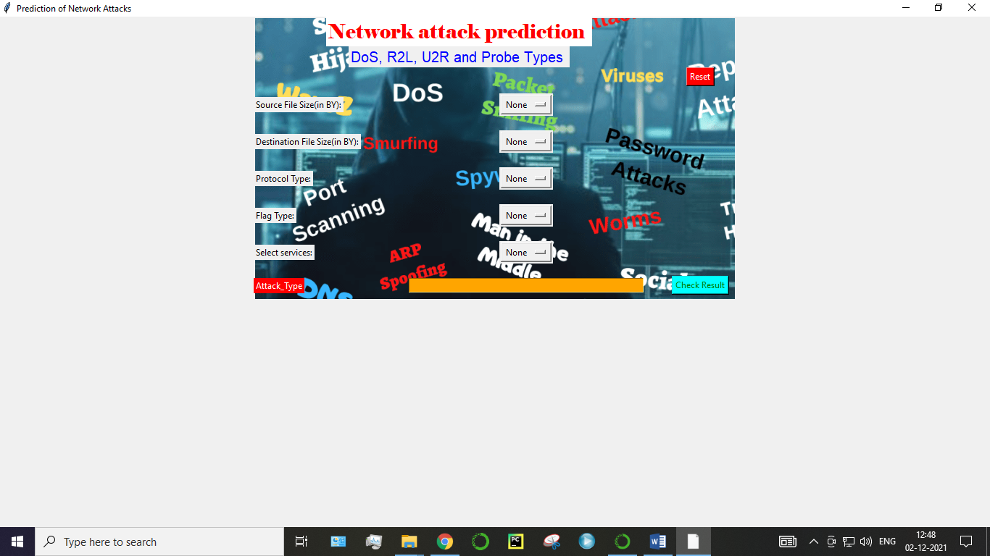

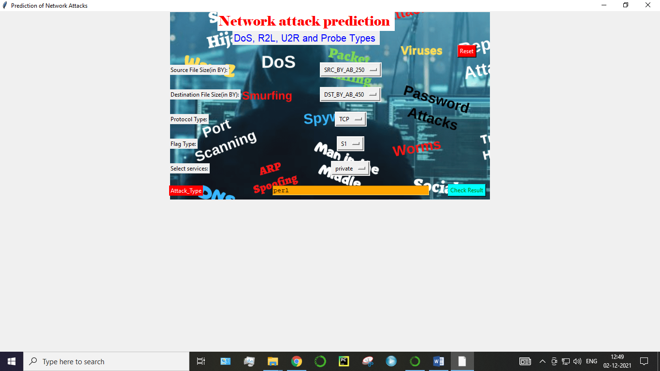

1. **Conclusion**

The analytical process started from data cleaning and processing, missing value, exploratory analysis and finally model building and evaluation. The best accuracy on public test set is higher accuracy score will be find out by comparing each algorithm with type of all network attacks for future prediction results by finding best connections. This brings some of the following insights about diagnose the network attack of each new connection. To presented a prediction model with the aid of artificial intelligence to improve over human accuracy and provide with the scope of early detection. It can be inferred from this model that, area analysis and use of machine learning technique is useful in developing prediction models that can helps to network sectors reduce the long process of diagnosis and eradicate any human error.

1. **Future Work**

* Network sector want to automate the detecting the attacks of packet transfers from eligibility process (real time) based on the connection detail.
* To automate this process by show the prediction result in web application or desktop application.
* To optimize the work to implement in Artificial Intelligence environment.